International Charitable Foundation “Alliance for Public Health”

Operational research study of the Drugstore Project among people who use psychoactive substances: 2025 findings

Kyiv, Ukraine
April 2026
Authors:

Vyacheslav Kushakov, Director: Behavioural Health & Crisis Response.
kushakov@aph.org.ua

Galyna Sergienko, Head of Team: Behavioural Health & Telehealth.
sergienko@aph.org.ua

Eugen Bolshov, Senior Researcher/Analyst: Behavioural Health & Telehealth.
bolshov@aph.org.ua

For enquiries about this study, please contact Eugen Bolshov, bolshov@aph.org.ua

© 2026 International Charitable Foundation “Alliance for Public Health”. All rights reserved. No part of this publication may be reproduced without the prior permission of the copyright holder.

The views, statements and opinions expressed in this report are those of the authors and do not necessarily reflect the official position of the International Charitable Foundation “Alliance for Public Health”, its partners or donors. The authors have made every effort to ensure the accuracy of the information; however, the organisation accepts no responsibility for any errors or inaccuracies.

Table of Contents
About the study 5
Glossary and list of abbreviations 5
List of tables 8
List of diagrams 10
Study methodology and design 11
Study sample 11
Study questionnaire 12
Technical solution for the study 14
Data cleaning 15
Data analysis 18
Data management and ethics 19
Study limitations 20
Summary of study findings 22
Discussion of the findings and directions for further research 29
Recommendations 34
1. Profile of study participants 36
1.1. Sex distribution 36
1.2. Age distribution 36
1.3. Distribution by oblast of residence 36
2. Psychoactive substance use 39
2.1. Cannabis use 39
2.2. Injecting use of psychoactive substances 42
2.3. Substances used by injection 47
2.4. Substances used by non-injection routes 50
2.5. Psychoactive substance use among friends and acquaintances 60
3. Drug checking: awareness of substance-checking tests and practices 62
3.1. Awareness of drug checking 62
3.2. Reasons for not using PartyBox reagents for checking psychoactive substances 66
3.3. Reasons why respondents did not test psychoactive substances 67
4. Concurrent use of alcohol and psychoactive substances. Problematic alcohol use 69
4.1. Concurrent use of alcohol and psychoactive substances 69
4.2. Psychoactive substances used concurrently with alcohol 70
4.3. Frequency of episodes of heavy alcohol consumption 71
4.4. International criteria for intensive / excessive alcohol use 72
4.5. Prevalence of intensive / excessive alcohol use according to international criteria in different populations and its association with psychoactive substance use 73
5. Experience of spiking and its consequences 76
6. Sexual life 81
6.1. Use of psychoactive substances during the most recent sexual encounter 81
6.2. Psychoactive substance use during sexual contact, by partner type, in the previous six months 83
6.3. Sexual preferences and sexual practices 83
6.3.1. Sexual practices of women 83
6.3.2. Sexual practices of men 84
6.4. Condom use during sex 85
6.5. Transactional sex 90
6.6. Group sex 92
7. Need for mental health services 93
8. Need for healthcare services 100
9. Testing for syphilis, hepatitis, and other sexually transmitted infections 104
10. HIV testing 109
11. HIV pre-exposure prophylaxis (PrEP) 115
12. Problems and adverse effects related to psychoactive substance use 118
12.1. Types of problems related to psychoactive substance use 118
12.2. Adverse effects related to psychoactive substance use 121
References 129

About the study

Glossary and list of abbreviations

I. Key populations and behavioural practices
MSM – Men who have sex with men.
Transactional sex – Sexual contact involving the exchange of sex for money, material goods, psychoactive substances, or other resources.
Sexualised drug use (SDU) – The intentional use of psychoactive substances before or during sexual activity to alter or intensify the sexual experience.
Spiking – The deliberate addition of psychoactive or other potent substances to a person’s drink or food without their knowledge or consent.

II. Prevention and infections
HIV – Human immunodeficiency virus.
AIDS – Acquired immunodeficiency syndrome.
STIs – Sexually transmitted infections.
PrEP (Pre-Exposure Prophylaxis) – HIV pre-exposure prophylaxis; a prevention method involving the use of antiretroviral medicines by HIV-negative individuals at increased risk of infection.
OST – Opioid substitution therapy.

III. Alcohol and related indicators
Standard drink – A conventional unit of alcohol consumption corresponding to a fixed amount of pure ethanol; in this report, the measure is operationalized using specified volumes of beverages with typical alcohol content.
Binge drinking – An episode of consuming a large amount of alcohol on a single occasion; the threshold is defined according to the methodology used.
HED (heavy episodic drinking) – Episodic heavy alcohol consumption according to the WHO definition: consumption of at least 60 g of pure alcohol on at least one occasion during the past 30 days.
Heavy drinking - Frequent episodic heavy alcohol consumption, the definition of which depends on the methodology used (SAMHSA, CDC, etc.).

IV. Institutions and research tools
WHO – World Health Organization.
CDC – Centers for Disease Control and Prevention (USA).
NIAAA – National Institute on Alcohol Abuse and Alcoholism (USA).
SAMHSA – Substance Abuse and Mental Health Services Administration (USA).
ESPAD – European School Survey Project on Alcohol and Other Drugs.
AUDIT – Alcohol Use Disorders Identification Test.
V. Psychoactive substances

PAS – Psychoactive substances.

2C-B – A synthetic psychoactive substance from the phenethylamine group, with psychedelic and stimulant effects.

Alpha-PVP (α-PVP) – A synthetic psychostimulant from the cathinone group, with a high potential for toxicity and dependence.

GHB/GBL – Gamma-hydroxybutyric acid and gamma-butyrolactone; substances with depressant effects on the central nervous system.

LSD (lysergic acid diethylamide) – A semi-synthetic psychedelic hallucinogen.

MDMA (ecstasy) – 3,4-methylenedioxymethamphetamine; a synthetic psychoactive substance with empathogenic and stimulant properties.

Nalbuphine – An opioid analgesic with a risk of misuse and dependence.

Pregabalin (brand name “Lyrica”) – A gabapentinoid that may produce euphoria and dependence when used non-medically.

DMT (dimethyltryptamine) – A psychoactive substance from the tryptamine group, commonly classified as a classic psychedelic.

5-MeO-DMT (5-methoxy-dimethyltryptamine) – A psychoactive substance from the tryptamine group; despite the similarity in name, it is not identical to DMT and has a different profile of effects.

VI. Information, analytical and record-keeping systems
KoboToolbox – An online platform for designing and administering surveys and collecting data.
SPSS (Statistical Package for the Social Sciences) – Software for statistical data analysis.
SyrEx – An information system for monitoring clients and services in HIV prevention programmes, developed by Alliance for Public Health to ensure anonymity and avoid double counting.
CASE++ – A client coding system for non-medical care and support programmes, developed by the All-Ukrainian Network of People Living with HIV, which is currently mandatory for use in HIV prevention programmes and is intended to facilitate the integration of client codes with medical patient record systems used by public healthcare institutions.

VII. Project programme components
PartyBox – A comprehensive prevention kit provided to Drugstore project clients, containing harm reduction materials, rapid diagnostic tests for infections, reagents for drug checking, and information resources.

VIII. Other abbreviations
CI – Confidence interval.
PTSD (post-traumatic stress disorder) – A mental health disorder that may develop following direct experience of, or witnessing, a traumatic event involving threat to life, serious danger or violence. It may manifest through intrusive memories, avoidance of reminders of the traumatic experience, heightened anxiety, emotional distress, and sleep disturbance.

List of tables

Table 1. Distribution of the sample by respondents’ oblast of residence. 37
Table 2. Statistical testing of changes in lifetime experience of psychoactive substance use. 56
Table 3. Statistical testing of changes in psychoactive substance use during the previous 30 days, by substance. 58
Table 4. Reasons why respondents had never used a test to check psychoactive substances (open-ended responses). 68
Table 5. During the previous six months, did you ever use alcohol and other psychoactive substances at the same time, or during the same session or party? 69
Table 6. Which substances did you most often combine with alcohol during the previous six months? (n = 2,052; respondents who combined alcohol and psychoactive substances; multiple responses allowed) 70
Table 7. During the previous year, how often did you drink five or more standard drinks of alcohol on a single occasion? 71
Table 8. Composite indicators of alcohol use. 74
Table 9. Have you ever experienced a situation in which a psychoactive substance was added to your drink or food without your knowledge or consent (so-called “spiking”)? 76
Table 10. What consequences did this spiking incident, or these spiking incidents, lead to? 77
Table 11. Consequences of incidents of spiking. 79
Table 12. Which substances were used during your most recent sexual encounter, excluding alcohol and cannabis? 82
Table 13. Sexual practices of women. 84
Table 14. Sexual practices of men. 85
Table 15. What were the reasons for not using a condom during the most recent sexual encounter? 87
Table 16. Reasons for not using a condom. 89
Table 17. During the previous 12 months, were there any cases when you entered into a sexual relationship primarily to obtain something you needed, such as money, gifts, psychoactive substances, or other resources that were important to you? 90
Table 18. What exactly did you receive in exchange for such sexual relationships during the previous 12 months? 91
Table 19. Need for help from a psychologist/psychotherapist and from a psychiatrist. 93
Table 20. Sources of psychological or psychiatric help. 95
Table 21. Channel through which support was received. 96
Table 22. Reasons for not seeking psychological or psychiatric help despite perceived need. 98
Table 23. Need for healthcare services during the previous six months. 100
Table 24. Sources of medical care received by respondents. 102
Table 25. Reasons why respondents did not seek medical care despite having felt a need for it. 103
Table 26. Testing for syphilis, hepatitis B, hepatitis C, and other STIs during the previous six months. 104
Table 27. Reasons for not testing for STIs. 106
Table 28. Where or how it would be most convenient to be tested for syphilis, hepatitis B, hepatitis C, or other STIs. 107
Table 29. Level of interest in self-testing at home using rapid multi-tests. 108
Table 30. Have you ever been tested for HIV? 109
Table 31. Proportion ever tested for HIV, by age. 109
Table 32. Timing of most recent HIV test. 110
Table 33. Result of the most recent HIV test. 111
Table 34. Awareness of rapid HIV self-tests. 111
Table 35. Preferred type of rapid HIV self-test. 112
Table 36. Which test is perceived as more accurate. 112
Table 37. Level of interest in self-testing at home using rapid HIV tests. 113
Table 38. Awareness of HIV pre-exposure prophylaxis (PrEP). 115
Table 39. PrEP use during the previous year. 116
Table 40. Do you take PrEP (HIV pre-exposure prophylaxis) continuously or on demand? 117

List of diagrams
Diagram 1. Cannabis use. 39
Diagram 2. Cannabis use by sex. 40
Diagram 3. Cannabis use by age. 41
Diagram 4. Experience of injecting psychoactive substances (2021-2025). 43
Diagram 5. Frequency of injecting psychoactive substance use. 44
Diagram 6. Frequency of injecting psychoactive substance use by sex. 45
Diagram 7. Frequency of injecting psychoactive substance use by age. 46
Diagram 8. Main substances used by injection (15 most frequent responses). 48
Diagram 9. Main substances used by injection by age (15 most frequent responses). 49
Diagram 10. Frequency of use of different psychoactive substances. 50
Diagram 11. Frequency of use of different psychoactive substances by sex. 52
Diagram 12. Experience of different psychoactive substance use by age. 53
Diagram 13. Frequency of psychoactive substance use in the previous 30 days, by age. 54
Diagram 14. Lifetime experience of non-injection psychoactive substance use (2021–2025). 55
Diagram 15. Non-injection psychoactive substance use in the previous 30 days (2021–2025). 57
Diagram 16. Psychoactive substance use among friends and acquaintances. 60
Diagram 17. Psychoactive substance use among respondents’ friends and acquaintances, by age. 61
Diagram 18. Awareness of drug checking. 62
Diagram 19. Experience of using tests to check psychoactive substances. 63
Diagram 20. Experience of using tests to check psychoactive substances, by age. 64
Diagram 21. Psychoactive substances most recently checked by respondents. 64
Diagram 22. Reasons for not using PartyBox reagents for checking psychoactive substances. 67
Diagram 23. Problems related to psychoactive substance use. 118
Diagram 24. Problems related to psychoactive substance use, by sex. 119
Diagram 25. Problems related to psychoactive substance use, by age. 120
Diagram 26. Experience of acute bodily reactions after psychoactive substance use. 121
Diagram 27. Experience of acute bodily reactions after psychoactive substance use, by sex. 122
Diagram 28. Experience of acute bodily reactions after psychoactive substance use, by age. 123
Diagram 29. Adverse bodily reactions after psychoactive substance use. 124
Diagram 30. Adverse bodily reactions after psychoactive substance use, by sex. 125
Diagram 31. Adverse bodily reactions after psychoactive substance use, by age. 126
Diagram 32. Perceived triggers of adverse bodily reactions after psychoactive substance use. 127
Diagram 33. Perceived triggers of adverse bodily reactions after psychoactive substance use, by age. 128

Study methodology and design
The data collection period for the study ran from 12 February 2025 to 26 December 2025. The section below provides a brief overview of the study methodology, including the study design, sample, recruitment approach, geographical coverage, data collection instrument, technical setup, survey implementation logic, including the integrated PartyBox intervention, data analysis, and data management.
The study focused on people who use psychoactive substances and were interested in receiving services from the Drugstore project implemented by Alliance for Public Health. The study used a non-probability sample and was conducted as continuous online data collection on the KoboToolbox platform, using a self-administered structured questionnaire. This approach helps reduce the influence of social desirability bias on data validity. Completion of the questionnaire was a condition for receiving the project’s prevention services.
The study followed the design of a continuous cross-sectional online survey with rotating modules: thematic blocks of questions were launched for a limited period and discontinued once the target number of respondents and/or the required precision of indicators had been reached. This design made it possible to test new hypotheses rapidly and to assess the prevalence of phenomena of interest to programme managers.
Each respondent was assigned a unique identifier: a SyrEx code throughout 2025 and a CASE++ code from summer 2025 onwards. This made it possible to integrate the study data into the prevention service monitoring system of Alliance for Public Health and the national monitoring system in Ukraine. The operational research cycle was as follows: recruitment → screening → main questionnaire → assignment of unique code(s) → respondent verification by a Drugstore project staff member → provision of a prevention kit, usually by post, and delivery of any other services the client was interested in, such as psychological counselling, HIV testing, or referral to other services, including medical or legal assistance. In this sense, the study also functioned as an intervention.

Study sample
Participants were recruited using a non-probability convenience sampling approach. The study was designed to reach the target population through digital communication channels and existing networks of interaction with potential project clients. The main emphasis was placed on social media, online communities, partner organisations’ communication channels, and network-based dissemination of information about the project and the study. Accordingly, the sampling approach may be described as a combination of river or social media sampling for respondents recruited through online advertising and the project’s social media activity, and snowball sampling for participants who learned about the study from friends, acquaintances, or other personal networks.
This approach involved participant self-selection: individuals joined the survey after learning about the study and deciding to take part. Accordingly, the sample was non-probability-based and is not intended to be representative of the wider population. Its purpose was to provide access to a relevant audience and generate data on their characteristics, needs, and behavioural patterns.
The inclusion criteria for the study were as follows: (1) being aged 14 years or older; (2) having used psychoactive substances other than cannabis or alcohol within the previous six months; (3) having provided informed consent to participate in the study; and (4) residing in Ukraine, excluding the Autonomous Republic of Crimea. The survey was conducted in Ukrainian. It is important to note that respondents living in temporarily occupied or non-government-controlled territories of Ukraine were unable to receive the PartyBox prevention kit due to logistical and security constraints. The online format made it possible to include respondents from remote localities, provided they had internet access, and to account for forced population displacement during martial law, as participants could complete the survey from any safe location within the country.
A total of 2,919 questionnaires were collected in 2025. Of these, 2,770 were unique records based on SyrEx code. Following data cleaning, 178 questionnaires were excluded (see the “Data cleaning” section), resulting in a final analytical sample of 2,592 questionnaires.

Study questionnaire
The study instrument was a structured online self-administered questionnaire comprising a set of substantive thematic modules. The questionnaire was developed by the Drugstore project team.
The questionnaire began with a brief description of the study and the project, followed by informed consent, a screening section covering place of residence, age, and use of psychoactive substances during the previous six months, a basic demographic section covering sex, age, and self-assessed financial situation, and a section for generating SyrEx and CASE++ codes, the latter introduced from summer 2025 onwards.
The questionnaire was organised into thematic modules and covered both respondents’ experience of interacting with the project and behavioural practices related to psychoactive substance use, sexual behaviour, and risk prevention. It opened with a section on previous use of the PartyBox harm reduction kit among respondents who had used it before. This made it possible to assess respondents’ prior interaction with the service and their perceptions of it.
The questionnaire then included modules on psychoactive substance use: cannabis use, injecting use, and non-injecting use of other psychoactive substances were considered separately. This distinction allowed for a more precise analysis of different patterns of use and the risks associated with them. Separate sections addressed the concurrent use of psychoactive substances and alcohol, indicators of problematic alcohol use, and experiences of spiking.
The next module focused on problems and adverse consequences that may arise in connection with psychoactive substance use. The questionnaire also included a module on drug-checking practices as an element of harm reduction. A substantial part of the questionnaire concerned sexual relationships and related risks, as well as testing for HIV, syphilis, viral hepatitis, and other STIs. The final module focused on experience of and awareness of pre-exposure prophylaxis (PrEP). During the data collection phase, some modules were rotated once the number of responses required by programme managers had been obtained. For example, the questionnaire initially included a module on respondents’ need for medical services and for psychological/psychiatric support, as well as their experience of receiving such services; this was later removed to introduce new indicators relating to sexual behaviour, and so forth. Rotation was used to avoid overburdening respondents with an excessively long questionnaire, which could increase the number of interrupted interviews and negatively affect data quality.
After completing the questionnaire, respondents received information about their unique coupon number, the date and time of survey completion, their SyrEx and CASE++ codes, and service offers with web links through which they could access project services if they wished. These included, for example, psychological counselling, support for people who inject drugs, if the respondent reported such experience, and other services. By sending project staff a screenshot showing the coupon number and the SyrEx and CASE++ codes, the respondent became eligible to receive a PartyBox prevention kit.
The median questionnaire completion time was 13.37 minutes, and the mean completion time was 15.43 minutes. These indicators were calculated only for questionnaires completed within 60 minutes, as a small proportion of respondents took long breaks between starting and submitting the questionnaire — in some cases lasting hours, and occasionally days or weeks.

Technical solution for the study
The web-based survey was implemented using KoboToolbox, a data collection platform that was well suited to the study requirements because it combined accessibility for respondents with flexible questionnaire configuration. The platform made it possible to distribute the questionnaire via a direct web link, allowing respondents to participate in the study from a smartphone, tablet, or computer without installing any additional applications.
KoboToolbox was used to implement skip logic and response validation, including screening, conditional display of modules, and checks for response consistency. This helped reduce the number of errors in critical fields. An important advantage was the ability to rotate individual thematic modules during the year by updating, reordering, enabling, or disabling modules without fully redesigning the questionnaire. This simplified maintenance of the instrument and allowed it to be adapted to the project’s current information needs.
The platform also enabled the automatic generation of unique codes for completed questionnaires and their display to respondents on the final screen. These generated codes, SyrEx and CASE++, were used for operational purposes, namely deduplication and integration with prevention service delivery processes. After questionnaire completion, a minimum necessary set of technical fields, including codes, coupon number, and date and time of completion, was shared with programme managers without giving them access to the substantive questionnaire responses.
Data transmission was carried out through a secure HTTPS channel with password-protected access, and access to the data was restricted to authorised team members. After data collection was completed, the data were exported in standard formats, CSV and XLSX, for further processing and analysis in SPSS.
During survey implementation, a technical issue was identified related to the in-app browser in the Instagram mobile application. When respondents opened the questionnaire link directly within the app, some users experienced difficulties completing and submitting the form correctly. To minimise this problem, the information materials included an additional recommendation to open the questionnaire in an external browser, such as Chrome or Safari. Nevertheless, it cannot be ruled out that some potential respondents were unable to complete the survey for technical reasons.

Overall, the use of KoboToolbox ensured effective instrument management, flexibility in updating the questionnaire, and reliable data handling in an online study on a sensitive topic.

Data cleaning
Surveys involving incentives — and receipt of the PartyBox prevention kit and other project services may be perceived by some potential respondents as an incentive — may attract inattentive or dishonest respondents, as well as bots, that is, automated survey participants. This can result in meaningless, perfunctory, or fraudulent responses and, consequently, low-quality data. It is therefore appropriate to identify and, where necessary, remove such responses to produce a cleaned, high-quality final dataset. In addition, some genuine respondents may complete the survey more than once within a year.
For this reason, questionnaires were first deduplicated. Potential duplicate records were identified and removed so that each participant was represented in the database only once during the year. Repeated submissions were identified using the SyrEx code and questionnaire completion dates, and only the earliest questionnaire by date was treated as valid. Only questionnaires with the following characteristics were included in the final dataset: (1) unique by SyrEx code; (2) successful completion of screening; and (3) a fully completed questionnaire, defined as having a response to the final question.

For each unique questionnaire, the following data quality indicators were calculated:
- Questionnaire completion time
In web surveys, speeding refers to situations in which respondents complete the questionnaire too quickly to adequately process the content of the questions, which may lead to careless responses and lower data quality. Methodological publications suggest that, to identify and minimise speeding, response time should be used together with other paradata and data quality indicators . For this component of the analysis, we excluded questionnaires with a completion time longer than 60 minutes, as well as those that began on one calendar day and ended on another. These records were not suitable for estimating actual questionnaire completion time because they likely included artificial pauses. The median questionnaire completion time, excluding questionnaires completed in more than 60 minutes, was 13.37 minutes; the mean time was 15.43 minutes (standard deviation: 8.07 minutes), and the interquartile range was 7.88 minutes (Q1 = 10.20; Q3 = 18.08). Percentile analysis showed that 10% of respondents completed the questionnaire in less than 7.98 minutes and 5% in less than 6.93 minutes; the minimum recorded value was 3.12 minutes.
- Inconsistency between two age indicators reported by the respondent
When completing the questionnaire, respondents reported their age twice in different formats. First, they answered a direct screening question about their age in completed years. Second, if they passed the screening stage, they reported their year of birth to generate SyrEx and CASE++ codes. Since the SyrEx code served as the “key” to receiving the PartyBox kit and other project prevention services, a discrepancy between the age reported in completed years and the age calculated from the reported year of birth was treated as one indicator of careless or dishonest questionnaire completion.
- Anomalies in self-reported age
Another indicator of data quality was the presence of highly implausible reported ages. In the 2025 survey, there were two respondents who reported ages of 80 and 100 years respectively.
- Response uniformity in battery questions (straightlining)
To assess data quality in two key matrix sections, substance use and sexual practices, we used an indicator of response uniformity at the respondent level. For each section, we calculated the standard deviation of responses across all items in that section. For example, if a respondent gave the same answer to every item on psychoactive substance use, such as “never” or “during the last 30 days”, the standard deviation for that section would be 0. This could serve as an indicator of mechanical or careless questionnaire completion.
- Number of logical inconsistencies in questionnaire responses
To monitor data quality, we also applied a set of logical filters, or logic checks, designed to identify internal contradictions between responses in different sections of the questionnaire. We checked for incompatible combinations, such as respondents stating that they had never had sex with men, women, or two or more partners of a given sex, while also indicating the timing of their most recent sexual contact with that category of partner. We also checked cases where respondents reported using drug-checking tests or the oral HIV test from the PartyBox kit while simultaneously stating that they did not know their HIV status, had never tested for HIV, or had never checked psychoactive substances.
Temporal consistency was checked separately. For example, this included cases where respondents reported that all substances had only been used more than six months ago, while also confirming that they had combined a specific substance with alcohol during the last six months. It also included situations where respondents reported checking or using during sex a substance that, in the basic list, they had stated they had never used. In total, more than 50 such conditions were constructed. Identified logical inconsistencies were interpreted as risk signals for data quality problems, including errors, inattention, or mechanical completion.
- Proportion of indeterminate responses
As an additional data quality measure, we identified a set of questions that were asked of all respondents, regardless of questionnaire filters and branching. For each questionnaire, we then calculated the proportion of responses such as “Difficult to say / Don’t know” or “Prefer not to answer”. This indicator made it possible to assess the proportion of missing or non-substantive responses without distortion caused by skip logic in the questionnaire or by differences in the number of questions answered by each respondent. A high proportion of indeterminate responses or refusals to answer was interpreted as a potential signal of low engagement, fatigue, or perfunctory questionnaire completion.
A composite index of data quality problems was then calculated for each respondent, based on the indicators listed above and using researcher-defined weights. For example, respondents with an inconsistency between the two versions of their age received an additional 5 points on the index; a complete absence of variance in responses to the psychoactive substance use section added a further 3 points, and so forth.
Based on this analysis, the 6.4% of questionnaires with the highest values on the data quality problems index were removed from the dataset, corresponding to 178 questionnaires. As a result, the final analytical dataset comprised 2,592 questionnaires.

Data analysis

Statistical analysis was carried out using SPSS. Descriptive statistics included frequencies and percentages for nominal and ordinal variables, as well as means, medians, and percentiles for metric variables. Indicators are presented for the number of respondents who answered the relevant question; therefore, the sample size may vary by variable.

To compare proportions between independent groups, z-tests were used. In addition, 95% confidence intervals for selected frequency indicators were calculated using the Agresti–Coull method. Distributions of quasi-metric or ordinal indicators were compared between two independent groups using the Mann–Whitney test in cases where the assumptions of parametric tests were not met.

Associations between variables were assessed according to their levels of measurement. Where appropriate, the gamma coefficient was used for pairs of ordinal variables. In cases involving one nominal and one ordinal variable, Pearson’s chi-square test was applied, with the strength of association assessed using Cramer’s V. In some cases, correlations between ordinal variables were also analysed using Spearman’s rank correlation coefficient. Statistical significance was assessed at the α = 0.05 level.

For the analysis of linear trends across waves in dichotomous indicators, the Cochran–Armitage test for trend was used. This test makes it possible to assess whether the proportion of respondents with a given characteristic changed consistently in one direction from wave to wave.

The analysis was conducted by respondents’ age and sex. By sex, results are presented separately for men and women. Respondents who selected the categories “transgender woman”, “transgender man”, or “non-binary person” were not treated as a separate analytical group because of their small numbers. They were included in the overall descriptive analysis but excluded from sex-based comparisons. By age, the sample was divided into the following categories: 18 years and younger, 19–20 years, 21–23 years, 24–28 years, 29–33 years, and 34 years and older.

Where possible and appropriate, the findings were compared with data from analogous waves of the Drugstore project study conducted in previous years.

The statistical tests and confidence intervals presented in this report are used descriptively for subgroup comparisons within the recruited sample and for generating programme hypotheses. Owing to the non-probability nature of the sample, the findings should not be interpreted as population estimates for all people who use psychoactive substances in Ukraine.

Data management and ethics
Ethical approval for the study was obtained from the Institutional Review Board (IRB) of the International Charitable Foundation “Alliance for Public Health” (registration No. IORG0010394). The study was reviewed under Protocol No. 31 as the operational study “Operational Study of People Who Use Psychoactive Substances in Recreational Contexts and Men Who Practice Chemsex”. The materials submitted to the Board included the study protocol, the structured questionnaire, the informed consent form, and the CV of the Principal Investigator. The Principal Investigator and person responsible for the study is Dr Vyacheslav Kushakov, Director of the Department of Behavioural Health, Telehealth and Crisis Response. Following the review, the study was approved.
Data management was carried out in accordance with the internal information protection policies of the organisation that initiated the study and with applicable Ukrainian legislation on personal data protection. Prior to the start of data collection, a study protocol was developed defining procedures for ensuring confidentiality, restricting access to information, and setting out the principles of data processing.
Data were collected through the KoboToolbox platform using a secure connection. Access to the full raw dataset at platform level was restricted to authorised members of the research team only.
The questionnaire did not contain direct respondent identifiers, such as full name, residential address, or similar information. Unique codes, including SyrEx and CASE++, were used exclusively for operational purposes, namely distribution of PartyBox kits and questionnaire deduplication, and were not used for analytical purposes.
In cases where participants provided contact details in order to receive a PartyBox kit, for example for delivery, this information was collected separately by programme managers, stored outside the research dataset, and was not accessible to the research team.
Access to data was granted on a restricted need-to-know basis. Analytical files were stored on the organisation’s secure internal resources with limited access. After completion of the study, the data will be retained for the period specified in the organisation’s internal regulations, after which they may be archived or destroyed in accordance with the data management policy.
At the beginning of the survey, participants were informed that participation was voluntary, that they could withdraw at any stage, and that the results would be used only in aggregated form, without identification of individual participants.

Study limitations

The principal limitation of the study is its targeted rather than population-based nature. The sample is non-random and consists of individuals who became aware of the Drugstore project and were willing to engage with it, which introduces a self-selection effect. Accordingly, the findings primarily describe the surveyed respondents and the project’s potential clients, rather than the entire population of people who use psychoactive substances in Ukraine. These data should therefore not be used to produce population-level estimates of the prevalence of behavioural practices or other indicators for the target group. At the same time, they are suitable for describing the respondent profile, analysing associations between indicators within the study group, and generating programme-relevant conclusions and working hypotheses for future population-based research.

The analytical value of the study lies in identifying the profile of the project’s potential clients, their needs, behavioural patterns, barriers to seeking help, and expectations regarding Drugstore services. The findings should therefore be interpreted as characterising the engaged audience and as a basis for improving the service model, communication, and channels of interaction.

Additional methodological limitations relate to the different channels through which information about the project was disseminated, including social media, online advertising, partner organisations, personal recommendations from other users, and offline Drugstore project events. These channels may have influenced the composition of the sample in different ways. The predominance of digital channels may have contributed to the over-representation of younger, more socially active, and more technologically engaged individuals, while less digitally connected groups may be under-represented.

Although the exact characteristics of the population of people who use psychoactive substances in Ukraine are unknown, we assume that the study sample has substantial geographical biases. For example, a considerable proportion of respondents were residents of Kyiv and Odesa Oblasts, whereas other regions were less well represented.

As in any study based on self-report, the findings depend on how accurately respondents recall events and on their willingness to disclose sensitive information. This may lead to either under-reporting or over-reporting of certain indicators. For this reason, the results should be interpreted with caution, and these data should preferably be integrated with other sources of information, such as project programme data, qualitative interviews, and other studies of people who use psychoactive substances.

A further factor that may have influenced the findings is that a substantial proportion of respondents took part in the survey with the expectation of receiving a PartyBox prevention kit. Such motivation may generate a social desirability effect or an instrumental response effect, for example by encouraging respondents to exaggerate their level of risky behaviour or need for services if they assume this increases the likelihood of receiving the kit. At the same time, the opposite effect is also possible: under-reporting of sensitive practices because of distrust or fear of stigmatisation. Thus, the presence of a material incentive may have influenced responses. However, we do not have an empirical instrument that would allow us to measure this effect. In addition, as shown by our analysis (see the “Data cleaning” section), there was a small group of respondents who provided low-quality answers and approached the survey only formally, for example by completing it very quickly or giving illogical responses; these cases were excluded from the analysis.

In addition, 29% of respondents in the 2025 study had previously received a PartyBox and had therefore completed a similar questionnaire in earlier years. This may create a risk of the so-called “experienced respondent effect”. First, such participants may respond more quickly and in a more routinised manner, drawing on their previous experience of completing the questionnaire. Second, they may demonstrate a higher level of awareness of risks and services, reflecting not so much their initial profile as the influence of the project itself. Third, repeat participation may generate a learning effect, resulting in more internally consistent or more “normative” responses aligned with the expected logic of harm reduction in relation to psychoactive substance use. As a result, some indicators may already reflect the effect of the intervention rather than solely the baseline characteristics of the audience, as would be expected if the sample had been formed randomly.

A separate technical limitation concerned the functioning of in-app browsers within social media mobile applications, particularly Instagram, through which some users accessed the KoboToolbox questionnaire. In some cases, this may have led to difficulties in correctly submitting the completed form. As a result, some questionnaires that were started may not have entered the final dataset. The potential impact of this factor lies in the possible loss of some respondents recruited specifically through Instagram, which may in theory have affected the structure of the sample, for example by age or by preference for different social media platforms. The exact scale of this effect cannot be estimated, but it should be considered when interpreting the findings.

Summary of study findings
The study sample has a distinctly young age profile: 10% of respondents were aged 18 years or younger, 15% were aged 19–20 years, and more than half were aged 21–28 years. Women in the sample were substantially younger than men: the proportion of respondents aged under 20 was almost twice as high among women as among men. The sample also shows marked geographical asymmetry, with more than half of respondents residing in Kyiv.
Experience of cannabis use was almost universal in the sample: 97% of respondents had tried it at least once, and more than 60% had used it in the last 30 days. Lifetime experience of cannabis use increased with age: among the youngest respondents, it was lower than among those aged 21 years and older.
Almost one in five respondents had experience of injecting psychoactive substances. Injecting experience was somewhat more common among men than among women, and this difference was also observed for recent use, defined as use in the last 30 days. At the same time, the gap was moderate, indicating that injecting practices were present among both men and women rather than being concentrated mainly among men.
Injecting use shows a pronounced U-shaped age profile: its prevalence is highest among the youngest respondents, decreases in the 21–33 age groups, and rises again among those aged 34 and older. Particularly concerning is the high proportion of respondents with injecting experience among adolescents and young people under 20, indicating early entry into risky practices. The main injected substance was most often mephedrone (14%), followed by amphetamine (9.7%), ketamine (6.9%), heroin (5.9%), and alpha-PVP (5.9%). Other opioid variants were also present but dispersed across many categories, including nalbuphine, various forms of methadone, morphine, opium extract, and others. There were no sex differences in the choice of the main injected substance, but the profile differed substantially by age. Older respondents were more likely to report street methadone, whereas among the youngest respondents, Lyrica was relatively more prominent than in other age groups.
Regarding non-injecting use, the most frequently reported substances, excluding cannabis, were ecstasy and amphetamine: most respondents had tried them, and more than half also reported experience of LSD, psilocybin mushrooms, Lyrica, cocaine, and mephedrone. During the last 30 days, respondents most often reported using amphetamine, ecstasy, Lyrica, and mephedrone. This indicates the predominance of stimulants and empathogens in the current pattern of use, with Lyrica also remaining prominent.
With regard to age-related patterns, younger age groups, those aged 18 years or younger and 19–20 years, less often reported experience of ecstasy, amphetamine, cocaine, and, to some extent, ketamine than older respondents. By contrast, older age groups more often reported experience of methamphetamine and GHB/GBL, while the 29–33 age group stood out for a higher proportion of respondents with experience of LSD use compared with the youngest group. At the same time, younger respondents more often reported experience of Lyrica, mephedrone, other salts, and substances reported in the open-text “other” category.
Recent use, defined as use during the last 30 days, of LSD, mushrooms/psilocybin, and Lyrica was more often reported by younger respondents and generally declined in older age groups. For mephedrone and substances reported in the open-text “other” category, a higher proportion of recent use among younger respondents was also evident, although this pattern was not strictly linear. By contrast, older age groups somewhat more often reported recent cocaine use.
For cocaine, ketamine, mephedrone, alpha-PVP, opioids, and other salts, synthetic cathinones, the proportion of respondents with experience of non-injecting use reached its highest level in 2025 across the entire observation period since 2021.
Analysis of linear trends across the four study waves from 2021 to 2025 identified a statistically significant decline in the proportion of respondents reporting use of ecstasy, amphetamine, LSD, and 2C-B. For all these substances, the figure in 2025 was significantly lower than in 2021. By contrast, cocaine, mephedrone, ketamine, alpha-PVP, opiates/opioids, and other salts (synthetic cathinones) showed a statistically significant linear increase, and in most of these cases the figure in 2025 was significantly higher than in 2021.
Awareness of drug-checking tests is high, with more than three quarters of respondents reporting awareness, and does not differ by sex or age. At the same time, actual use of such tests is much lower: even among those who were aware of them, fewer than half had used them. The substances most often tested were the same as those most used, above all ecstasy and amphetamine. In most cases, the test confirmed the expected psychoactive substance; however, in a noticeable proportion of cases, around 20%, the results identified a different substance or were unclear. The main reasons for not using tests were access barriers, including lack of tests, difficulty obtaining them, or cost. The second most important reason was trust in the source of the substance.
Concurrent use of alcohol and other psychoactive substances was widespread: around 80% of respondents reported this practice. Almost one third did so regularly, indicating a common pattern of combined use rather than isolated cases. Alcohol was most often combined with stimulants and empathogens, above all amphetamine and ecstasy. At the same time, a noticeable proportion of respondents combined alcohol with pregabalin, which is a potentially risky practice given its depressant effects on the central nervous system.
The study findings point to an extremely high level of episodic heavy alcohol use in the sample. Most respondents (83.4%) reported consuming five or more standard drinks on a single occasion at least occasionally during the previous year, a pattern broadly corresponding to commonly used definitions of binge drinking. When compared with the WHO definition of binge drinking — consumption of at least 60 grams of pure alcohol on at least one occasion during the previous 30 days — every second participant in the study (50.7%) met this criterion. This is more than twice the average figure for the general population in the European Region (23%) and the United States (24.4%), indicating a particularly risky pattern of alcohol use in this sample.
Compared with international data, the picture appears even more concerning when regular heavy drinking is analysed. Almost one quarter of the sample (24.2%) met the SAMHSA criterion for heavy drinking, defined as episodic heavy alcohol use on at least five occasions per month. Notably, no gender differences were found in the prevalence of these patterns. By contrast, age played a clear differentiating role: younger age groups, under 28 years, showed substantially higher levels of both episodic heavy alcohol use and heavy drinking than older groups, aged 29 years and over.
Attention should also be paid to the relationship between heavy alcohol use and the use of other psychoactive substances. According to CDC data from the United States, more than half of those who had used psychoactive substances during the previous month also engaged in binge drinking. In the Ukrainian sample studied here, an almost identical picture is observed: 50.7% of psychoactive substance users meet the definition of episodic heavy alcohol use according to WHO and NIAAA criteria. This suggests that heavy alcohol use and the use of other psychoactive substances are closely linked behavioural patterns rather than isolated phenomena.
Almost one in five respondents (18.2%) had experienced “spiking” — the addition of psychoactive substances to a drink or food without their knowledge or consent. Despite the stereotypical perception of this phenomenon as exclusively a women’s issue, the data indicate that it is prevalent among both sexes: 21.3% of women and 15.3% of men reported such experience. Young people are the most vulnerable group: among respondents aged under 20, the proportion of those who had experienced spiking at least once reached 22–24%, whereas after age 29 this fell to 12–13%. Particularly telling is the fact that the youngest respondents most often reported recent experience, that is, incidents occurring within the previous six months, indicating that this practice remains a real and current risk for young people rather than merely a phenomenon of the past.
Sexualised drug use (SDU) is a common practice in the sample: more than one third of respondents reported using psychoactive substances, excluding alcohol and cannabis, before or during their most recent sexual encounter. No sex differences were identified, with figures for women and men being almost identical, suggesting that this behaviour is normalised in both groups. When behaviour over the previous six months is analysed, rather than only the most recent sexual contact, the prevalence of SDU is even higher. Clearly, sexualised use is not merely an episodic “last time” event, but rather a stable practice among a substantial proportion of respondents.
Same-sex sexual experience is common: almost half of women and more than one third of men had such experience at least once in their lives.
Almost one in five respondents had engaged in group sex during the previous six months. In the sample, group sex is generally not a one-off experiment: almost two thirds of respondents who had engaged in it during the previous six months reported doing so more than once, and one third reported doing so frequently, indicating an established behavioural pattern. This is not an episodic event, but a stable part of the sexual repertoire for a considerable proportion of the sample.
At their most recent sexual encounter, fewer than half of respondents used a condom, meaning that unprotected contact was more typical than protected sex. Men more often reported condom use than women. The age gradient is clear: in the group aged 29 years and over, the proportion reporting unprotected sex was statistically significantly higher than among the youngest respondents. The main reasons for not using condoms in this group were related not to lack of access, but to trust and a sense of safety within the partnership.
The age pattern in reasons for non-use of condoms is fairly clear: in younger groups, situational and resource-related motives predominate, such as not having a condom available, forgetting under the influence of substances, or not wanting to spend money, whereas with increasing age, trust within a stable relationship becomes more prominent. Thus, among younger respondents, unprotected sex is more often a consequence of impulsivity or circumstance, while among older respondents it is more often a conscious decision within a partnership.
Group sex is substantially more often associated with psychoactive substance use and is characterised by less consistent condom use compared with the “average” sexual encounter in the sample. Thus, group sex represents a context of heightened risk, both because of the high frequency of SDU during such encounters and because of less regular use of barrier protection.
Transactional sex during the previous year was reported by approximately one in six respondents. Although women reported such experience more often, it is not an exclusively “female” practice: more than 10% of men also reported such experience. The prevalence of transactional sex clearly declines with age: the highest figures are observed among respondents aged under 20, while after age 24 they are statistically significantly lower. In most cases, the compensation was money, but almost half received goods and two in five received psychoactive substances, underlining the close links between transactional sex and both economic and drug-related vulnerability.
The need for psychological and emotional support is widespread in the sample: more than 60% of respondents reported needing help from a psychologist, and 44% from a psychiatrist. Women were substantially more likely to report needing both psychological and psychiatric help, while men more often reported no need at all, which may reflect both real differences in mental health status and sex differences in willingness to seek help.
Age differences are less pronounced for the need for psychological help, but more noticeable for psychiatric help: younger respondents more often reported such a need, while its prevalence declined in older groups. Overall, this points to a high level of psychological and emotional vulnerability in the sample, especially among women and younger participants.
Having a need does not guarantee seeking help: among those who felt they needed psychological support, more than half had not contacted any specialist. A similar situation was observed for psychiatric help: almost every second person who reported such a need had not received professional support. This indicates a substantial gap between need and actual access to, or willingness to seek, help.
Those who did receive mental health support mostly used private-sector services; public and non-governmental services played a much smaller role. Thus, access to mental health services in this sample largely depended on individual resources rather than systemic support.
The main barrier to seeking psychological or psychiatric help was financial inaccessibility: the cost of services far outweighed all other reasons. The second most important barrier was lack of information: almost one third did not know where to go, indicating poor navigation of the service system.
At the same time, barriers related to trust and belief in the effectiveness of help are also noticeable, but less significant than economic factors. Social stigma and logistical difficulties play a secondary role. Thus, the problem lies not so much in the physical absence of services as in their financial and informational accessibility, as well as the level of trust in them. Women are significantly more likely to cite financial inaccessibility as the key reason for not seeking help, whereas men more often refer to distrust of professionals and fear of judgement. In other words, for women, the dominant barrier is lack of resources, while for men, it is trust-related and social-perception barriers.
The need for medical care during the previous six months was common in the sample (45%) and showed marked sex differentiation: women were significantly more likely both to report needing care and to seek help, whereas men more often reported no need and used services less frequently. Among those who had a need, around two thirds sought help, indicating a relatively higher conversion of need into help-seeking compared with mental health support. The main channel was the private sector, although more than half also used public facilities, pointing to a mixed model of access to medical services. Financial inaccessibility was the main barrier to receiving medical care: it was cited by most of those who had a need but did not seek help.
Coverage of testing for syphilis, viral hepatitis, and other STIs remained low in the sample: more than two thirds of respondents had not undergone any such test during the previous six months. A clear sex difference was that women were tested less often than men. An age gradient was also evident: younger respondents were less likely to test for these conditions, while with increasing age, the proportion who had been tested gradually rose. This points to the need to strengthen both access to and motivation for testing, particularly among younger project clients and women.
The main barrier to this category of testing was neither fear nor stigma, but the absence of a subjective sense of need: more than 40% did not see any point in being tested. The second line of barriers consisted of informational and financial factors, as well as time constraints. Concerns about confidentiality and fear of learning the result were much less important. Thus, the testing problem appears to be related more to low risk perception and poor awareness than to direct avoidance or stigmatisation.
Sex differences in barriers to testing for hepatitis, syphilis, and other STIs are generally minimal; however, women more often cite financial reasons and unwillingness to know the result, while men more often say they do not see any need for testing. The age pattern is clearer: younger respondents more often face informational, financial, and confidentiality-related barriers, and are also more likely to avoid testing because they do not wish to know the result. With age, these barriers decline, while the response “I do not see the need” becomes more common, which may reflect stabilisation of behavioural strategies or a false sense of safety.
It is notable that most respondents prefer self-testing and receiving tests by post, while offline formats are less attractive, especially public and NGO services. This indicates demand for anonymous, autonomous, and convenient models of access to testing for hepatitis, syphilis, and other STIs. Interest in home self-testing for STIs is exceptionally high: almost three quarters of respondents rated their interest at 8–10 points, and six in ten gave the maximum score. Women were statistically significantly more interested in such self-testing than men.
Most respondents had experience of HIV testing; however, almost one third had never been tested. No sex differences were identified, but a clear age gradient was evident: coverage was lowest among the youngest respondents, while in older groups it was substantially higher, with a particularly sharp increase after age 20. This indicates the need for targeted strategies for adolescents and young people.
At the same time, even among those who had been tested, a substantial proportion had done so more than a year earlier, indicating considerable potential for re-engagement in regular testing. Only around one third had relatively recent testing experience, meaning that testing regularity remained limited.
The overwhelming majority of those who had been tested reported a negative result (93.3%). The proportion reporting HIV-positive status was 1.1% among those tested and 0.7% of the total sample. The 95% confidence interval for the proportion with positive HIV status among those tested was 0.7%–1.8%.
Awareness of rapid HIV self-tests was high: 70.4% of respondents knew about their existence, and a further 21.8% had at least heard of them. In terms of preferred format, oral tests predominated, while blood-based tests were less often selected as the priority option. At the same time, most respondents regarded blood-based tests as more accurate. Thus, there was a gap between convenience of format and perceived reliability, and this should be considered in communication. Interest in home HIV self-testing was very high: almost three quarters of respondents rated their interest at 8–10 points, and more than half gave the maximum score. Women were significantly more likely to show maximum interest, while men more often chose middle or lower values on the scale.
Awareness of PrEP in the sample remained low: only around one quarter of respondents had heard of this prevention method, while more than two thirds had no information about it. Men were somewhat more likely to be aware of PrEP; however, the key factor was age: the lowest level of knowledge was found among adolescents and young people under 20, whereas in the 21–28 age groups awareness was statistically significantly higher.
Current PrEP users accounted for fewer than 8%, and a further small proportion reported previous use. PrEP use was clearly differentiated by sex: men were significantly more likely to report both current and past use. Among men, PrEP use was closely linked to sexual contact with men: the highest level was observed among those with recent same-sex experience, whereas among those without such experience, use was minimal. At the same time, no association was found with injecting psychoactive substance use or age.
Situational use predominated, while only around one quarter of users followed a daily regimen. This suggests that in this sample, PrEP was more often used as a tool for episodic risk management rather than as a systematic prevention strategy.

Discussion of the findings and directions for further research

Demographic characteristics of the study participants

The study findings show that a substantial proportion of the project’s potential clients come from younger cohorts of people who use psychoactive substances, particularly adolescent girls and young women. This is important, as it indicates the project’s ability to establish contact with very young people who use psychoactive substances at early stages of use and to engage in prevention work with groups that often remain less visible to traditional programmes, particularly adolescent girls and young women. The 2024 European School Survey Project on Alcohol and Other Drugs (ESPAD) showed that over the previous five years in Ukraine, the proportion of adolescents aged 15–16 with experience of psychoactive substance use had increased from 9% in 2019 to 14.9% in 2024. Accordingly, engaging these cohorts in prevention has become an even more urgent task.
The regional distribution of respondents is highly uneven: almost 70% of study participants are concentrated in the city of Kyiv and in Lviv and Odesa Oblasts. This sample structure reflects not so much the entire population of people who use psychoactive substances in Ukraine as the profile of the audience most readily reached through digital channels and Drugstore project services; this calls for caution when extending the findings to other groups. One possible explanation for the uneven geographical coverage is the substantial concentration of psychoactive substance use in contexts linked to nightlife, which is itself concentrated in large cities.
Different HIV-related risk groups are represented in the study

The study sample includes substantial representation of different behavioural profiles associated with HIV risk, not limited solely to non-injecting use of psychoactive substances. One in five respondents had experience of injecting drug use, and 14% reported such use during the previous six months. Among men in the sample, around 30% were MSM, meaning that they had had sexual contact with men during the previous six months and were therefore exposed to the corresponding risks of HIV infection. A notable proportion of both women and men had also engaged in transactional sex: 17% reported providing sexual services in exchange for compensation during the previous year. This indicates the simultaneous presence within the sample of several epidemiologically significant groups and risk practices. At the same time, from a programme perspective, these findings suggest that the project’s approach makes it possible to engage diverse client groups in prevention and creates a basis for adapting services to their risk profiles and needs.

Emergence of new popular psychoactive substances and their impact on behaviour
The study identified a high prevalence of “Lyrica” (pregabalin) use, a pharmaceutical medicine that occupies a prominent place in the pattern of psychoactive substance use among respondents. More than half of respondents reported experience of its use, and 27% reported having used it during the previous 30 days. By this measure, pregabalin ranked third after amphetamine and ecstasy. “Lyrica” was used more often by women and younger respondents; among users aged under 21, it was the most popular substance in terms of current use, defined as use during the last 30 days.
The importance of this finding is also supported by data from the qualitative study “Recreational Use of Pregabalin in Ukraine: Availability, Patterns of Use and Use in Chemsex”, which indicates that pregabalin is often used for non-medical purposes, including in the context of chemsex. According to that study, pregabalin use may be associated with increased sexual desire, reduced barriers to sexual interaction, increased duration of sexual acts, reduced use of harm reduction measures, initiation of sexual contacts that might not otherwise have occurred without the substance, and an increased number of sexual partners over a given period.
Our survey data also indicate a notable role of pregabalin in the context of sexualised psychoactive substance use. Among respondents who reported using psychoactive substances during their most recent sexual encounter, 21% reported using “Lyrica”. Only amphetamine, ecstasy, and mephedrone were mentioned more frequently in this context.

Gradual changes in the drug scene
In addition to the emergence of the highly popular “Lyrica”, other changes in the drug scene have taken place in recent years, judging by the consumption patterns observed in our sample: the popularity of mephedrone, alpha-PVP, methamphetamine, ketamine, other synthetic cathinones, opioids, and cocaine has increased. Since the study uses a non-random sample, we cannot determine whether these trends reflect changes in the broader population of people who use psychoactive substances or only changes in the profile of clients interacting with the Drugstore project.
The youngest people who use psychoactive substances as a group at heightened risk of problematic substance use
The study data indicate that the youngest groups of people who use psychoactive substances are characterised by riskier behaviour and a heavier burden of adverse outcomes associated with substance use. In this age group, injecting use of psychoactive substances, episodes of heavy alcohol consumption, experiences of spiking, involvement in transactional sex, need for psychiatric support, and a broader range of problems and adverse consequences related to use were all reported more frequently.
In view of this, the youngest people who use psychoactive substances, aged 14–23 years, should be treated as a priority target group for both research and prevention programmes aimed at people who use psychoactive substances.
Not only psychoactive substance use, but also alcohol, is a serious problem
Alongside psychoactive substance use, alcohol consumption also represents a significant public health problem in our sample. The overwhelming majority of respondents reported concurrent use of alcohol and psychoactive substances. This may substantially increase the risks of acute intoxication, injury, unwanted sexual contact, and other negative consequences.
The proportion of respondents meeting international criteria for binge drinking (WHO, NIAAA) and heavy drinking (SAMHSA) substantially exceeds average figures for populations in the European Region and the United States, indicating an over-concentration of intensive alcohol use in the target audience.
Indicators of problematic alcohol use in the Ukrainian sample of people who use psychoactive substances are close to the results obtained in the United States for a comparable population. This may suggest that elevated alcohol consumption among people who use psychoactive substances is more universal in character and not limited to the specific features of one country. Accordingly, prevention programmes should take this “dual” problem — the combined use of psychoactive substances and alcohol — into account when working with this group.
The absence of substantial gender differences in indicators of binge or heavy drinking suggests that interventions should be equally responsive to the needs of both men and women, rather than relying on traditional assumptions about “male” alcohol risk.
Further research could include more detailed indicators of alcohol-specific consequences, for example AUDIT or harm scales.

Drug checking and risk perceptions

Despite the high level of awareness of drug-checking tests, reported by more than three quarters of respondents, actual use remains noticeably lower, especially in the youngest age group. The main barriers are lack of access, the cost of tests, and trust in the source of the substance. These factors should directly inform programme design, including the locations and channels for distributing reagents and the content of communication messages.

A noticeable proportion of project clients who received tests as part of the PartyBox kit reported difficulties understanding the instructions. This indicates a need to revise them.
The problem of spiking
In our sample, spiking does not appear to be a rare phenomenon: almost one in five respondents had experienced it. Clearly, this is a real and widespread risk rather than an isolated occurrence. The data also challenge the stereotypical view of spiking as a «women’s issue»: both women and men reported such experiences, and the greatest vulnerability was observed among the youngest respondents, who also reported recent incidents more often.

The normalisation of sexualised drug use

In this sample, sexualised use of psychoactive substances appears not as an exception, but as a routine practice. It is better understood as a stable behavioural pattern than as a one-off event. The fact that the figures for women and men are almost identical further underlines the normalisation of SDU in both groups and the need to address it as a shared risk across the whole audience.

Age-related patterns in reasons for not using condoms

Younger respondents more often explain non-use of condoms in terms of resource-related reasons, such as “did not have one available” and “did not want to / could not afford to spend money”. For this group, a potentially appropriate solution may be regular targeted distribution of kits containing condoms and, where possible, lubricant. This would remove the cost barrier and ensure the constant availability of protection when needed.

High prevalence of group sex

In this sample, group sex appears in most cases not as a “one-off experiment”, but as a repeated practice: most of those who had such experience in the previous six months had engaged in it more than once, and one third had done so frequently, indicating an established behavioural pattern. At the same time, it is precisely in this context that sexual activity is more often combined with psychoactive substance use and condom use is less frequent than in the “average” sexual encounter, meaning that group sex represents a situation of heightened risk.

Problems in accessing psychological and psychiatric support

The need for psychological and emotional support in the sample is very high, but actual receipt of help is largely dependent on respondents’ financial resources: services are provided predominantly by the private sector, while public and non-governmental services play a noticeably smaller role. As a result, in the absence of financial resources, people simply do not receive the services they need, despite widespread demand.

Attitudes towards HIV and STI self-testing

High demand for remote and home-based models of HIV and STI testing, including self-testing, indicates that the target audience is willing to use rapid self-testing kits as a convenient and acceptable way of learning their status.

Recommendations

1. In future, the project should purposefully expand its presence and participant recruitment in regions that are currently less well represented, to ensure more balanced territorial coverage of both the research and intervention components.

2. Additional services should be offered to respondents with different risk profiles, for example MSM. At present, such practice already exists for respondents who reported experience of injecting psychoactive substances and are additionally encouraged to contact the Help24 service.

3. Non-medical use of pregabalin should be defined as a distinct focus of prevention and intervention activities, particularly in the context of sexualised psychoactive substance use and chemsex. The high prevalence of this substance, as well as its noticeable presence in sexual situations, indicates the need to include pregabalin in outreach messages, risk-screening tools, and ongoing monitoring within the project.

4. The motivations for and contexts of “Lyrica” (pregabalin) use, as well as the reasons for its high prevalence among users, should be studied in greater detail.

5. Research and prevention activities should focus on the youngest users, aged 14–23 years, as the priority group at highest risk and experiencing the greatest burden of consequences related to psychoactive substance use.

6. Representative studies should test the hypotheses regarding the growing popularity of mephedrone, alpha-PVP, other synthetic cathinones, opioids, and cocaine.

7. Harm reduction components focused on mephedrone, other synthetic cathinones, and opioids should be strengthened.

8. Given the extremely high levels of binge and heavy drinking, brief screening tools, for example AUDIT-C, should be integrated into the service model.

9. Structured components aimed at reducing high-risk alcohol consumption should be integrated into the PartyBox model, including information materials on binge/heavy drinking and clear self-help and help-seeking pathways.

10. The instructions for the substance-checking tests included in PartyBox should be revised: they should be made shorter and more user-friendly, using a step-by-step format, simple wording, and visual prompts, and their comprehensibility should be tested with a small group of users before scaling up.

11. Regular targeted distribution of condoms for the youngest participants should be introduced as a key measure for reducing resource-related barriers.

12. Free or significantly subsidised access to psychological and psychiatric support for people who use psychoactive substances should be expanded through community-based organisations.

13. HIV and STI self-testing should be scaled up, including through delivery and online ordering, with straightforward referral pathways to confirmatory testing and further care.

14. Data on the high prevalence of intensive alcohol use and the growing role of synthetic cathinones and opioids should be used to advocate for expanded funding for harm reduction and youth mental health programmes.

1. Profile of study participants

1.1. Sex distribution

Study participants were distributed by sex as follows: women — 47.9%; men — 50.2%; transgender men — 0.8%; transgender women — 0.5%; and non-binary people — 0.6%. Given the small size of the transgender women, transgender men, and non-binary groups, with fewer than 20 respondents in each group, subsequent sex-based analyses in this report include women and men only.

1.2. Age distribution
The distribution of respondents by age group was as follows: 18 years and younger — 10.0% of respondents; 19–20 years — 14.6%; 21–23 years — 25.2%; 24–28 years — 27.4%; 29–33 years — 12.4%; and 34 years and older — 10.4%. Thus, almost half of study participants were aged 14–23 years.
The analysis identified statistically significant age differences between the men and women who took part in the study. Men were older on average (26.2 years) than women (23.9 years), a difference of 2.3 years. Age variability among men was also somewhat higher than among women.
Among women who took part in the study, the proportion in the youngest age groups was higher than among men: 13.2% of women belonged to the 14–18 age group, and 17.8% were aged 19–20 years; the corresponding percentages among men were 6.9% and 11.2%. Thus, the proportion of those aged 20 years or younger among women was almost twice as high as among men. By contrast, among men, the proportion of respondents aged 34 years and older was almost three times higher: 15.0%, compared with 5.8% among women.

1.3. Distribution by oblast of residence

Overall, 2,592 respondents from different regions of Ukraine took part in the study. All regions of Ukraine were represented in the study, except Luhansk Oblast, the Autonomous Republic of Crimea, and the city of Sevastopol. The most represented location was the city of Kyiv, which accounted for 53.3% of respondents (1,382 individuals), more than half of the total sample. Other regions with relatively high representation were Lviv Oblast (8.8%, 228 respondents), Odesa Oblast (6.6%, 172 respondents), Kyiv Oblast (5.6%, 146 respondents), Dnipropetrovsk Oblast (3.9%, 100 respondents), and Kharkiv Oblast (3.8%, 98 respondents), although their shares were substantially lower than that of Kyiv.

The smallest numbers of participants were recorded in the government-controlled parts of Donetsk Oblast (0.5%, 14 respondents) and Kherson Oblast (0.2%, 6 respondents), Zakarpattia Oblast (0.3%, 7 respondents), and the non-government-controlled part of Zaporizhzhia Oblast (<0.05%, 1 respondent). The non-government-controlled parts of Donetsk and Kherson Oblasts were not represented in the sample.

Table 1. Distribution of the sample by respondents’ oblast of residence.
Oblast of residence | n | %
City of Kyiv | 1382 | 53.3
Lviv Oblast | 228 | 8.8
Odesa Oblast | 172 | 6.6
Kyiv Oblast | 146 | 5.6
Dnipropetrovsk Oblast | 100 | 3.9
Kharkiv Oblast | 98 | 3.8
Vinnytsia Oblast | 59 | 2.3
Rivne Oblast | 42 | 1.6
Ivano-Frankivsk Oblast | 37 | 1.4
Khmelnytskyi Oblast | 35 | 1.4
Cherkasy Oblast | 35 | 1.4
Poltava Oblast | 29 | 1.1
Zaporizhzhia Oblast (government-controlled) | 28 | 1.1
Sumy Oblast | 27 | 1.0
Chernihiv Oblast | 26 | 1.0
Zhytomyr Oblast | 24 | 0.9
Volyn Oblast | 20 | 0.8
Mykolaiv Oblast | 20 | 0.8
Kirovohrad Oblast | 19 | 0.7
Chernivtsi Oblast | 19 | 0.7
Ternopil Oblast | 18 | 0.7
Donetsk Oblast (government-controlled) | 14 | 0.5
Zakarpattia Oblast | 7 | 0.3
Kherson Oblast (government-controlled) | 6 | 0.2
Zaporizhzhia Oblast (non-government-controlled) | 1 | 0

2. Psychoactive substance use

2.1. Cannabis use
Experience of cannabis use was very common among respondents: 96.8% of study participants had tried cannabis at least once. 60.9% had used it during the previous 30 days, 19.3% during the previous six months but not during the last 30 days, 6.9% between six and 12 months ago, and 9.6% more than a year ago. Only 1.7% of respondents had never tried cannabis. A further 1.5% provided no response.

Diagram 1. Cannabis use.
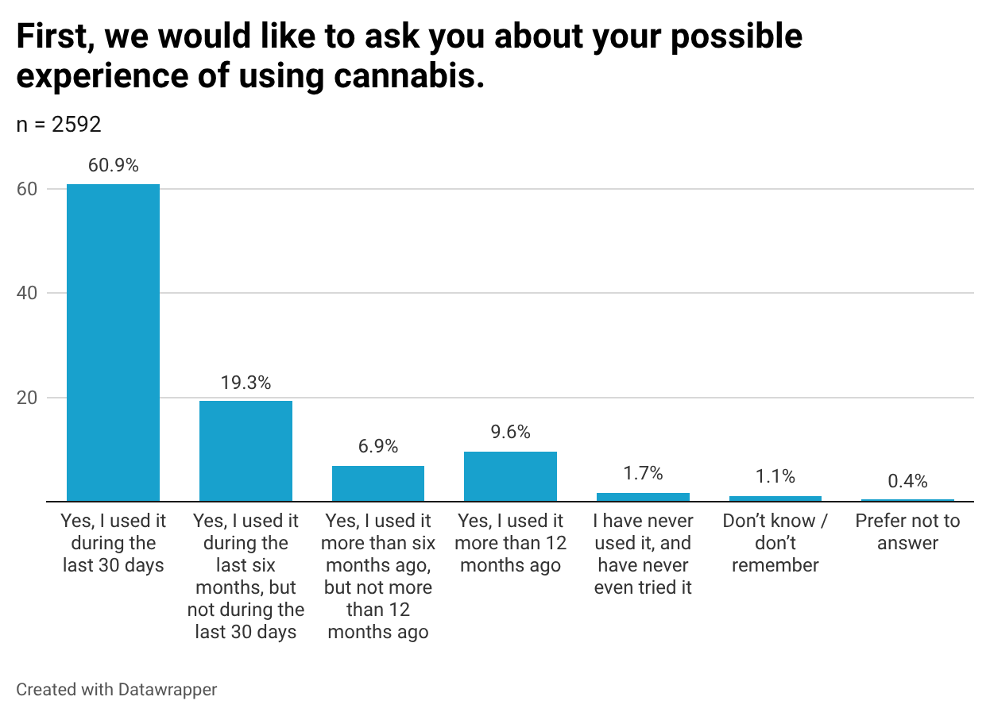
A higher proportion of men than women reported using cannabis during the previous 30 days: 64.8% and 56.8%, respectively .

Diagram 2. Cannabis use by sex.
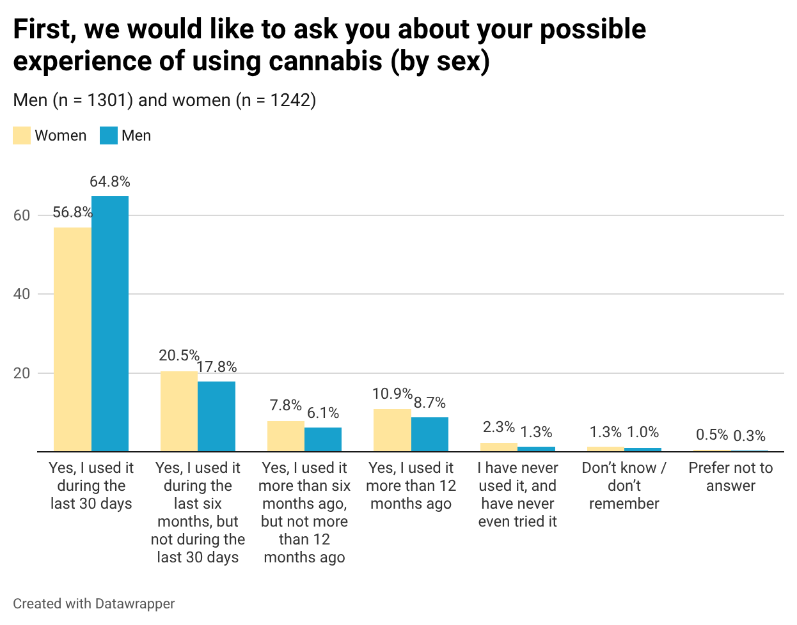
Participants aged under 21 were less likely to report experience of cannabis use than older respondents: 91.5% among those aged 18 years and younger, 93.4% among those aged 19–20 years, and at least 98% in all other age groups. The youngest respondents were more likely to give an indeterminate response, while those aged 19–20 were more likely to report never having used cannabis. By contrast, respondents aged 21–23 more often reported having used cannabis during the previous 30 days, whereas those aged 24 and older more often reported use more than 12 months ago.

Diagram 3. Cannabis use by age.
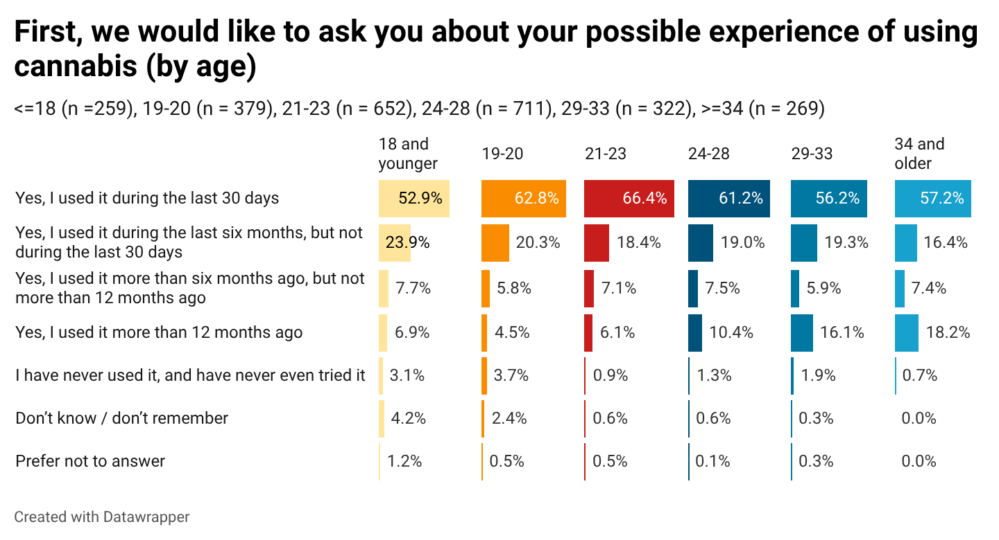

2.2. Injecting use of psychoactive substances

Among study participants, 19.5% reported experience of injecting psychoactive substances. The proportion of respondents with experience of injecting psychoactive substances was only 9.5% in the 2021 sample; it increased substantially to 26.5% in 2022–2023, declined somewhat to 17.2% in 2024, and showed a slight increase of 2.3 percentage points in 2025.

Diagram 4. Experience of injecting psychoactive substances (2021-2025).
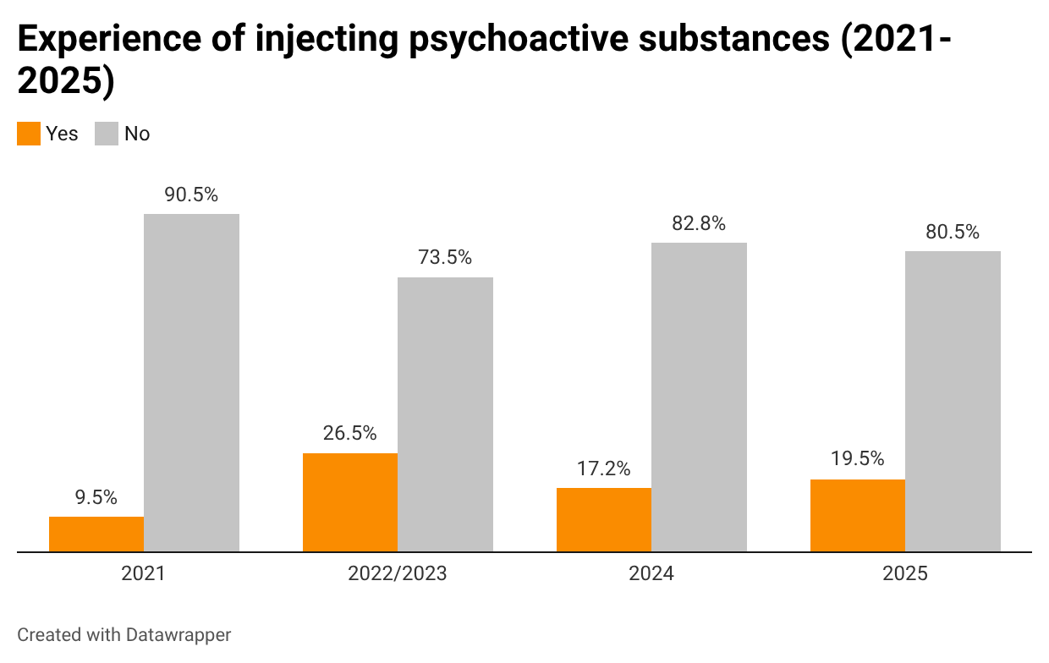

Overall, 8.6% of respondents reported having injected psychoactive substances during the previous 30 days, 5.5% during the previous six months but not during the last 30 days, 2.0% between six and 12 months ago, and 3.4% more than a year ago. According to their own reports, 75.5% had never used or tried psychoactive substances by injection. A further 5.0% did not answer the question.

Diagram 5. Frequency of injecting psychoactive substance use.
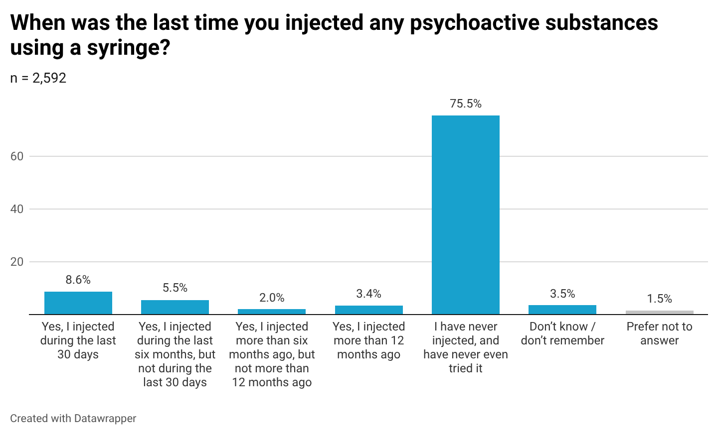
Experience of injecting psychoactive substances was somewhat more common among men than among women: 21.2% versus 16.7%. Men were also slightly more likely than women to report injecting psychoactive substances during the previous 30 days: 9.6% and 7.2%, respectively.

Diagram 6. Frequency of injecting psychoactive substance use by sex.
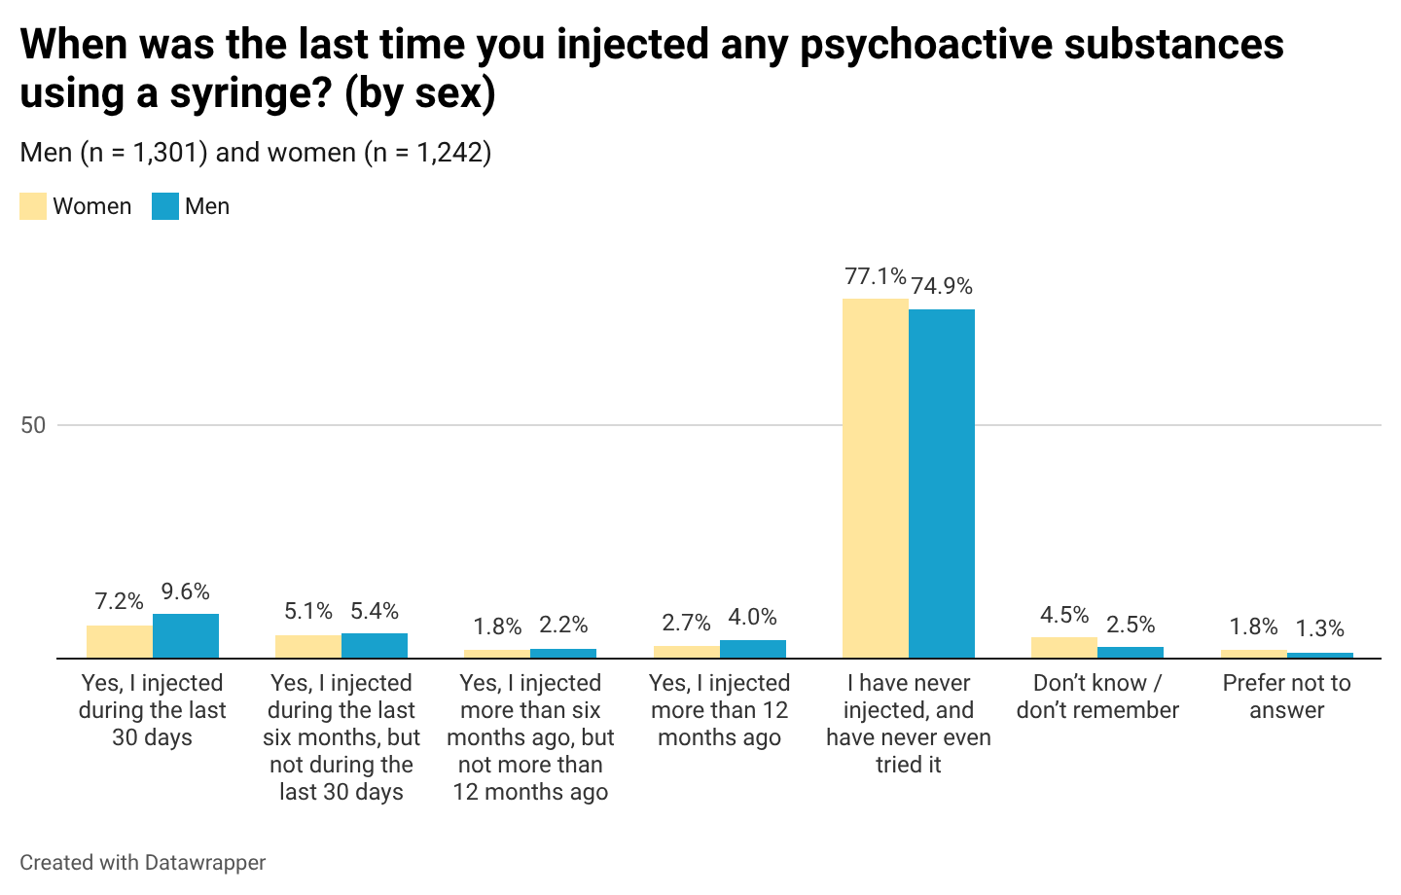

Experience of injecting psychoactive substances was most common among the younger age groups: 26.6% among those aged 14–18 years and 26.9% among those aged 19–20 years. Such experience was somewhat less common among study participants aged 34 years and older, 23.4% of whom had ever injected psychoactive substances. The lowest proportion of respondents with injecting experience was found among those aged 21–33 years: 17.6% among those aged 21–23 years, 14.5% among those aged 24–28 years, and 16.8% among those aged 29–33 years. Respondents aged 19–20 years and those aged 34 years and older were more likely to report having injected psychoactive substances during the previous 30 days. The association between age group and experience of injecting psychoactive substances was statistically significant.

Diagram 7. Frequency of injecting psychoactive substance use by age.
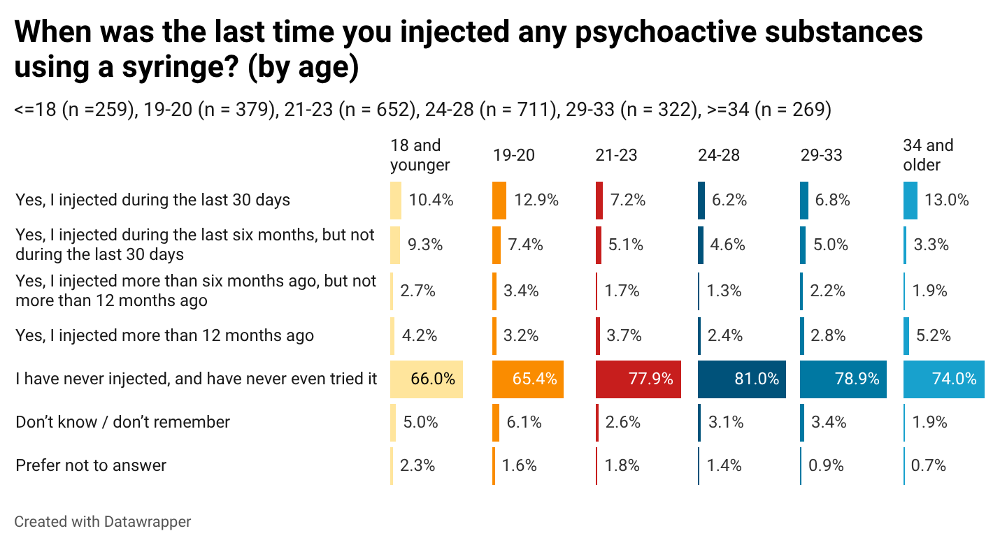

2.3. Substances used by injection
Among people who inject psychoactive substances, the largest proportion identified mephedrone as their main injected substance (14.0%). Other main psychoactive substances used by injection included powdered amphetamine (9.7%), ketamine (6.9%), heroin (5.9%), and alpha-PVP (5.9%).
Between 2% and 5% of people who inject psychoactive substances also identified nalbuphine (4.5%), “street methadone” (4.3%), “Lyrica” (4.3%), diphenhydramine (3.8%), cocaine (3.4%), morphine (3.0%), liquid opium extract (2.6%), codeine (2.6%), informally purchased methadone tablets (2.0%), and crystalline methamphetamine (2.0%) as their main injected substance.
Between 1% and 2% identified methadone tablets received through OST programmes, tramadol, informally purchased buprenorphine tablets, homemade methamphetamine, and barbiturates as their main injected substance. Other substances, such as fentanyl and desomorphine, were reported by fewer than 1% of respondents. A further 4.2% (21 respondents) selected the response option “other”, and 10.5% were unable to answer. There were relatively few substantive open-ended responses among those who selected “other”: some respondents mentioned ketamine, “Lyrica”, fentanyl, DMT, and 5-MeO-DMT.

Diagram 8. Main substances used by injection (15 most frequent responses).
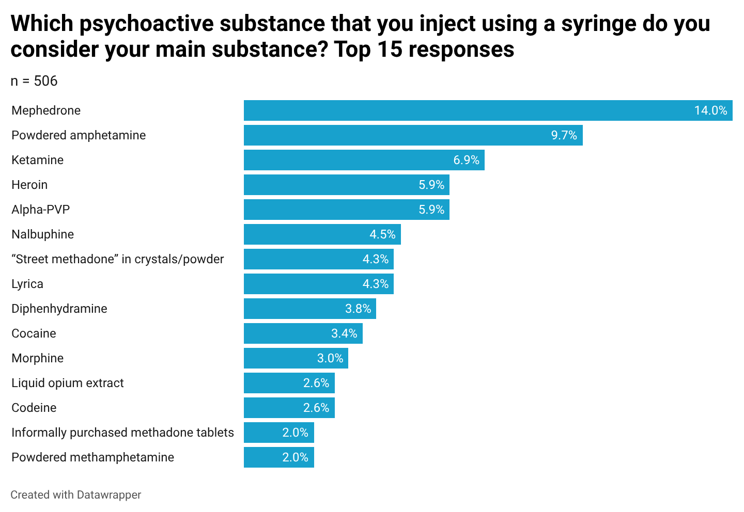

Women and men who inject psychoactive substances did not differ statistically significantly in their preferences for a main substance; by contrast, differences were observed across age groups. Among those aged 34 years and older, almost one quarter (22.2%) identified “street methadone” as their main substance, whereas in the other age groups, the popularity of this substance was substantially lower (<5%). “Lyrica” was most popular among the youngest users (11.6%).

Diagram 9. Main substances used by injection by age (15 most frequent responses).
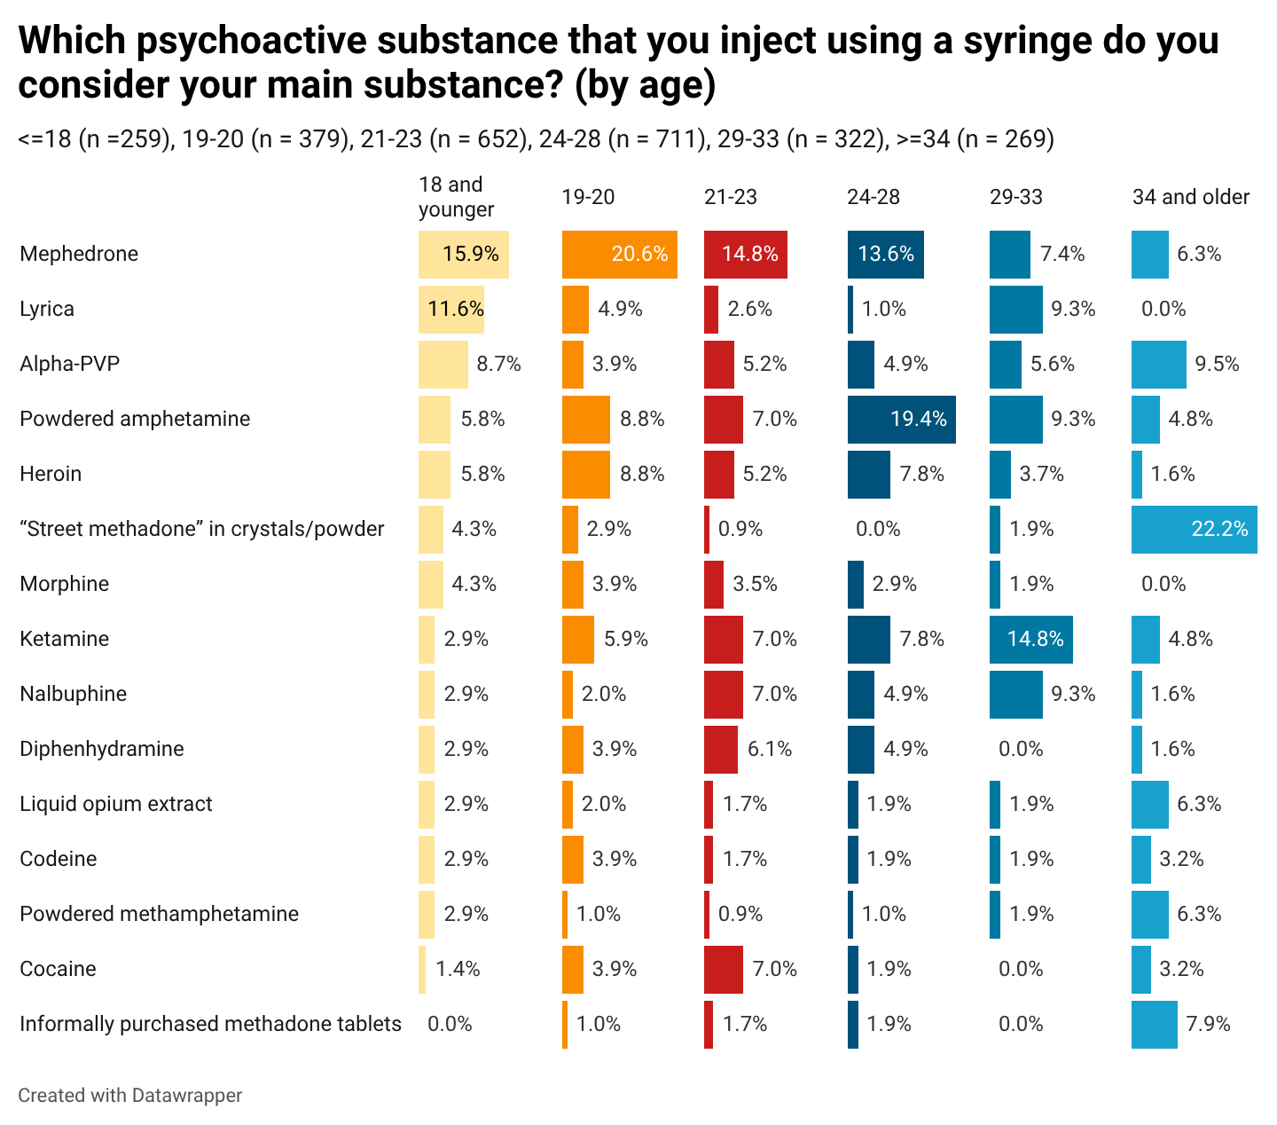

2.4. Substances used by non-injection routes
The substances that the largest proportion of study participants had ever used by a non-injection route were ecstasy (84.4%) and amphetamine (72.8%). At least half of respondents had at some point used LSD (60.6%), mushrooms/psilocybin (58.5%), “Lyrica” (55.0%), cocaine (53.7%), and mephedrone (50.6%). In addition, 42.7% of respondents reported experience of non-injection methamphetamine use, 38.2% ketamine use, 28.0% alpha-PVP use, 26.2% 2C-B use, 24.6% opiate/opioid use, 17.6% GHB/GBL use, and 21.4% use of other salts (synthetic cathinones), excluding those listed above.
During the previous 30 days, 31.9% of study participants had used amphetamine by a non-injection route, 29.1% ecstasy, 26.9% “Lyrica”, 20.3% mephedrone, 15.9% cocaine, 12.3% mushrooms/psilocybin, 11.6% methamphetamine, 10.8% LSD, 10.5% ketamine, 7.2% alpha-PVP, 6.9% opiates/opioids, 3.3% 2C-B, 2.7% GHB/GBL, and 5.1% other salts (synthetic cathinones).
Diagram 10. Frequency of use of different psychoactive substances.
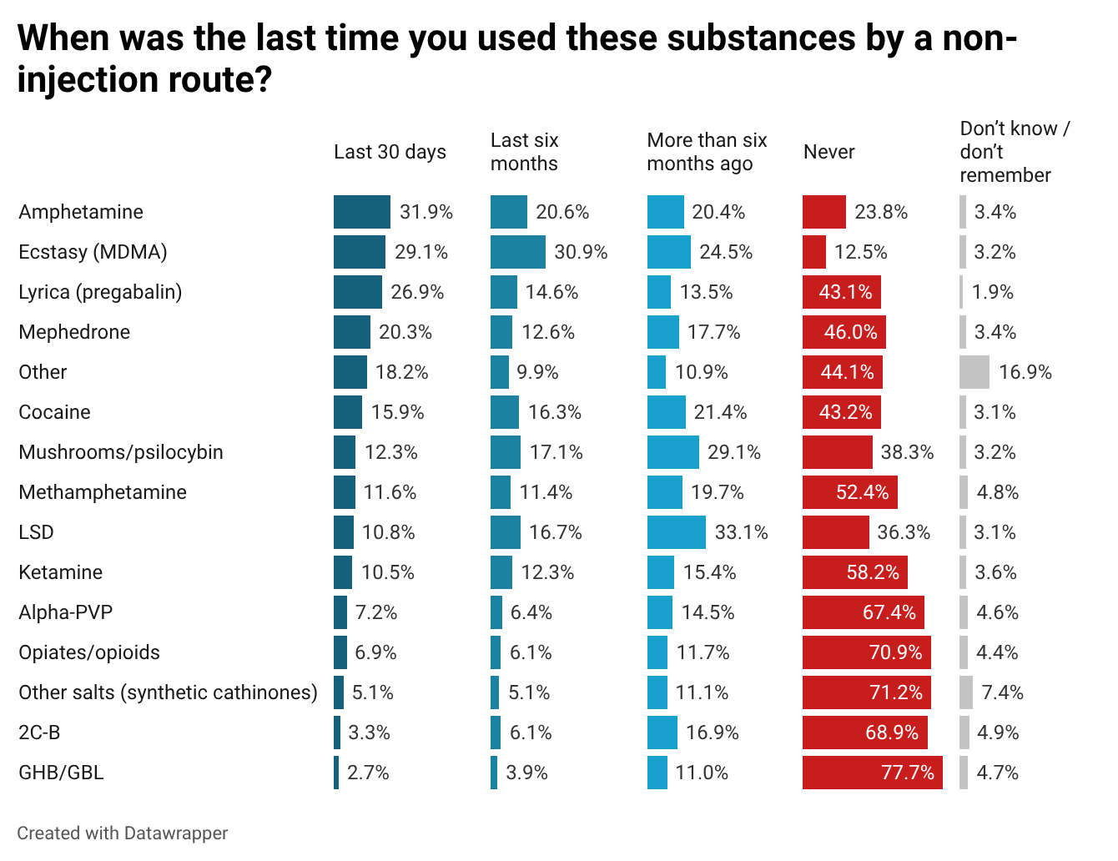
Compared with women, men more often reported experience of non-injection use of many psychoactive substances: in particular, a higher proportion of male respondents had ever used LSD, methamphetamine, GHB/GBL, mushrooms/psilocybin, 2C-B, opiates/opioids, and other salts. By contrast, a higher proportion of women had used “Lyrica” by a non-injection route, both overall and during the previous 30 days.

Diagram 11. Frequency of use of different psychoactive substances by sex.
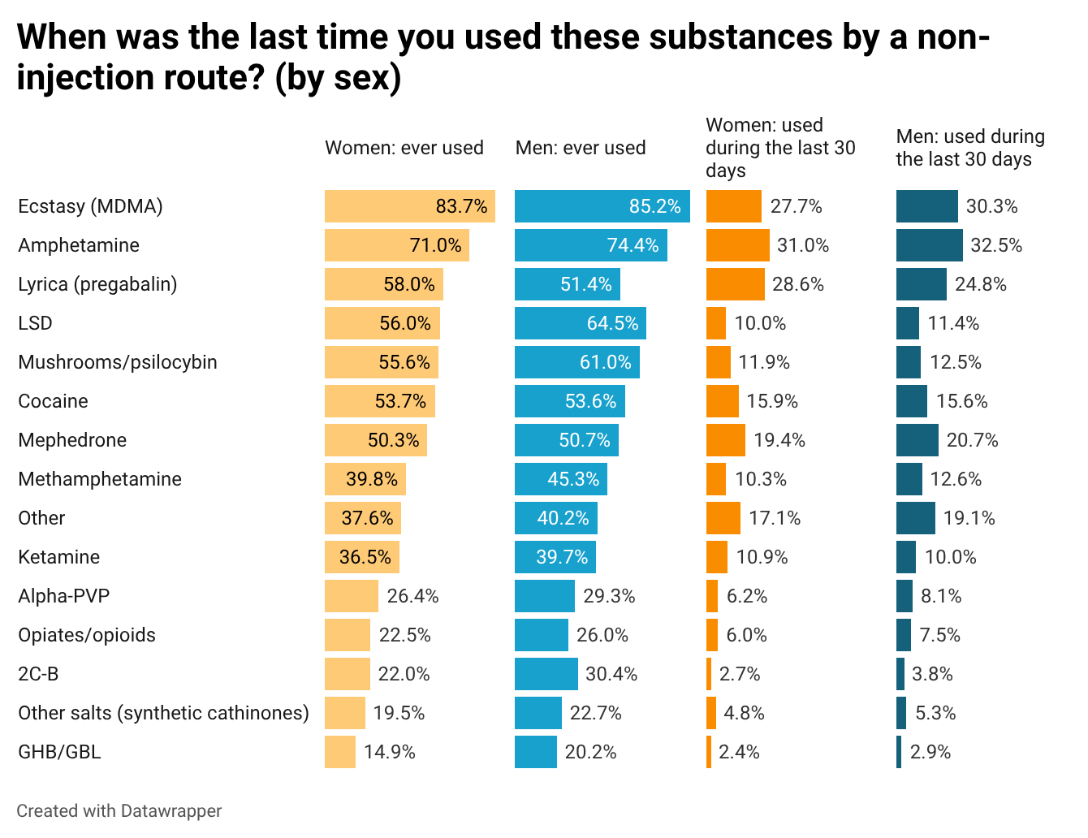

Regarding age-related patterns, younger age groups, those aged 18 years and younger and 19–20 years, less often reported experience of ecstasy, amphetamine, cocaine, and, to some extent, ketamine than older respondents. By contrast, older age groups more often reported experience of methamphetamine and GHB/GBL, while the 29–33 age group stood out for a higher proportion of respondents with experience of LSD use compared with the youngest group. At the same time, younger respondents more often reported experience of “Lyrica”, mephedrone, other salts, and substances reported in the open-text “other” category.

Diagram 12. Experience of different psychoactive substance use by age.
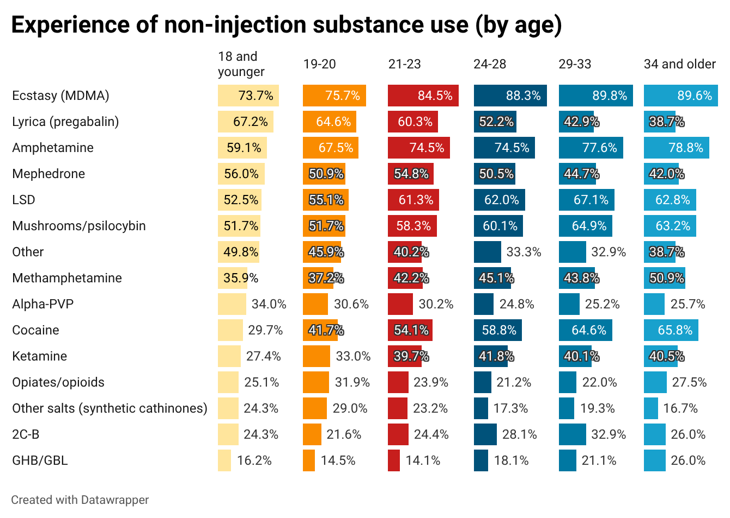

Recent use, defined as use during the previous 30 days, of LSD, mushrooms/psilocybin, and “Lyrica” was more often reported by younger respondents and generally declined in older age groups. For mephedrone and the “other substances” category, a higher proportion of recent use among younger respondents was also observed, although this pattern was not strictly linear. By contrast, older age groups somewhat more often reported recent cocaine use.

Diagram 13. Frequency of psychoactive substance use in the previous 30 days, by age.
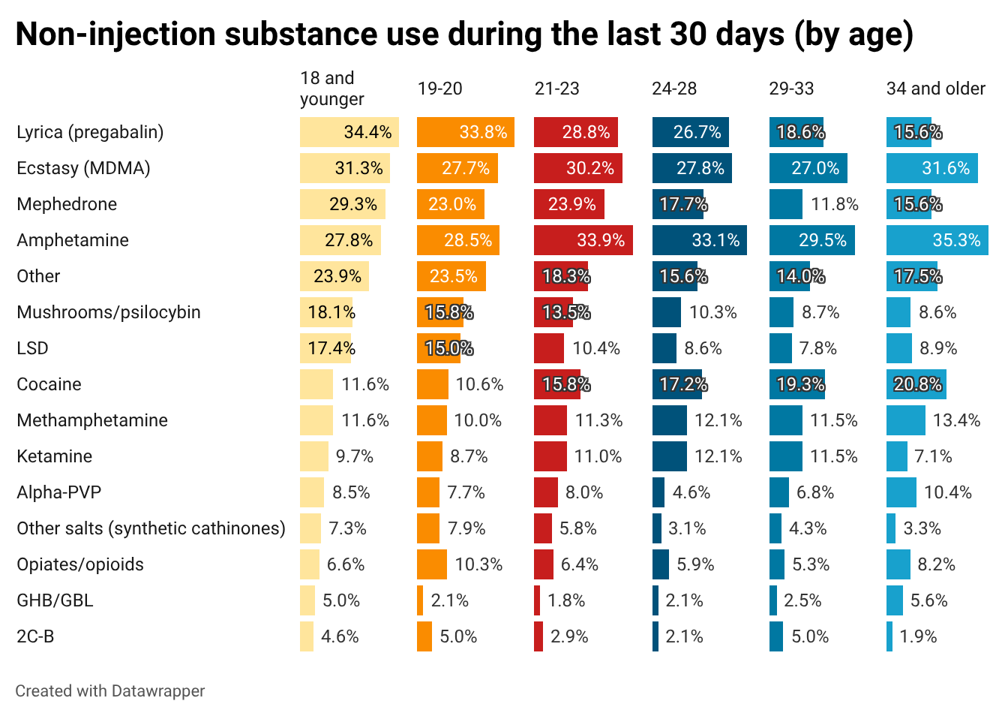

According to statistical testing of the lifetime experience of non-injection psychoactive substance use, the Cochran–Armitage test for linear trend across the four study waves, from 2021 to 2025, showed a statistically significant increase for cocaine, mephedrone, methamphetamine, ketamine, alpha-PVP, opiates/opioids, and other salts (synthetic cathinones), as well as a statistically significant decline for ecstasy (MDMA), amphetamine, LSD, and 2C-B. No statistically significant linear trend was identified for mushrooms/psilocybin or GHB/GBL.
A separate comparison of proportions between the 2025 and 2021 waves produced a similar pattern. However, for methamphetamine, the difference between these two time points was not statistically significant, although the overall linear trend across the four waves was significant.

Diagram 14. Lifetime experience of non-injection psychoactive substance use (2021–2025).
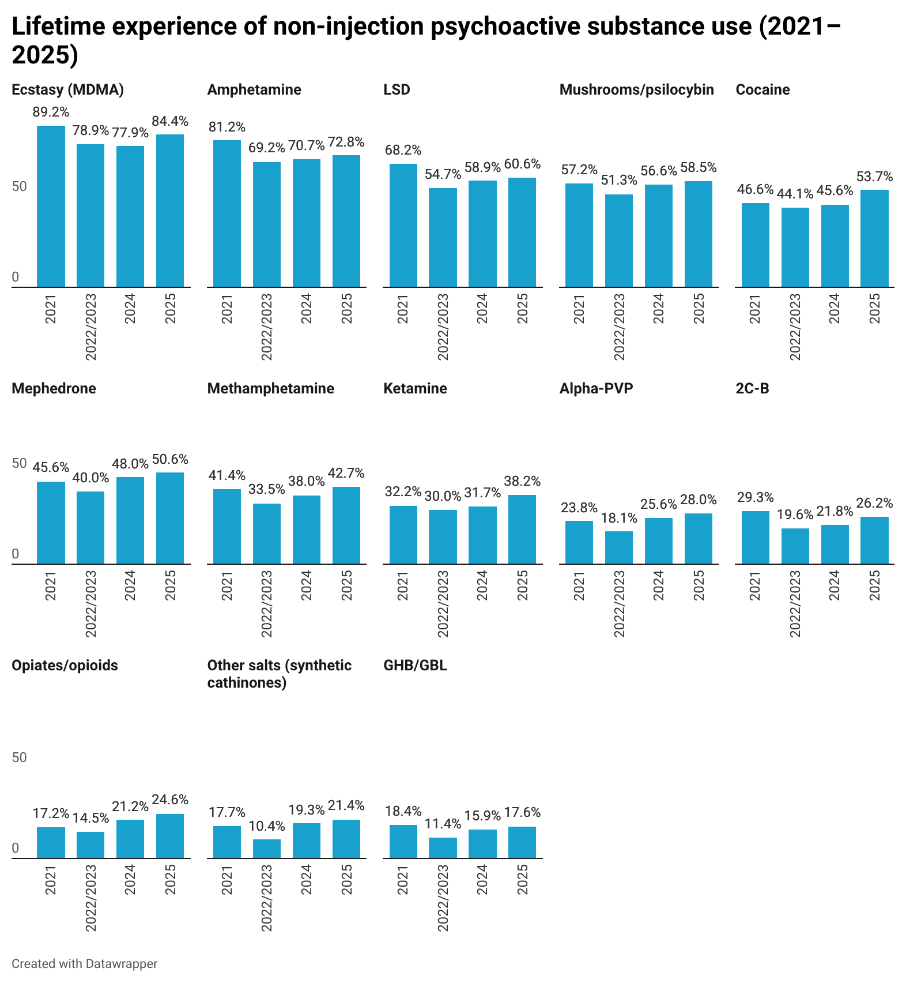

Table 2. Statistical testing of changes in lifetime experience of psychoactive substance use.
Substance | Linear trend test (four waves) | 2025 vs 2021 comparison
Ecstasy (MDMA) | Significant linear decrease | Significantly lower in 2025 than in 2021
Amphetamine | Significant linear decrease | Significantly lower in 2025 than in 2021
LSD | Significant linear decrease | Significantly lower in 2025 than in 2021
Mushrooms/psilocybin | No statistically significant linear trend identified | No statistically significant difference between 2025 and 2021
Cocaine | Significant linear increase | Significantly higher in 2025 than in 2021
Mephedrone | Significant linear increase | Significantly higher in 2025 than in 2021
Methamphetamine | Significant linear increase | No statistically significant difference between 2025 and 2021
Ketamine | Significant linear increase | Significantly higher in 2025 than in 2021
Alpha-PVP | Significant linear increase | Significantly higher in 2025 than in 2021
2C-B | Significant linear decrease | Significantly lower in 2025 than in 2021
Opiates/opioids | Significant linear increase | Significantly higher in 2025 than in 2021
Other salts (synthetic cathinones) | Significant linear increase | Significantly higher in 2025 than in 2021
GHB/GBL | No statistically significant linear trend identified | No statistically significant difference between 2025 and 2021

According to statistical testing of indicators of non-injection use of different psychoactive substances during the previous 30 days, the Cochran–Armitage test for linear trend across the four waves showed a statistically significant decline for ecstasy (MDMA), amphetamine, LSD, and mushrooms/psilocybin, and a statistically significant increase for cocaine, mephedrone, ketamine, alpha-PVP, and opiates/opioids. No statistically significant linear trend was identified for methamphetamine, 2C-B, other salts (synthetic cathinones), or GHB/GBL.

A separate comparison of proportions between the 2025 and 2021 waves showed a similar pattern for ecstasy, amphetamine, LSD, mushrooms/psilocybin, cocaine, mephedrone, and opiates/opioids. For ketamine and alpha-PVP, however, the overall linear trend was significant, while the difference between 2025 and 2021 was not statistically significant.

Diagram 15. Non-injection psychoactive substance use in the previous 30 days (2021–2025).
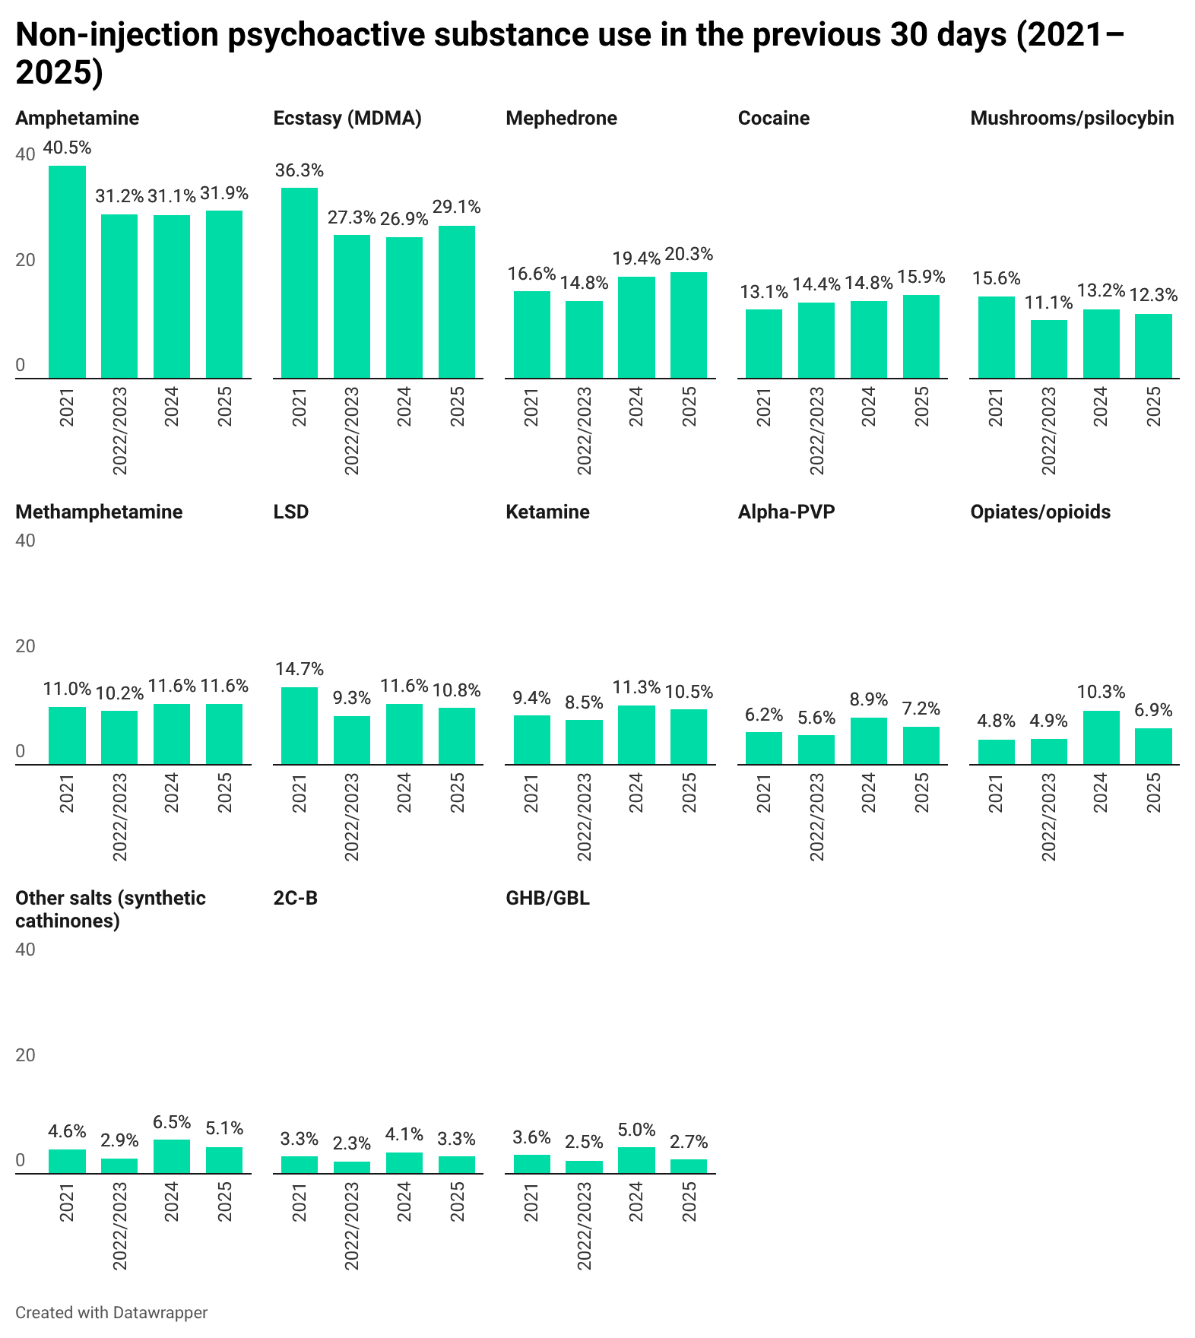

Table 3. Statistical testing of changes in psychoactive substance use during the previous 30 days, by substance.
Substance | Linear trend test (four waves) | 2025 vs 2021 comparison
Ecstasy (MDMA) | Significant linear decrease | Significantly lower in 2025 than in 2021
Amphetamine | Significant linear decrease | Significantly lower in 2025 than in 2021
LSD | Significant linear decrease | Significantly lower in 2025 than in 2021
Mushrooms/psilocybin | Significant linear decrease | Significantly lower in 2025 than in 2021
Cocaine | Significant linear increase | Significantly higher in 2025 than in 2021
Mephedrone | Significant linear increase | Significantly higher in 2025 than in 2021
Methamphetamine | No statistically significant linear trend identified | No statistically significant difference between 2025 and 2021
Ketamine | Significant linear increase | No statistically significant difference between 2025 and 2021
Alpha-PVP | Significant linear increase | No statistically significant difference between 2025 and 2021
2C-B | No statistically significant linear trend identified | No statistically significant difference between 2025 and 2021
Opiates/opioids | Significant linear increase | Significantly higher in 2025 than in 2021
Other salts (synthetic cathinones) | No statistically significant linear trend identified | No statistically significant difference between 2025 and 2021
GHB/GBL | No statistically significant linear trend identified | No statistically significant difference between 2025 and 2021

Taken together, the indicators of lifetime experience of use and use during the previous 30 days point to a gradual transformation in patterns of consumption within the sample of project clients. For cocaine, mephedrone, and opiates/opioids, increases were observed both in accumulated lifetime experience and in current use, defined as use during the previous 30 days, which may indicate a growing role for these substances in respondents’ current practices. For ketamine and alpha-PVP, an upward trend was also evident, although it was more clearly expressed in overall lifetime experience.

By contrast, for ecstasy/MDMA, amphetamine, and LSD, declines were observed both in lifetime experience and in recent use. For some substances, in particular methamphetamine, mushrooms/psilocybin, 2C-B, GHB/GBL, and other salts, the picture was less clear-cut: in these cases, the changes either did not form a stable unidirectional pattern or were more likely to reflect fluctuations in interest and experience than a clear increase or decrease.

2.5. Psychoactive substance use among friends and acquaintances
Almost all surveyed people who use psychoactive substances have friends and acquaintances who also use psychoactive substances, excluding cannabis, tobacco, and alcohol: 96.9% know at least one such person, whereas only 1.9% have no friends or acquaintances who use psychoactive substances, and 1.2% did not answer.
In most cases, the proportion of friends and acquaintances who use psychoactive substances does not exceed half of respondents’ wider social circle. For 33.1% of respondents, this refers to one or two people, while for 39.7%, a noticeable share of their friends and acquaintances use psychoactive substances, but fewer than half. A further 18.7% reported that the majority of their friends and acquaintances use psychoactive substances, and for 5.4%, this applies to all or almost all of them.

Diagram 16. Psychoactive substance use among friends and acquaintances.
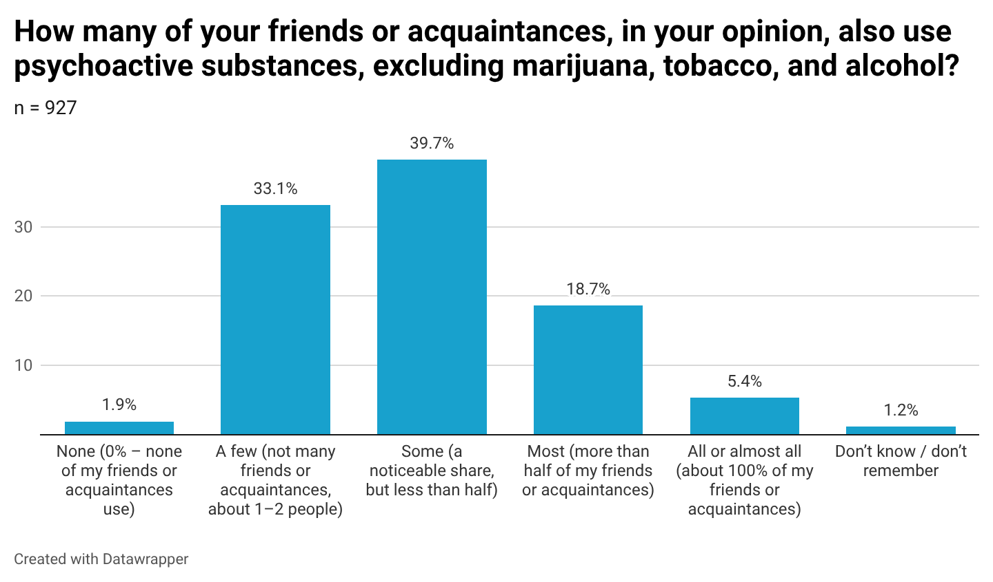

The proportion of people who use psychoactive substances within respondents’ social circles did not differ substantially between men and women. Some differences were observed across age groups, but not in the form of a linear trend: respondents aged 19–20 years were more likely than others to report that only a few of their friends or acquaintances use psychoactive substances (43.8%); those aged 21–23 years were more likely to report that the majority do so (24.0%); and those aged 24–28 years were more likely to report that fewer than half do so (50.4%).
Diagram 17. Psychoactive substance use among respondents’ friends and acquaintances, by age.
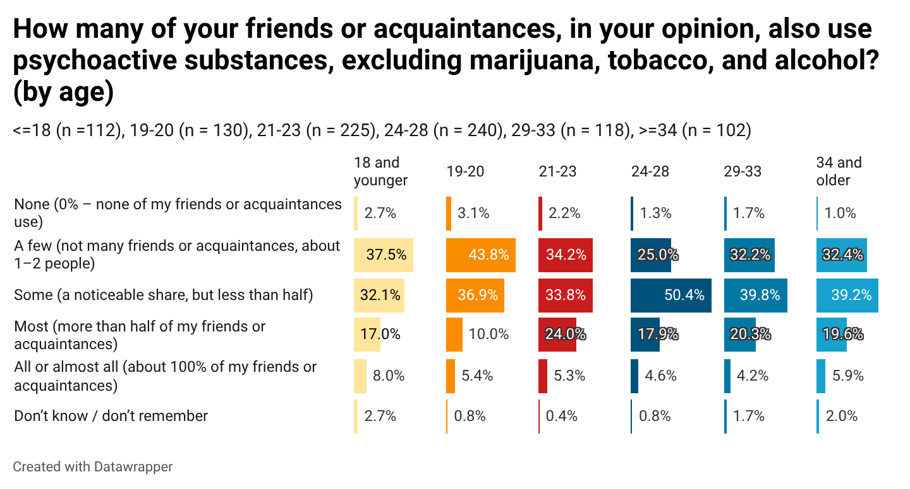

3. Drug checking: awareness of substance-checking tests and practices

3.1. Awareness of drug checking
Overall, 78.3% of respondents reported being aware of special tests for checking psychoactive substances, 18.8% were not aware of them, and 2.9% did not answer. Differences in awareness between women and men, as well as across age groups, were not statistically significant.
Diagram 18. Awareness of drug checking.
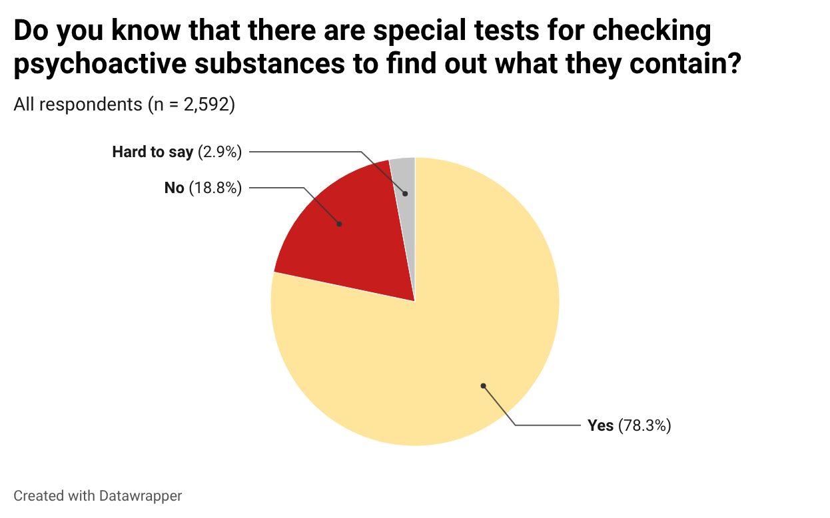

Among respondents who were aware of special tests for checking psychoactive substances, 42.5% had used them at least once.

Diagram 19. Experience of using tests to check psychoactive substances.
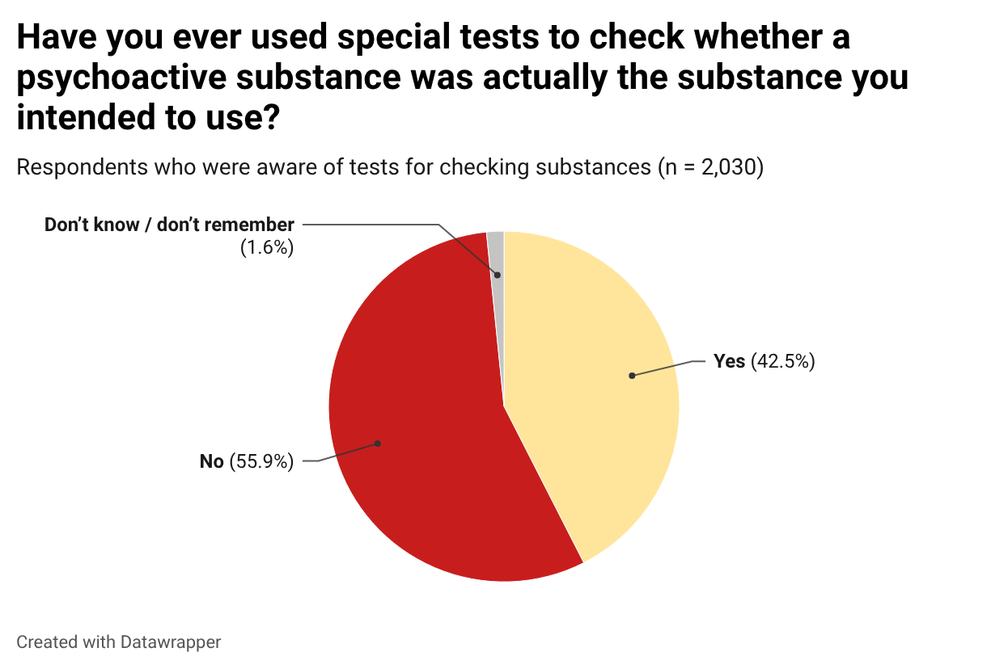

The proportions of men and women who had checked psychoactive substances using tests differed very little. By contrast, differences were observed across age groups: experience of checking psychoactive substances was less common among respondents aged 14–20 years and more common among older respondents. Among respondents aged 14–20 years who were aware of such tests, around one third had ever used them. In the older age groups, experience of checking psychoactive substances was more common, with the corresponding proportion ranging from 45% to 48%.

Diagram 20. Experience of using tests to check psychoactive substances, by age.
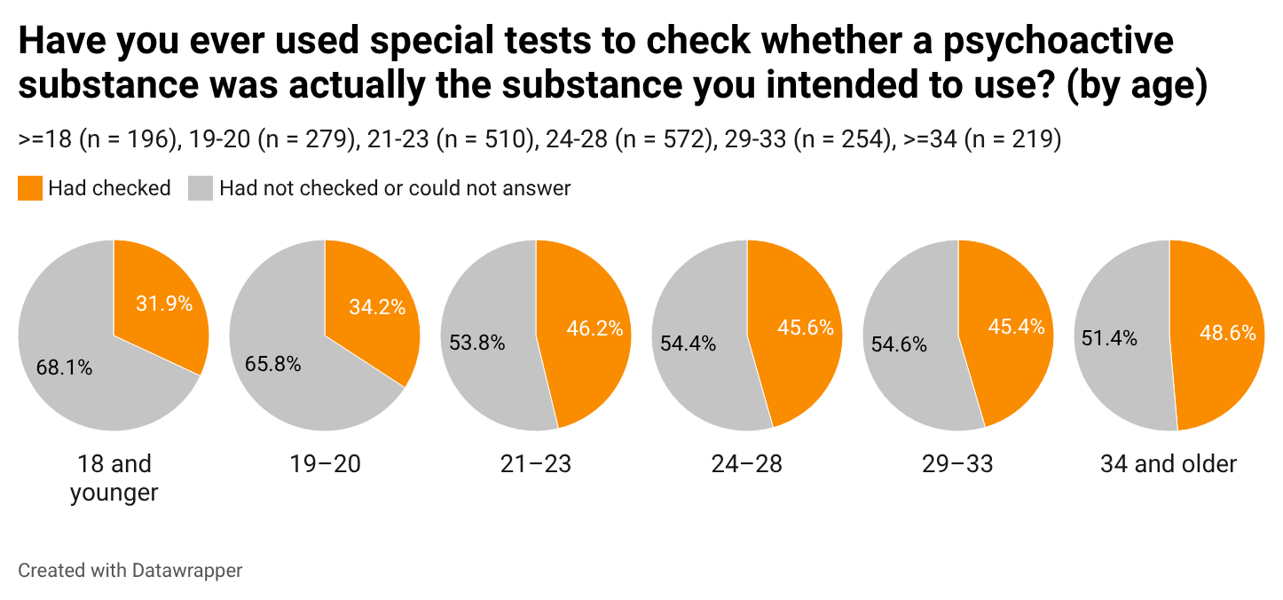
The substances most often checked by respondents during their most recent test were also among the most used substances: ecstasy (30.5%) and amphetamine (23.5%). Among other substances, 13.6% named mephedrone, 12.8% cocaine, 6.6% LSD, 3.6% ketamine, 3.1% methamphetamine, 1.6% alpha-PVP, 1.5% opiates/opioids, 0.7% 2C-B, 1.3% other salts, and 1.2% other substances.

Diagram 21. Psychoactive substances most recently checked by respondents.
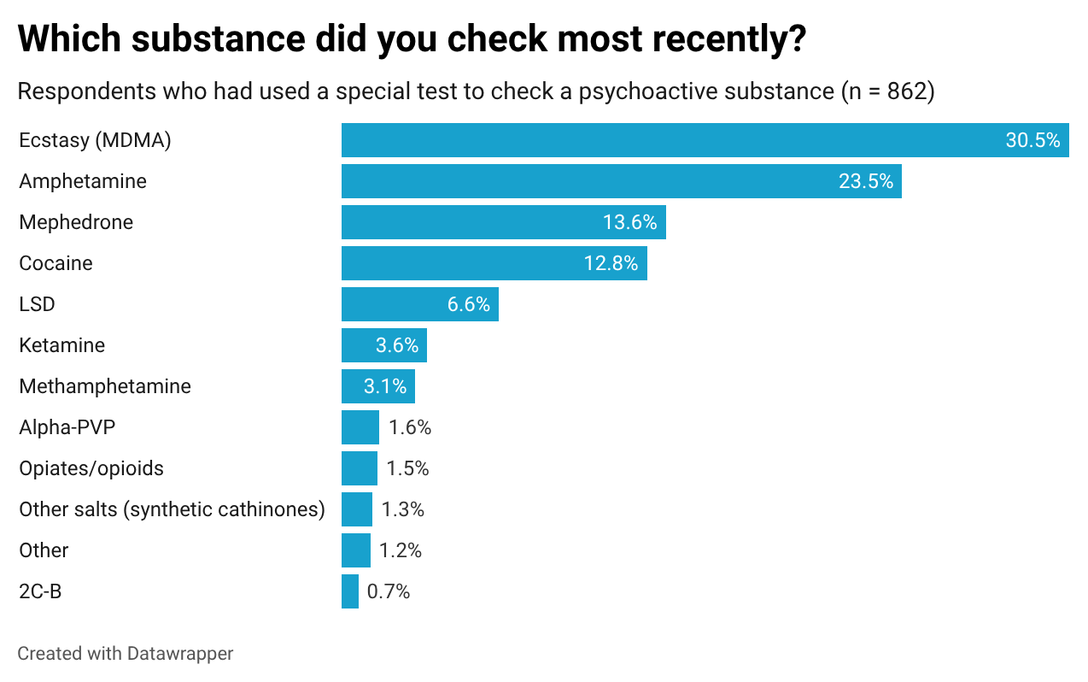
Among respondents who had checked psychoactive substances, in 75.2% of cases the result confirmed that the substance was the one they had purchased or received; in 7.7% of cases, it turned out to be a different substance, and a further 12.5% received an unclear result. A small proportion (1.4%) reported another outcome, most often indicating that the substance contained adulterants. A further 3.2% did not answer. Overall, 83.1% used the substance they had tested.

3.2. Reasons for not using PartyBox reagents for checking psychoactive substances
Respondents who had not used the psychoactive substance-checking reagents included in PartyBox (125 respondents in the analytical subsample) most often explained this by saying that they were confident in the quality of the substance (32.0%). A further 22.4% did not understand the instructions, and 12.0% did not want to spend time on checking.
The remaining respondents either did not remember (16.0%) or cited other reasons (17.6%), such as the absence of reagents in the kit for the substance concerned or not having had an opportunity to check it. No statistically significant differences by sex or age were observed, except that a higher proportion of men than women stated that they had other reasons for not using the reagents (29.3% and 7.5%, respectively).

Diagram 22. Reasons for not using PartyBox reagents for checking psychoactive substances.
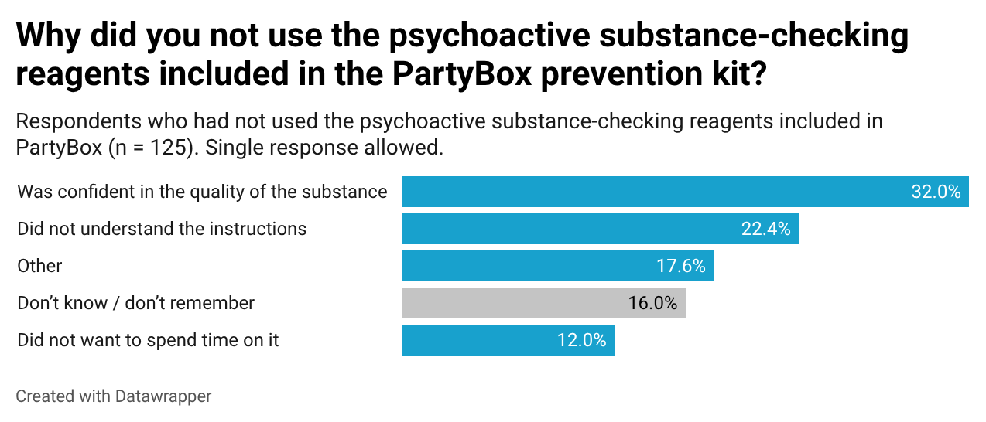

3.3. Reasons why respondents did not test psychoactive substances
Among respondents who answered the open-ended question on why they had never checked psychoactive substances, access barriers predominated: not having tests or reagents readily available, not knowing where to obtain them, and references to high cost or difficulty obtaining them. The second major group of responses related to trust in the source of the substance, such as friends, “trusted sellers/suppliers”, or “I know what I am using”.
A further noticeable set of responses reflected low perceived need, such as “didn’t care”, “why would I”, or “didn’t see the point”, as well as lack of knowledge or information, including not knowing that such tests existed or how to use them. A smaller proportion explained this by laziness, postponement, or lack of time. Less frequently, respondents referred to using psychoactive substances rarely or not using them at all, while isolated responses mentioned fear or risk, including references to the police or stigma.

Table 4. Reasons why respondents had never used a test to check psychoactive substances (open-ended responses).
Category | Number | Share | Examples of responses
Access barriers (no tests/reagents available, nowhere to obtain them, expensive or difficult to get, not available at the time) | 520 | 48% | “There was no opportunity”; “I didn’t have a test”; “I didn’t know where to get one”; “Tests are hard to access and expensive”; “There were no reagents”
Trust in the source / “trusted people” / confidence in the substance | 190 | 17% | “I buy from trusted sources”; “I trusted the supplier”; “I knew what I was using”; “I was confident in the quality”
Low perceived need / indifference / “didn’t see the point” | 150 | 14% | “Why would I?”; “I didn’t care”; “I didn’t see the point”; “I didn’t think it was necessary”
Lack of knowledge or information (did not know about tests or how to use them) | 110 | 10% | “Because I didn’t know such things existed”; “I didn’t know how”; “Lack of education”; “I didn’t understand the instructions”
Laziness / postponement / lack of time | 85 | 8% | “Laziness”; “I forgot”; “There was no time”; “I hadn’t thought about it”
Rare or no use / no substances available | 30 | 3% | “Because I don’t use”; “I use something very rarely”; “I didn’t have any substances”
Other / isolated motives (fear, stigma, risks) | 7 | 1% | “I was afraid”; “Because of the risk of police…”; “It looks strange to people around me”

4. Concurrent use of alcohol and psychoactive substances. Problematic alcohol use

4.1. Concurrent use of alcohol and psychoactive substances
The overwhelming majority of respondents (79.2%) reported concurrent use of alcohol and other psychoactive substances during the previous six months: almost one third did so regularly (29.4%), while half did so sometimes or rarely (49.8%). Only 17.8% reported that they never combined alcohol with other substances. Thus, combined use was a typical practice in the study sample, with important implications in terms of risks of intoxication, loss of control, and other adverse effects.

Table 5. During the previous six months, did you ever use alcohol and other psychoactive substances at the same time, or during the same session or party?
(n=2 592)
Response option | n | %
Yes, regularly (almost every time I use psychoactive substances) | 762 | 29.4%
Yes, sometimes / rarely | 1,290 | 49.8%
No, never | 461 | 17.8%
Hard to say | 79 | 3.0%

The association between sex and the practice of combining alcohol with other psychoactive substances was statistically significant but very weak. The only statistically significant difference concerned the response “No, never”: men were more likely than women to state that they did not combine alcohol with other substances (19.9% versus 15.6%). Combined use of alcohol and psychoactive substances was common among both men and women, and the influence of sex on this behaviour was minimal.
The association between the practice of combining alcohol with other psychoactive substances and respondents’ age was very weak. Although the overall association in the contingency table did not reach statistical significance at the 0.05 level, additional tests indicated a very weak ordered trend: in the older age groups, the proportion of “No, never” responses increased slightly. Accordingly, younger respondents may be somewhat more likely to combine alcohol with psychoactive substance use.

4.2. Psychoactive substances used concurrently with alcohol
The substances most commonly used concurrently with alcohol were stimulants and empathogens: amphetamine (39.1%) and ecstasy/MDMA (38.8%). Pregabalin ranked third (33.9%), which is an important signal given the potential risks of central nervous system depression when combined with alcohol.

Around one quarter of respondents combined alcohol with cocaine (26.6%) and mephedrone (24.4%). Psychedelics, including LSD, psilocybin, and 2C-B, were combined much less frequently (3%–10%). The least common combinations were alcohol with GHB/GBL (1.4%) and with other salts (2.0%).

Table 6. Which substances did you most often combine with alcohol during the previous six months?
(n = 2,052; respondents who combined alcohol and psychoactive substances; multiple responses allowed)
Substance | n | %
Amphetamine | 803 | 39.1%
Ecstasy (MDMA) | 797 | 38.8%
Lyrica (pregabalin) | 695 | 33.9%
Cocaine | 546 | 26.6%
Mephedrone | 500 | 24.4%
Methamphetamine | 245 | 11.9%
LSD | 202 | 9.8%
Ketamine | 183 | 8.9%
Mushrooms / Psilocybin | 171 | 8.3%
Alpha-PVP | 138 | 6.7%
Opiates / opioids | 95 | 4.6%
2C-B | 61 | 3.0%
Other salts (synthetic cathinones) | 42 | 2.0%
GHB, GBL | 29 | 1.4%
Other | 213 | 10.4%

4.3. Frequency of episodes of heavy alcohol consumption
The overwhelming majority of respondents (83.4%) reported consuming five or more standard drinks on a single occasion at least sometimes during the previous year. A standard drink was defined as 330 ml of beer (approximately 5% alcohol), 150 ml of wine (approximately 12% alcohol), or 40 ml of spirits, such as vodka or whisky (approximately 40% alcohol). This practice most commonly occurred once a month or less often (32.7%) or 2–4 times per month (26.5%).
At the same time, almost one quarter of the sample (24.2%) reported regular heavy drinking, ranging from 2–3 times per week to four or more times per week. Only 11.2% stated that they had never had such experience.
Table 7. During the previous year, how often did you drink five or more standard drinks of alcohol on a single occasion?
(n=2 592)
Response option | n | %
Never | 291 | 11.2%
Once a month or less | 847 | 32.7%
2–4 times a month | 687 | 26.5%
2–3 times a week | 371 | 14.3%
4 or more times a week | 257 | 9.9%
Difficult to answer | 139 | 5.4%

4.4. International criteria for intensive / excessive alcohol use
The question measuring the frequency of consumption of five or more standard drinks of alcohol, containing approximately 70 grams of ethanol, with 14 grams per standard drink, is close to the indicator of heavy episodic or binge drinking used, for example, by the National Institute on Alcohol Abuse and Alcoholism (NIAAA). However, our study did not specify the duration of the drinking episode (two hours) and did not differentiate between men and women, whereas the NIAAA definition refers to consumption within two hours and uses a threshold of five drinks for men and four for women. A similar indicator is also used in the Alcohol Use Disorders Identification Test (AUDIT), which measures hazardous or harmful alcohol use.
As shown, in our sample, 84.4% of respondents engaged in heavy episodic drinking over the course of the year; over the course of a month, almost every second respondent did so (50.7%); and over the course of a week, 24.2% did so.
The Substance Abuse and Mental Health Services Administration (SAMHSA) defines heavy drinking as binge drinking on at least five days during the previous month. According to this criterion, almost one in four respondents in our study (24.2%) fell into the category of heavy drinking.
The CDC (U.S. Centers for Disease Control and Prevention) defines heavy drinking using sex-specific thresholds: eight or more standard drinks per week for women and 15 or more for men. Accordingly, in our sample, the proportion of respondents falling into this category is at least 9.9%, corresponding to the category “four or more times a week”, and at most 24.2%, if the category “2–3 times a week” is also included.
The WHO considers heavy episodic drinking (HED), defined as consumption of at least 60 grams of pure alcohol on at least one occasion during the previous 30 days, to be the best indicator of alcohol consumption associated with adverse health consequences. Accordingly, respondents in our study who reported drinking five standard drinks of alcohol, approximately 70 grams of pure alcohol, 2–4 times a month, 2–3 times a week, or four or more times a week meet this WHO definition. This applies to every second respondent in our sample (50.7%).

4.5. Prevalence of intensive / excessive alcohol use according to international criteria in different populations and its association with psychoactive substance use

According to WHO data, 23% of the total population in the European Region meet the criterion for heavy episodic drinking (HED):

“About 23% of the adult population in the Region, more than 175 million people, reported engaging in heavy episodic drinking (HED) — a pattern of consumption associated with acute consequences such as injuries and poisoning. Prevalence was higher among men (34.0%) than among women (12.8%). When considering only those who consume alcohol, this figure rose to more than one in three drinkers (36.9%). However, because the prevalence of HED is based on respondents’ self-report in surveys, these figures are likely to be substantially underestimated.”

Similar data on the prevalence of this drinking pattern, defined as consumption of ≥5 standard drinks for men or ≥4 standard drinks for women on at least one occasion during the previous 30 days, a definition comparable to that used by the WHO, were obtained for the U.S. population: 24.4% (95% CI: 24.0–24.8).

The European School Survey Project on Alcohol and Other Drugs (ESPAD) uses episodes of drinking five or more alcoholic drinks on one occasion during the previous 30 days as a key indicator of heavy alcohol use — a definition analogous to those used by the WHO and NIAAA. According to 2024 data, the average across participating countries was 31%. As noted above, almost every second respondent in our sample (50.7%) met this criterion. Since the ESPAD sample is limited to adolescents aged 15–16 years, and our study included only 18 respondents of that age, direct comparison of the findings is not possible.

Table 8. Composite indicators of alcohol use.
Indicator | Organisation | Reference period | Value in this study
Heavy episodic or binge drinking | National Institute on Alcohol Abuse and Alcoholism (NIAAA) | Year | 84.4%
Heavy episodic or binge drinking | National Institute on Alcohol Abuse and Alcoholism (NIAAA) | Month | 50.7%
Heavy drinking | Substance Abuse and Mental Health Services Administration (SAMHSA) | Month | 24.2%
Heavy episodic drinking (HED) | WHO | Month | 50.7%
Heavy alcohol use | European School Survey Project on Alcohol and Other Drugs (ESPAD) | Month | 50.7%
Heavy drinking | CDC (U.S. Centers for Disease Control and Prevention) | Week | 9.9%–24.2%

According to the study “Binge Drinking, Other Substance Use, and Concurrent Use in the U.S., 2016–2018”, in the general population of the United States, heavy episodic alcohol use (“binge drinking”) was associated with 4.2 times higher odds of using other psychoactive substances compared with those who did not consume alcohol. The prevalence of psychoactive substance use increased with the frequency of heavy episodic drinking. The study found that more than half (15.7 million) of the approximately 29.9 million people aged 12 years and older who had used other psychoactive substances during the previous month had also engaged in heavy episodic drinking.

This is broadly consistent with the results obtained in our sample: using the WHO and NIAAA definitions, 50.7% of people who use psychoactive substances in our sample had engaged in heavy episodic alcohol use (“binge drinking”).
In our sample, sex did not substantially differentiate the prevalence of heavy episodic alcohol use, according to the WHO/NIAAA/ESPAD definition, or heavy drinking, according to the SAMHSA definition. The WHO indicator was 52.6% among women and 48.9% among men, and the difference was not statistically significant. The heavy drinking indicator, according to the SAMHSA definition, was 23.3% among women and 25.1% among men, and this difference was also not statistically significant.
Unlike sex, age was associated with heavy episodic and heavy alcohol use. Both indicators showed a systematic decline in the older age groups.
Heavy episodic alcohol use according to the WHO/NIAAA/ESPAD criterion differed substantially across age groups: the highest proportions were recorded among younger respondents (18 years and younger: 54.4%; 19–20 years: 58.0%; 21–23 years: 53.1%; 24–28 years: 51.5%), whereas in the older groups the indicator was noticeably lower (29–33 years: 42.2%; 34 years and older: 39.4%). Comparisons of proportions confirmed that the 29–33 and 34+ groups had statistically significantly lower proportions than the younger groups, particularly those aged 19–20 and 21–23 years, indicating a marked age-related decline.

A similar, although weaker, age gradient was also evident for the indicator of heavy drinking according to the SAMHSA definition: the highest proportion was found among respondents aged 19–20 years (30.1%) and among the youngest respondents (18 years and younger: 27.0%); the figure then declined (21–23 years: 24.2%; 24–28 years: 24.1%) and was lowest in the older groups (29–33 years: 19.6%; 34+ years: 19.3%). Tests of proportions also indicated that the older groups (29+) had statistically significantly lower values than the younger groups.

5. Experience of spiking and its consequences

Almost one in five respondents reported lifetime experience of spiking — the addition of a psychoactive substance to a person’s drink or food without their knowledge or consent. Specifically, 4.1% stated that this had happened during the previous six months, while a further 14.1% reported that it had happened more than six months ago. At the same time, 71.7% of respondents reported that they had never experienced such a situation.

Table 9. Have you ever experienced a situation in which a psychoactive substance was added to your drink or food without your knowledge or consent (so-called “spiking”)?
(n=2 592)
Response option | n | %
Yes, during the previous six months | 106 | 4.1%
Yes, more than six months ago | 366 | 14.1%
No, never | 1,859 | 71.7%
Hard to say | 261 | 10.1%
Experience of spiking was reported noticeably more often by women than by men, although it was not an exclusively female issue: men also reported being affected by this practice. If the two positive response categories, “during the previous six months” and “more than six months ago”, are combined, 21.3% of women versus 15.3% of men reported lifetime experience of spiking. The difference was driven primarily by the response “more than six months ago”: 17.0% among women versus 11.5% among men. At the same time, men were significantly more likely to state that they had never experienced such situations (76.4% versus 67.0% among women).
There was a statistically significant association between age and experience of spiking: younger respondents more often reported experience of having psychoactive substances added without their consent, particularly during the previous six months. The highest level of recent spiking experience, defined as experience during the previous six months, was recorded among the youngest respondents. In the group aged 18 years and younger, 7.3% reported such incidents; in the 19–20 age group, 5.8%; and in the 21–23 age group, 5.4%. After age 24, this figure declined markedly and did not exceed 2.7%.
A similar pattern was observed for cumulative experience of spiking, that is, lifetime experience. Among the youngest respondents, the proportion of those who had experienced spiking at least once was 24.3% in the group aged 18 years and younger and 21.9% in the 19–20 age group. At ages 21–23, this figure fell to 18.7%, and in the 29–33 age group, to 12.8%.
At the same time, the proportion of those stating that they had never experienced such situations increased consistently with age: from 64.9% among the youngest respondents to 78.4% in the group aged 34 years and older.

The most common consequence of spiking was memory impairment: almost half of those affected (48.1%) stated that they could not remember what had happened. More than one third of respondents (35.2%) reported severe intoxication or overdose, and almost one in four (24.6%) reported unwanted sexual contact, including sexual violence or exploitation, which is a particularly alarming finding. Less common, but still important, consequences included loss of consciousness (17.8%) and robbery or other unlawful acts (11.2%).

Table 10. What consequences did this spiking incident, or these spiking incidents, lead to?
(n=472)
Response option | n | %
Memory impairment (I do not remember what happened) | 227 | 48.1%
Severe intoxication / overdose | 166 | 35.2%
Unwanted sexual contact (sexual violence or exploitation) | 116 | 24.6%
Loss of consciousness | 84 | 17.8%
Robbery / other unlawful acts | 53 | 11.2%
Other (please specify) | 100 | 21.2%
Don’t know / don’t remember | 26 | 5.5%

Women were statistically significantly more likely than men to report memory loss because of spiking: 53.4% among women versus 41.4% among men. The most pronounced sex difference in the consequences of spiking concerned unwanted sexual contact, including sexual violence or exploitation: women were almost one and a half times more likely than men to report this consequence (29.2% among women versus 17.7% among men). Men were more likely to select the response option “Other” when answering the question about the consequences of spiking.
Among the 96 respondents who provided clarification on the other consequences of spiking they had experienced, approximately one third reported no serious consequences or said that they had managed to avoid harm in time. At the same time, more than 60% described negative physical, psychological, emotional, or cognitive effects, including loss of control, derealisation, panic reactions, cardiovascular symptoms, and hospitalisation.

Attention should be paid to cases of sexual violence or attempted sexual coercion, reported by more than 8%, as well as other criminal consequences, such as robbery or physical assault. The presence of even isolated reports of PTSD and prolonged mental health problems suggests that the consequences may be long-lasting. At the same time, a small proportion of responses contained ambivalent or positive interpretations of the experience.

Table 11. Consequences of incidents of spiking.
(open-ended responses)
Category | Number | Share | Examples of responses
No serious consequences / harm avoided | 30 | 31.3% | “There were none”; “None”; “No consequences”; “Everything was fine”; “No consequences at all, I pulled myself together and went home”; “Nothing, I left quickly”; “I was told about it and my drink was replaced”
Impaired consciousness / loss of control | 22 | 22.9% | “Loss of control”; “Uncontrolled behaviour”; “Uncontrolled actions and emotions”; “Disorientation”; “Derealisation”; “The walls were moving”; “I did not understand what was happening to my body”
Physical symptoms | 21 | 21.9% | “Vomiting”; “Severe dizziness and impaired coordination”; “They spiked me with alpha-PVP; I had very high blood pressure and palpitations, was shaking all night, and could not sleep”; “I lost my breath and felt dizzy”; “I ended up in a toxicology unit”
Psychological and emotional consequences | 18 | 18.8% | “Panic”; “PTSD, anxiety disorders, and initially psychosis/paranoia”; “Severe derealisation that lasted for several months and returned from time to time afterwards, panic, and deterioration in mental state”; “Temporary short-term low mood and increased anxiety”
Sexual violence / attempted coercion | 8 | 8.3% | “Detained against my will, physically assaulted, attempted rape”; “They tried to pressure me into sex. Strangers helped me”; “I could have become a victim of sexual violence, but managed to leave the place by myself”; “An attempt to drag me into bed, but I was conscious enough to resist”
Criminal consequences (robbery, assault, coercion) | 6 | 6.3% | “My phone was stolen”; “They wanted to rob me”; “It led to extreme aggression on my part, and the person responsible was seriously injured”; “I was persuaded to commit an unlawful act”
Positive / ambivalent interpretation | 5 | 5.2% | “Sometimes positive”; “An interesting experience, although I was not expecting it”; “I was more aroused and active”; “Sex I wanted”

6. Sexual life

6.1. Use of psychoactive substances during the most recent sexual encounter
More than one third of respondents (35.0%) reported that they had used psychoactive substances, excluding cannabis and alcohol, before or during their most recent sexual encounter; that is, they had practised sexualised drug use (SDU). The majority (61.0%) stated that they had not used such substances, while a further 4.0% were unable to answer.
Use of psychoactive substances before or during the most recent sexual encounter did not show statistically significant differences by sex. The proportion reporting such behaviour was almost identical among women (35.1%) and men (34.3%).
Use of psychoactive substances before or during the most recent sexual encounter was statistically associated with age, although the strength of the association was weak. The proportion reporting substance use during sex ranged between 32% and 36% in most age groups: 33.6% among those aged 18 years and younger, 35.4% among those aged 19–20 years, 32.1% among those aged 21–23 years, 35.6% among those aged 24–28 years, and 34.2% among those aged 29–33 years. At the same time, in the group aged 34 years and older, this figure was noticeably higher, at 42.8%.
The pattern of psychoactive substance use during sex was concentrated around stimulants and empathogens. The most common substances used in such situations were amphetamine (29.4%), MDMA (28.7%), and mephedrone (27.1%). A relatively high proportion of “Lyrica” (pregabalin) use also stood out (20.6%).
Cocaine and methamphetamine were each mentioned by around one in ten respondents who had used psychoactive substances during sex (11.1% and 10.9%, respectively). Psychedelics, dissociatives, and depressants, including LSD, ketamine, GHB/GBL, and psilocybin, were reported much less frequently (3%–6%).

Table 12. Which substances were used during your most recent sexual encounter, excluding alcohol and cannabis?
(n=908)
Substance | n | %
Amphetamine | 267 | 29.4%
Ecstasy (MDMA) | 261 | 28.7%
Mephedrone | 246 | 27.1%
Lyrica (pregabalin) | 187 | 20.6%
Cocaine | 101 | 11.1%
Methamphetamine | 99 | 10.9%
Alpha-PVP | 76 | 8.4%
LSD | 56 | 6.2%
Ketamine | 43 | 4.7%
Mushrooms/psilocybin | 35 | 3.9%
Opiates/opioids | 35 | 3.9%
GHB/GBL | 30 | 3.3%
Other salts (synthetic cathinones) | 18 | 2.0%
2C-B | 12 | 1.3%
Other | 33 | 3.6%

6.2. Psychoactive substance use during sexual contact, by partner type, in the previous six months
Among respondents who had had sexual contact with one man or several men during the previous six months, 47.5% reported that they had used psychoactive substances, excluding alcohol and cannabis, before or during sex specifically to alter the sexual experience; that is, they had practised sexualised drug use (SDU).
Among those who had had sexual contact with one woman or several women during the previous six months, 44.9% reported using psychoactive substances for the purpose of altering the sexual experience. Thus, the prevalence of this practice in this type of contact was somewhat lower than in the case of contact with men, but still approached half of the group.
Among respondents who had had sexual contact with two or more partners of different sexes at the same time during the previous six months, 56.0% reported using psychoactive substances for this purpose. The prevalence of SDU was highest in this type of sexual contact.

6.3. Sexual preferences and sexual practices

6.3.1. Sexual practices of women
Sex with a man was an almost universal experience among women. Overall, 78.2% had had such contact during the previous 30 days, a further 11.0% during the previous six months, but not during the previous 30 days, and 6.5% more than six months ago. Only 3.2% had never had such experience, while 1.1% were unable to answer. Thus, 95.7% of women had had sex with a man at some point in their lives.
Sexual experience with a woman was much less common, although still not rare. During the previous 30 days, 11.3% of women had had such contact, a further 10.7% during the previous six months, and 25.7% more than six months ago. Overall, 49.3% had never had such experience, while 3.1% were unable to answer. Thus, 47.7% of women had had sexual experience with a woman at some point in their lives.
Group practices among women occurred less frequently and were predominantly episodic in nature. Sex with two or more men at the same time had been experienced by 22.4% of women at some point in their lives, including 3.9% during the previous 30 days. Sex with two or more women at the same time had been experienced by 13.0%. Sex with partners of different sexes at the same time had been experienced by 26.9%.

Table 13. Sexual practices of women.
Type of contact | Last 30 days | Last six months | More than six months ago | Never | Don’t know | Ever in lifetime
With a man | 78.2% | 11.0% | 6.5% | 3.2% | 1.1% | 95.7%
With a woman | 11.3% | 10.7% | 25.7% | 49.3% | 3.1% | 47.7%
With ≥2 men at the same time | 3.9% | 6.0% | 12.6% | 75.0% | 2.7% | 22.4%
With ≥2 women at the same time | 2.2% | 3.8% | 7.0% | 85.1% | 1.9% | 13.0%
With ≥2 partners of different sexes at the same time | 4.3% | 7.7% | 14.8% | 71.2% | 1.9% | 26.9%

6.3.2. Sexual practices of men
Overall, 61.6% of men had had sex with a woman during the previous 30 days, a further 13.9% during the previous six months, but not during the previous 30 days, and 13.4% more than six months ago. Only 10.1% had never had such experience, while 1.0% were unable to answer. Thus, 88.9% of men had had sex with a woman at some point in their lives.

Sex with a man was considerably less common. Overall, 22.7% reported such contact during the previous 30 days, 6.8% during the previous six months, and 5.5% more than six months ago. At the same time, 63.3% had never had such experience, while 1.6% were unable to answer. Thus, 35.0% of men had had sexual experience with a man at some point in their lives.

Group practices were also notably prevalent. Sex with two or more men at the same time had been experienced by 17.5% of men at some point in their lives, including 5.5% during the previous 30 days. Sex with two or more women at the same time had been experienced by 30.0%, including 5.5% during the previous 30 days. Sex with partners of different sexes at the same time had been experienced by 19.3%, including 3.5% during the previous 30 days.

Table 14. Sexual practices of men.
Type of contact | Last 30 days | Last six months | More than six months ago | Never | Don’t know | Ever in lifetime
With a man | 22.7% | 6.8% | 5.5% | 63.3% | 1.6% | 35.0%
With a woman | 61.6% | 13.9% | 13.4% | 10.1% | 1.0% | 88.9%
With ≥2 men at the same time | 5.5% | 5.0% | 7.1% | 81.4% | 1.1% | 17.5%
With ≥2 women at the same time | 5.5% | 6.9% | 17.5% | 68.0% | 2.0% | 30.0%
With ≥2 partners of different sexes at the same time | 3.5% | 4.8% | 10.9% | 79.5% | 1.2% | 19.3%

6.4. Condom use during sex
At their most recent sexual encounter, 44.0% of respondents reported using a condom, while 52.3% reported not using one. In other words, more than half of the sample reported that no condom was used during their most recent sexual contact.
Among men, 50.0% reported that a condom had been used at their most recent sexual encounter, whereas among women this figure was 37.9%.
Age differences in condom use were driven primarily by a higher proportion of sex without a condom among respondents aged 29 years and older compared with the youngest respondents. The lowest proportion reporting non-use of a condom was observed among respondents aged 18 years and younger, at 43.6%. By contrast, in the older age groups this figure was statistically significantly higher: 56.5% among those aged 29–33 years and 58.0% among those aged 34 years and older. This may reflect a transition to stable partnerships or the use of alternative methods of contraception.
Non-use of condoms was explained predominantly by a sense of safety and emotional motivation, such as trust and intimacy, whereas structural barriers, such as lack of condoms or lack of money, and pharmacological risk compensators, such as PrEP, played a much smaller role.
Table 15. What were the reasons for not using a condom during the most recent sexual encounter?
(n = 1,452; multiple responses allowed)
Reason | %
My partner and I, or my partners and I, trusted one another and did not consider condom use necessary | 58.2%
Desire for intimacy and connection without barriers | 24.6%
I, or we, did not have condoms available | 21.7%
I, or we, was/were under the influence of substances or alcohol and forgot about it | 9.0%
I or my partner was concerned that condoms affect sensation | 8.1%
I did not want to spend additional money on condoms | 7.2%
Because of pressure from my partner or partners; I did not want to argue about it | 4.1%
I or my partner was concerned that condoms affect erection | 3.7%
I, or my partner or partners, was/were taking PrEP (pre-exposure prophylaxis to prevent HIV), so I felt safe | 3.2%
Don’t know / don’t remember | 3.2%
Other | 9.9%

Several statistically significant sex differences were identified among the reasons for not using a condom at the most recent sexual encounter. Men more often than women referred to concerns about the physiological effects of condoms, in particular their impact on erection and sensation. Men were also noticeably more likely to cite, as a reason, that they or their partners were taking PrEP and therefore felt safe.
By contrast, women more often reported situations related to interaction with a partner, in particular pressure from a partner or partners and unwillingness to argue. In addition, women more often selected the response option “Other”, which may indicate a broader range of situational or individualised reasons.

With regard to age differences, the clearest pattern concerned availability and situational factors: “I, or we, did not have condoms available” was reported more often by younger respondents (18 years and younger: 34.8%; 19–20 years: 27.8%), whereas the proportion citing this reason declined with age (29–33 years: 15.4%; 34 years and older: 11.9%).
Similarly, the reason “I, or we, was/were under the influence of substances or alcohol and forgot about it” was more common among younger respondents (19–20 years: 16.7%; 18 years and younger: 12.6%) and less common in the older groups (24–28 years: 6.3%; 29–33 years: 4.8%; 34 years and older: 5.0%).
The proportion citing the economic reason “I did not want to spend additional money on condoms” also declined with age (18 years and younger: 16.3%; 24–28 years: 5.3%; 29–33 years: 4.3%; 34 years and older: 4.4%).
By contrast, the proportion citing the reason “My partner and I, or my partners and I, trusted one another and did not consider condom use necessary” increased markedly with age. Significant age differences were also observed for the reason “Because of pressure from my partner or partners; I did not want to argue about it”: this was highest among those aged 19–20 years (8.1%) and 18 years and younger (5.9%), and lowest among those aged 34 years and older (1.3%).
Open-ended responses in the “Other” category regarding reasons for not using condoms show that this decision was most often based on a subjective sense of safety within stable relationships and trust, as well as on replacing the barrier method with other forms of contraception. At the same time, the risk of infection was often interpreted as being under control because of testing or monogamy. A small number of responses pointed to situations of coercion or loss of control, which require particular attention in prevention work.

Table 16. Reasons for not using a condom.
(responses to open-ended questions)
Category | Number | Share | Examples of responses
Long-term / monogamous relationship, marriage | 70 | 49% | “We are married”; “My regular partner”; “We trust each other completely”
Alternative contraception / medical reasons | 36 | 25% | “I take the combined oral contraceptive pill”; “I have an intrauterine device”; “Contraception in the form of vaginal suppositories (‘Erotex’)”
Previous testing / belief that the situation was safe | 18 | 13% | “We had tests done”; “We undergo testing regularly”
Oral sex / no penetration | 8 | 6% | “Oral sex”; “There was no penetration”
Female same-sex contact | 6 | 4% | “We are women, we do not need a condom”
Allergy | 4 | 3% | “Latex allergy”
Trying to conceive | 3 | 2% | “Trying to get pregnant”
Impulsivity / indifference | 5 | 3% | “We were reckless”
Signs of coercion / lack of control | 2 | 1% | “Without consent”

6.5. Transactional sex
Overall, 17.2% of respondents reported that during the previous 12 months they had engaged in sexual relationships primarily to obtain resources they needed, such as money, goods, psychoactive substances, or other resources. The majority (80.5%) reported no such experience, while a further 2.4% were unable to give a definite answer. Thus, among those who provided a definite response, approximately one in six had experienced transactional sexual relationships during the previous year.

Table 17. During the previous 12 months, were there any cases when you entered into a sexual relationship primarily to obtain something you needed, such as money, gifts, psychoactive substances, or other resources that were important to you?
(n=927)
Response option | n | %
Yes | 159 | 17.2%
No | 746 | 80.5%
Don’t know / don’t remember | 22 | 2.4%
Although women reported such experience substantially more often (21.7%), the phenomenon of transactional sex was also present among men: 10.6% reported having engaged in such contacts during the previous year. Experience of transactional sexual relationships during the previous year was significantly more common among younger respondents, and its prevalence gradually declined with age.
In the youngest groups, those aged 18 years and younger and 19–20 years, the proportion reporting such experience was 27.7%; in the 21–23 age group, it was 18.2%; this then declined to 14.2% among those aged 24–28 years, 9.3% among those aged 29–33 years, and only 5.9% among respondents aged 34 years and older. Comparisons of proportions confirmed that the youngest respondents, aged 20 years or younger, had a statistically significantly higher proportion of positive responses regarding transactional sex than the older age groups, starting from 24 years and older.
Among respondents who reported experience of sexual relationships entered into for the purpose of obtaining resources and who answered the follow-up question, the most common form of compensation was money, reported by 63.9%. Almost half (48.7%) received gifts or material goods, and 40.5% received psychoactive substances. Other response options were reported much less frequently (8.9%).

Table 18. What exactly did you receive in exchange for such sexual relationships during the previous 12 months?
(n = 158; multiple responses allowed)
Option | n | %
Money | 101 | 63.9%
Gifts or material goods | 77 | 48.7%
Psychoactive substances | 64 | 40.5%
Other | 14 | 8.9%
Don’t know / don’t remember | 6 | 3.8%

The only difference between women and men concerned receiving money in exchange for sex: among women, this form of compensation was statistically significantly more common (69.8% among women versus 51.1% among men). For other forms of exchange, such as gifts, psychoactive substances, or other resources, there were no statistically significant sex differences. Respondent age was not associated with the types of compensation received in transactional sex.

6.6. Group sex
Almost one in five respondents (19.4%) had experienced group sex during the previous six months.

Among respondents who had had sex with two or more partners during the previous six months, the most common pattern was repeated but not highly frequent participation: 2–3 times (39.4%). At the same time, almost one third (31.5%) belonged to the group practising group sex frequently, defined as four or more occasions, indicating a more stable behavioural pattern rather than a one-off situation.

A single experience, once during the previous six months, was reported by 29.1% of respondents. This means that approximately one third engaged in group sex episodically, whereas around two thirds practised it more than once.

Overall, 63.8% of respondents reported that during their most recent sexual encounter with two or more partners, they had used psychoactive substances, excluding alcohol and cannabis. Almost one third (30.2%) stated that they had not used psychoactive substances, while a further 6.0% did not remember.

Thus, group sex practices were more often associated with psychoactive substance use, including chemsex or other forms of sexualised substance use, than sexual encounters overall: in response to the question about their most recent sexual encounter of any kind, 35.0% reported practising sexualised drug use.

With regard to condom use during the most recent sexual encounter with two or more partners, only 33.6% stated that a condom had been used consistently, that is, for every act of penetration with all partners. A further 33.8% answered that a condom had been used, but not on every occasion, while 27.2% reported that it had not been used at all; 5.4% did not remember. Thus, only one third of respondents reported fully consistent condom use, while almost two thirds either used condoms inconsistently or did not use them at all.

For comparison, when asked about their most recent sexual encounter of any kind, 44.0% of respondents reported that they had used a condom. In other words, group sex practices appear to involve higher levels of risk.

Need for mental health services

Needs for services that could improve psychological and emotional wellbeing were common among respondents.

During the previous six months, 60.6% of respondents stated that they had felt a need for help from a psychologist or psychotherapist to improve their psychological and emotional state. The need for help from a psychiatrist was somewhat lower: 44.0% of respondents reported such a need.

Table 19. Need for help from a psychologist/psychotherapist and from a psychiatrist.
(n = 1 692)
Response | Psychologist / psychotherapist, % | Psychiatrist, %
Yes | 60.6 | 44.0
No | 29.6 | 46.2
Hard to say | 9.8 | 9.8

The most common pattern was a simultaneous need for both psychological/psychotherapeutic and psychiatric services, reported by 39.8% of respondents. A further 20.8% reported a need only for psychological support, whereas a need exclusively for psychiatric help was much less common, at 4.3%. At the same time, 35.2% reported no need for either type of support.
This response pattern indicates that the need for psychiatric help was usually not isolated but tended to co-occur with the need for psychological support.
Women were significantly more likely to report a need for psychological support (70.6% versus 51.0% among men), while men were more likely to report no such need (38.8% versus 20.0% among women). Women were also more likely to report a need for psychiatric help (53.4% versus 34.8% among men), whereas men more often reported no such need.
Almost half of women (49.2%) reported a simultaneous need for both psychological and psychiatric help, compared with 30.5% of men. Men were significantly more likely to report no need for any type of support (44.7% versus 25.3% among women).
The need for psychological support was relatively evenly distributed across age groups, with no statistically significant differences. By contrast, for psychiatric help, a weak but statistically significant age gradient was observed: younger respondents were more likely to report such a need, whereas older respondents were more likely to report no such need. The contrast was greatest between the extreme age groups: among respondents aged 18 years and younger, 51.4% reported a need for psychiatric help, whereas in the group aged 34 years and older, the figure was 32.4%.
During the previous six months, most respondents had not sought psychological or psychiatric help. This was reported by 64.5% of respondents. At the same time, around one third reported having sought help from mental health professionals. Specifically, 19.8% had consulted a psychologist or psychotherapist, 6.8% a psychiatrist, and a further 7.4% both a psychologist or psychotherapist and a psychiatrist. Actual help-seeking was substantially less common than stated need, indicating a gap between need and fulfilment.
Among respondents who had felt a need for help from a psychologist or psychotherapist during the previous six months, only around half had sought professional support. Specifically, 27.4% had consulted a psychologist or psychotherapist, 10.4% had consulted both a psychologist or psychotherapist and a psychiatrist, and a further 9.4% had consulted only a psychiatrist. At the same time, 51.7% of those who had reported such a need had not sought any help for their psychological and emotional state.
Among respondents who reported a need for psychiatric help, slightly more than half had sought professional support, but almost every second person had not done so. Specifically, 13.5% had consulted a psychiatrist, a further 13.9% had consulted both a psychiatrist and a psychologist or psychotherapist, and 23.8% had consulted only a psychologist or psychotherapist. At the same time, 48.0% of those who had reported a need for psychiatric help had not sought any help at all.
Psychological or psychiatric help was obtained predominantly in the private sector: almost three quarters of those who sought help received services from a private clinic or private specialist. Public-sector facilities were used much less frequently, by fewer than one in five respondents who sought help. Seeking assistance from non-governmental organisations was even less common, at around 13%.

Table 20. Sources of psychological or psychiatric help.
(n = 569; multiple responses allowed)
Response option | % among those who sought help
At a public clinic, such as a psychoneurological dispensary or city/regional hospital | 17.8%
At a private clinic or practice, or from a private psychologist or psychotherapist | 72.4%
At a non-governmental organisation, such as a charitable foundation, civil society organisation, helpline, or telephone support line | 12.8%
Other (please specify where) | 5.1%
Don’t remember / hard to say | 1.8%

Twenty-eight respondents provided an open-ended response in the “Other” category. These responses tended mainly to specify the mode of access to support. A substantial proportion of respondents clarified the format in which services were received, such as online consultations, digital platforms, or remote work with a specialist. This suggests that, for some respondents, not only the institutional affiliation of the service but also the mode of delivery was important.
A notable segment of responses referred to receiving support through the workplace, such as a staff or corporate psychologist, or access to a specialist as part of an employee benefits package. This indicates the role of the employer as a distinct channel of access to mental health services, which was not fully captured in the standard categories. Some responses also reflected personalised pathways to care, through doctors known personally, recommendations, or specific projects or initiatives. This underlines the importance of informal social ties in seeking help.
Isolated mentions of family support or descriptions of the regularity of therapy suggest that respondents’ understanding of “help” extended beyond formal institutions. Overall, the open-ended responses help to clarify the ecosystem of access to services: alongside the private and public sectors, digital platforms, employers, and informal referral channels also played a noticeable role.
Some respondents mentioned support provided by the Drugstore project, both as a direct service provider and as an organisation that referred them to other institutions; the following platforms for finding medical specialists were also mentioned: єЛікарі, Pleso, and Mindly.
Table 21. Channel through which support was received.
Channel through which support was received | Number | Share | Examples of responses
Online / digital format | 8 | 28.6% | “On the internet, online”; “An individual online psychoanalytic session”; “On the єЛікарі online platform”; “An online consultation on the Pleso website”; “Mindly”; “Pleso”
Through the workplace / corporate format | 6 | 21.4% | “Corporate psychologist”; “There is a staff psychologist at work”; “Psychologist and psychotherapist provided through work”; “I regularly work with a psychologist through my company…”
Private practice (format clarification) | 4 | 14.3% | “A psychologist and psychiatrist working independently as sole practitioners”; “From a private practitioner”; “From a private psychologist”; “Through friends, a private psychologist”
Through personal contacts / recommendations | 3 | 10.7% | “A psychologist I know who knows my parents”; “Doctors known personally who were recommended by *******”; “Recommendations”
Specific institution / initiative / project | 4 | 14.3% | “At the Innovatsiia clinic, to which Drugstore referred me”; “Women’s March”; “With you”; “Within your project”
Informal support | 1 | 3.6% | “My mother”
Description of format without naming the institution | 2 | 7.1% | “Weekly psychotherapy sessions”; “I see a psychotherapist once a week”

The key barrier to seeking psychological or psychiatric help was financial: almost two thirds of respondents (62.8%) who had such needs but did not seek services stated that they “did not have enough money / the cost was too high”. This greatly exceeded all other reasons and indicates the dominance of the economic barrier over psychological or organisational ones.
The second most common reason was lack of information: 30.4% answered, “I did not know where exactly to go”. In other words, almost one in three respondents faced not only financial but also navigational difficulties within the service system. Around one quarter of respondents (24.5%) did not believe in the effectiveness of help, and 16.5% directly reported distrust of psychologists or psychiatrists. This points to the presence of barriers related to perceptions of professional support.
Social barriers, such as fear of judgement (14.2%), and logistical barriers, such as transport difficulties (4.0%), were less common. Time constraints and a preference for online formats, combined with not knowing where to find such services, were reported by 15.8%. Overall, the pattern of reasons shows that the main barriers were economic and informational, whereas the physical inaccessibility of services played a secondary role.

Table 22. Reasons for not seeking psychological or psychiatric help despite perceived need.
(n = 576; multiple responses allowed)
Reason | % among those who did not seek help despite having felt a need
Did not have enough money / the cost was too high | 62.8%
Did not know where exactly to go | 30.4%
I did not feel that it would really help | 24.5%
I did not trust psychologists / psychiatrists | 16.5%
There was no time to access services in person; only online support would have been convenient, but I did not know where to look | 15.8%
I was afraid of being judged by others | 14.2%
There were difficulties with transport or access; I would have had to travel to another city or district | 4.0%
Other (please specify) | 7.8%
Hard to say | 7.3%

Three reasons for not seeking psychological or psychiatric help differed between men and women. The most pronounced difference concerned the financial barrier, “Did not have enough money / the cost was too high”: 70.2% of women versus 55.6% of men cited this reason. In other words, women were more likely to cite financial reasons as an obstacle.

By contrast, men more often than women reported distrust of professionals: “I did not trust psychologists / psychiatrists” was reported by 20.8% of men versus 11.9% of women. A similar, though weaker, pattern was observed for fear of judgement, “I was afraid of being judged by others”: 17.3% among men versus 11.2% among women.

Thus, the economic barrier was more characteristic of women, whereas among men, barriers related to trust and social perception were more common. Across age groups, there were no differences in the prevalence of reasons for not seeking psychological or psychiatric help.

Need for healthcare services

Almost half of respondents (45.2%) stated that during the previous six months they had felt a need for medical care, such as examinations, treatment of acute or chronic illnesses, or other medical services.

Table 23. Need for healthcare services during the previous six months.
(n = 1 692)
Response | %
Yes | 45.2%
No | 47.0%
Hard to say | 7.7%
Women were significantly more likely than men to report a need for medical care during the previous six months: 54.8% versus 36.1% among men. Men were more likely to state that they had not felt such a need (56.7% versus 37.2% among women).
There were no age differences in the need for medical care; the prevalence of need for medical care showed clear differentiation by sex, but not by age. During the previous six months, the proportions of those who sought and did not seek medical care were almost identical. Overall, 48.7% of respondents stated that they had sought medical care, whereas 48.8% answered that they had not. Women were more likely than men to report having sought medical care: 55.7% versus 42.0% among men. Men were significantly more likely than women to state that they had not sought care (56.0% versus 41.1% among women). There were no differences across age groups in the frequency of seeking medical care during the previous six months.
Among those who had felt a need for medical care, 67.7% sought care, whereas 31.2% did not. Among those who received medical care, the most common channel was the private sector: 62.0% consulted a private clinic or private doctor. At the same time, more than half (51.5%) also used public healthcare facilities. Contacts with non-governmental organisations were rare (1.6%), as were responses in the “Other” category (1.1%).
Table 24. Sources of medical care received by respondents.
(n = 824; multiple responses allowed)
Place where help was received | n | % among those who received help
At a public clinic, such as a polyclinic or hospital | 424 | 51.5%
At a private clinic or from a private doctor | 511 | 62.0%
At a non-governmental organisation, such as a charitable foundation, civil society organisation, or outreach mobile clinic | 13 | 1.6%
Other (please specify) | 9 | 1.1%
Don’t remember / hard to say | 5 | 0.6%

The key barrier to obtaining medical care among those who needed it was financial: almost six in ten respondents (59.0%) stated that they had not sought care because they did not have enough money or because the cost of services was too high. Time constraints and insufficient information about alternative formats of care also played a noticeable role (25.9%). Institutional and trust-related barriers were also substantial: 21.8% did not trust public facilities or doctors, 18.0% feared judgement or stigmatisation because of psychoactive substance use or for other reasons, and 17.6% did not know where exactly to go. Less common reasons were the belief that help would not be effective (15.5%) and difficulties with transport access (5.0%).

Table 25. Reasons why respondents did not seek medical care despite having felt a need for it.
(n = 239; multiple responses allowed)
Reason | n | % among those who did not seek care
Did not have enough money / the cost was too high | 141 | 59.0%
There was no time to access services in person, and I did not know about possible online or outreach formats | 62 | 25.9%
I did not trust public facilities or doctors | 52 | 21.8%
I was afraid of judgement or stigmatisation because of psychoactive substance use or for other reasons | 43 | 18.0%
Did not know where exactly to go | 42 | 17.6%
I did not feel that it would really help | 37 | 15.5%
There were transport or access difficulties; I would have had to travel to another city or district | 12 | 5.0%
Other (please specify) | 16 | 6.7%
Hard to say | 8 | 3.3%

Testing for syphilis, hepatitis, and other sexually transmitted infections

Most respondents (67.8%) reported that during the previous six months they had not been tested for any of the listed infections: syphilis, hepatitis B, hepatitis C, or other STIs. At the same time, approximately one in five had been tested for hepatitis B (21.1%), hepatitis C (20.6%), or syphilis (19.6%). Testing for other STIs was reported by 10.5% of respondents.

Table 26. Testing for syphilis, hepatitis B, hepatitis C, and other STIs during the previous six months.
(n = 1,692; multiple responses allowed)
Response option | n | %
No, I was not tested for any of these infections during the previous six months | 1,148 | 67.8%
Yes, I was tested for syphilis | 331 | 19.6%
Yes, I was tested for hepatitis B | 357 | 21.1%
Yes, I was tested for hepatitis C | 349 | 20.6%
Yes, I was tested for other STIs | 177 | 10.5%
Don’t remember | 91 | 5.4%

Experience of testing for STIs and viral hepatitis during the previous six months was statistically significantly associated with respondents’ sex: women were generally less likely to undergo such testing. Men more often reported having been tested for syphilis (22.1% versus 16.7%), hepatitis B (23.9% versus 18.3%), and especially hepatitis C (24.4% versus 16.7%). Men were also more likely to have been tested for other STIs (12.8% versus 8.1%). Accordingly, women more often stated that during the previous six months they had not been tested for any of these infections (70.9% versus 65.0%).
Younger respondents were less likely to have been tested for hepatitis and other STIs. The older the study participant, the less likely they were to report that they had not been tested for any of the listed infections, and the more likely they were to report having undergone testing. In particular, the proportion reporting “not tested” declined from 74.8% in the group aged 18 years and younger to 59.8% in the group aged 34 years and older, indicating a small but statistically significant trend towards greater testing coverage in the older age groups.
The same pattern was observed for individual tests: with increasing age, the proportion of respondents tested for syphilis rose from 10.9% in the youngest group to 27.0% in the oldest group. A similar increase was observed for hepatitis B (from 10.2% to 29.9%), hepatitis C (from 10.9% to 29.3%), and other STIs (from 2.7% to 19.5%).
Among the barriers to STI testing, the dominant response was “I do not see any need for it” (41.3%), indicating the absence of a subjective sense of risk. This was followed by an information barrier: 25.8% did not know where to get tested. Financial barriers (18.3%) and time constraints (17.8%) were also notable. Confidentiality concerns were of secondary importance (9.2%), while the reason “I do not want to know my result” was mentioned even less frequently (2.7%). Overall, the pattern of barriers shows that the key issues were not so much fear or stigma as the absence of perceived need and limited awareness of available testing opportunities.

Table 27. Reasons for not testing for STIs.
(among those who had not been tested; n = 1,148; multiple responses allowed)
Reason | n | %
I did not see any need for it | 474 | 41.3%
I did not know where exactly I could get tested | 296 | 25.8%
The cost was too high / I did not have enough money | 210 | 18.3%
I did not have enough time / the opening hours of testing sites were inconvenient | 204 | 17.8%
I had concerns about confidentiality | 106 | 9.2%
I did not want to know my result | 31 | 2.7%
Hard to say | 81 | 7.1%
Other | 62 | 5.4%
Most barriers to STI testing did not show statistically significant differences by sex; however, such differences were observed for three items. The financial barrier was cited more often by women (23.5% versus 13.1% among men), and reluctance to know the result was also reported somewhat more often by women (3.8% versus 1.4%). By contrast, the absence of a perceived need for testing was more often reported by men (46.1% versus 36.9% among women).
With regard to age differences, younger respondents more often reported lack of knowledge about where testing was available as a barrier. For example, this reason was reported by 37.3% of respondents aged 18 years and younger, compared with 9.6% in the group aged 34 years and older. The financial barrier was also more salient in younger age groups: it was cited most often by respondents aged under 23 years, whereas its relevance declined in the older groups. Confidentiality concerns were also more often a barrier for younger respondents, with their importance decreasing with age. Reluctance to know one’s result also more often influenced the decision not to test for STIs among younger respondents. The only barrier that increased with age was the response “I did not see any need for it”. This reason was reported especially often by respondents aged 24 years and older.
Respondents’ answers indicate demand for remote and autonomous testing formats. Almost two thirds of respondents (63.1%) selected receiving a kit by post and testing themselves as the most convenient option, which substantially exceeded interest in any face-to-face format. Among in-person formats, the private medical sector appeared to be the most acceptable option (37.6%), whereas public-sector facilities (13.7%) and non-governmental organisations (16.7%) were chosen much less often.
Table 28. Where or how it would be most convenient to be tested for syphilis, hepatitis B, hepatitis C, or other STIs.
(n = 1,692; multiple responses allowed)
Response option | n | %
Receive a kit by post and test independently, using a rapid test with instructions | 1,068 | 63.1%
At a private clinic or laboratory | 637 | 37.6%
At a non-governmental organisation, for example one providing testing services | 283 | 16.7%
At a public polyclinic or hospital | 232 | 13.7%
Hard to say | 85 | 5.0%
Other (please specify) | 9 | 0.5%

Respondents showed a high level of interest in the possibility of self-testing at home using rapid multi-tests for syphilis, hepatitis B, hepatitis C, or other sexually transmitted infections (STIs). Overall, 59.8% of study participants rated their level of interest as 10 out of 10, that is, “very interested”. Taken together, ratings of 8–10 accounted for 73.8% of the sample, indicating a high level of acceptability and potential demand for home multi-testing. Low interest, defined as ratings of 1–3, was reported by only 8.0% of respondents. The proportion of mid-range ratings, defined as 4–6, was moderate (10.2%).

Table 29. Level of interest in self-testing at home using rapid multi-tests.
(1–10 scale; n = 1,692)
Rating | n | % among those who responded
1 – not at all interested | 95 | 5.6%
2 | 15 | 0.9%
3 | 26 | 1.5%
4 | 35 | 2.1%
5 | 85 | 5.0%
6 | 53 | 3.1%
7 | 102 | 6.0%
8 | 147 | 8.7%
9 | 89 | 5.3%
10 – very interested | 1,011 | 59.8%
Hard to say | 34 | 2.0%

Women showed greater interest in self-testing at home using rapid multi-tests: there was a statistically significant difference in the mean level of interest, and the proportion of women who selected option 10 — “very interested” — was statistically significantly higher than among men, at 67.0% versus 52.6%. Correlation analysis did not identify a statistically significant association between age and level of interest in STI self-testing.

HIV testing
Almost two thirds of the sample (64.9%) had undergone HIV testing at some point, whereas around one third (31.7%) had never been tested.

Table 30. Have you ever been tested for HIV?
(n=2,592)
Response option | n | %
Yes | 1,682 | 64.9%
No | 821 | 31.7%
Don’t know / don’t remember | 89 | 3.4%

There was no difference between men and women with regard to experience of HIV testing. In the youngest age group, only one third had ever been tested, whereas among respondents aged 34 years and older, more than four fifths had done so. The sharpest increase occurred between the 19–20 and 21–23 age groups, where the proportion ever tested rose from 46.2% to 64.1%. The survey findings demonstrate a clear age gradient in lifetime HIV testing and indicate the need for a specific focus on the youngest respondents as the group with the lowest level of testing.

Table 31. Proportion ever tested for HIV, by age.
(n = 2,592)
Age group | % ever tested
18 years and younger | 32.8%
19–20 years | 46.2%
21–23 years | 64.1%
24–28 years | 72.3%
29–33 years | 81.4%
34 years and older | 84.8%

Among those who had been tested, the largest proportion had last been tested more than a year ago (38.5%), indicating substantial potential for renewed testing even among those already reached. At the same time, 37.3% had been tested during the previous six months, including 9.8% during the previous 30 days, which points to an active subgroup of respondents with a relatively regular testing practice.

Table 32. Timing of most recent HIV test.
(n = 1,682)
Response option | n | % among those who had been tested
More than 12 months ago | 648 | 38.5%
During the previous six months, but not during the previous 30 days | 463 | 27.5%
During the previous 6–12 months | 384 | 22.8%
During the previous 30 days | 165 | 9.8%
Don’t know / don’t remember | 22 | 1.3%

The overwhelming majority of those who had been tested reported a negative result (93.3%). The proportion reporting HIV-positive status was 1.1% among those tested, corresponding to 0.7% of the total sample. The 95% confidence interval for the proportion with HIV-positive status among those tested was 0.7%–1.8%. A small proportion of respondents did not wish to disclose their result (2.4%) or did not know / did not remember it (3.2% combined).

Table 33. Result of the most recent HIV test.
(n = 1,682)
Response option | n | % among those who had been tested
HIV-positive | 19 | 1.1%
HIV-negative | 1,569 | 93.3%
I do not wish to disclose | 40 | 2.4%
Don’t remember | 34 | 2.0%
I took the test but did not receive the result / do not know the result | 20 | 1.2%

The proportion of HIV-positive results did not differ statistically significantly across age groups or by respondents’ sex.

Awareness of the existence of rapid HIV self-tests was fairly high: 70.4% of respondents knew about them, and a further 21.8% had “heard something” about them.

Table 34. Awareness of rapid HIV self-tests.
(n = 2,530)
Response option | n | %
Yes, I know about them | 1,780 | 70.4%
I have heard something about them, but am not sure | 552 | 21.8%
No, this is the first time I have heard of them | 198 | 7.8%

In terms of preferred test type, oral tests predominated (48.2%), while a further 37.8% were willing to use either of the two options: an oral or a blood-based test. Only 9.0% explicitly preferred a blood-based test.

Table 35. Preferred type of rapid HIV self-test.
(n = 2,530)
Response option | n | %
Oral test (saliva-based) | 1,219 | 48.2%
Either option is suitable | 957 | 37.8%
Blood-based test (rapid finger-prick test) | 227 | 9.0%
I do not intend to self-test for HIV | 84 | 3.3%
Hard to say | 43 | 1.7%

It is worth noting that the pattern was different with regard to perceived test accuracy: 58.9% considered the blood-based test more accurate, whereas only 8.9% considered the oral test more accurate. In other words, there was a certain cognitive gap: the oral test was likely to be attractive because of its convenience, while the blood-based test was perceived as more reliable in terms of result accuracy. This is an important communication point for self-testing programmes, as it calls for additional information about the accuracy of different types of tests.

Table 36. Which test is perceived as more accurate.
(n = 2,530)
Response option | n | %
Blood-based test (finger-prick) | 1,490 | 58.9%
Both tests are equally accurate | 459 | 18.1%
Oral test (saliva-based) | 226 | 8.9%
Don’t know / hard to say | 355 | 14.0%

Respondents showed a very high level of interest in self-testing at home using rapid HIV tests. Overall, 56.9% of study participants rated their level of interest as 10 out of 10, that is, “very interested”. Taken together, ratings of 8–10 accounted for 72.6% of the sample, indicating a high level of acceptability of home testing and considerable potential demand for it. Low interest, defined as ratings of 1–3, was reported by only 8.0% of respondents, whereas the proportion of mid-range ratings, defined as 4–6, was moderate, at 11.4%.
Table 37. Level of interest in self-testing at home using rapid HIV tests.
(1–10 scale; n = 2,530)
Rating | n | % among those who responded
1 – not at all interested | 129 | 5.1%
2 | 24 | 0.9%
3 | 51 | 2.0%
4 | 50 | 2.0%
5 | 156 | 6.2%
6 | 81 | 3.2%
7 | 159 | 6.3%
8 | 218 | 8.6%
9 | 179 | 7.1%
10 – very interested | 1,439 | 56.9%
Hard to say | 44 | 1.7%

There was a statistically significant, but very weak, negative association between age and level of interest in HIV self-testing. By contrast, the association between sex and level of interest in self-testing at home using rapid HIV tests was stronger. In both groups, interest in home testing was high; however, women were significantly more likely to express maximum, unequivocal interest. Men, by contrast, more often selected responses in the middle or lower part of the scale. Women more often selected the maximum rating of 10 (64.6% versus 51.3%), whereas men more often selected lower and mid-range values.

HIV pre-exposure prophylaxis (PrEP)

Awareness of PrEP in the sample was relatively low: only 25.7% of respondents had heard of HIV pre-exposure prophylaxis, whereas 68.3% had no information about it at all. This points to a substantial information gap regarding one of the most effective contemporary tools for HIV prevention.

Table 38. Awareness of HIV pre-exposure prophylaxis (PrEP).
(n = 2,530)
Response option | n | %
No, I have not heard of it | 1,729 | 68.3%
Yes, I have heard of it | 651 | 25.7%
Don’t know / don’t remember | 150 | 5.9%
Men more often reported having heard of PrEP: 28.5% versus 22.5% among women. There was a statistically significant association between respondents’ age and awareness of PrEP. The findings show a clear gap between adolescents and young adults: awareness of PrEP was lowest in the two youngest age groups.
The lowest level of awareness was recorded among respondents aged 18 years and younger: only 15.0% had heard of PrEP, while 78.7% had never heard of it. In the 19–20 age group, the situation was somewhat better, but awareness was still low: 19.7% reported awareness, whereas 74.3% had not heard of PrEP. By comparison, in the 21–28 age groups, the proportion aware of PrEP was already around 28%–29%, which differed statistically significantly from the youngest groups.
Experience of injecting psychoactive substances did not increase respondents’ awareness of PrEP. At the same time, in the male subsample, lifetime experience of sexual contact with men was associated with a substantially higher likelihood of knowing about PrEP: 50.2% versus 16.5%.
Even among respondents who knew about PrEP, the overwhelming majority (82.5%) had not taken it during the previous year. The proportion of current users was 7.7%, while a further 8.4% had used PrEP in the past but were not currently taking it. Thus, the level of actual PrEP use remained low even within the group with basic awareness.

Table 39. PrEP use during the previous year.
(among those who had heard of PrEP; n = 651)
Response option | n | %
No, I did not take PrEP | 537 | 82.5%
Yes, I used PrEP, but I am not taking it now | 55 | 8.4%
Yes, I used PrEP and am taking it now | 50 | 7.7%
Don’t know / don’t remember | 9 | 1.4%

Among respondents who knew about PrEP, men were much more likely to report using it. Men were significantly more likely to report current PrEP use (11.9% versus 2.5% among women). Likewise, men more often reported past use of PrEP (12.7% versus 2.5%).
Among men, PrEP use was clearly associated with the presence and recency of sexual contact with men. The highest level of current use was observed in the group with recent sexual contact with men, defined as contact during the previous month: 23.3%, the highest figure across all groups. In the group of men who had never had sex with other men, current PrEP use was only 4.5%.
For respondents of both sexes, the hypothesis was also tested that PrEP use was more common among respondents with lifetime or current experience of injecting psychoactive substance use. However, injecting psychoactive substance use did not show a statistically significant association with PrEP use. Nor was there any statistically significant association between PrEP use and respondent age.

Among respondents who reported PrEP use during the previous year, an on-demand regimen predominated, at 61.0%. Daily use, that is, a continuous regimen, was practised by 26.7% of users. Thus, in this group, PrEP was more often used as a tool for situational risk control rather than as a continuous prevention strategy.

Table 40. Do you take PrEP (HIV pre-exposure prophylaxis) continuously or on demand?
(among those who had used PrEP during the previous year; n=105)
Response option | n | %
I take PrEP continuously, daily and regardless of plans for sex | 28 | 26.7%
I take PrEP on demand, only before potentially risky sex | 64 | 61.0%
Don’t know / don’t remember | 13 | 12.4%

12. Problems and adverse effects related to psychoactive substance use

12.1. Types of problems related to psychoactive substance use

The most common problem was psychological and emotional difficulties, selected by 51.6% of respondents. One in three respondents reported health-related problems (30.0%), while one in four reported financial problems (26.5%) and problems in relationships with others (24.8%). Problems at work or in education affected one fifth of respondents (20.0%), and conflicts with law enforcement affected one in ten (10.2%). At the same time, almost one third of respondents (30.9%) reported no difficulties related to psychoactive substance use.

Diagram 23. Problems related to psychoactive substance use.
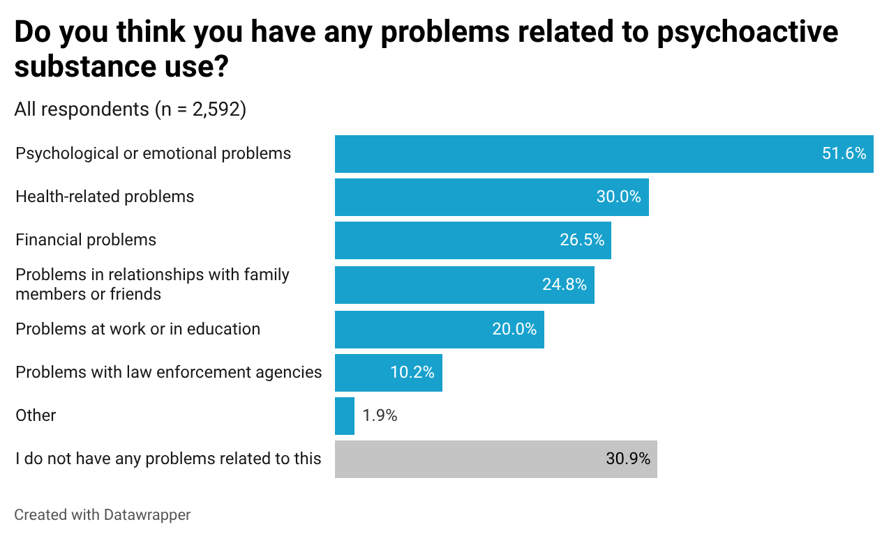
Women were more likely than men to report psychological or emotional problems (56.1% versus 46.9%) and health-related problems (32.0% versus 28.0%), but were less likely to report problems with law enforcement agencies (6.0% versus 14.3%). The remaining differences, including financial problems, problems at work or in education, and problems in relationships, were not statistically significant.

Diagram 24. Problems related to psychoactive substance use, by sex.
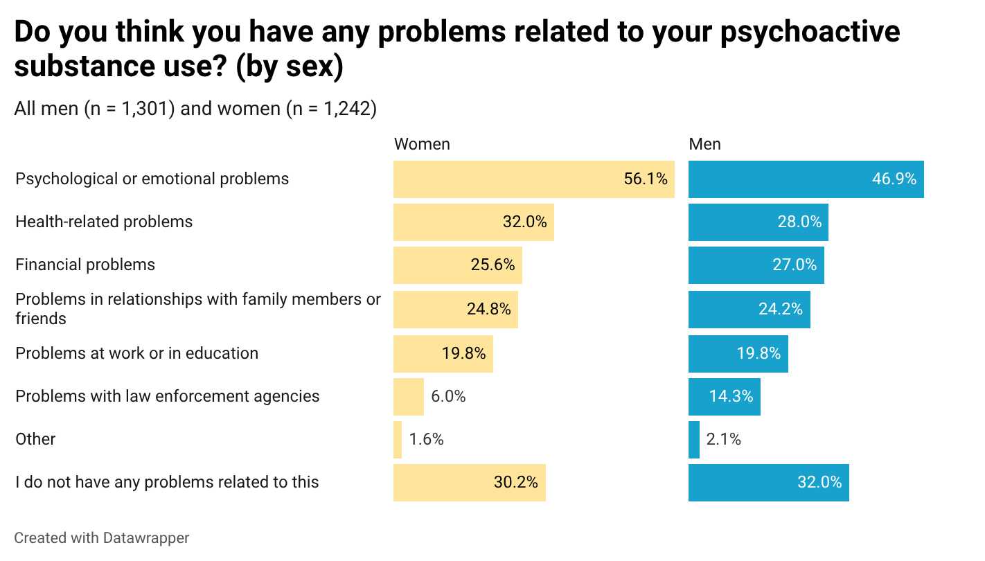
Respondents aged 20 years or younger showed the highest burden of subjectively perceived consequences of psychoactive substance use: 81.5% of those aged 14–18 years and 75.7% of those aged 19–20 years reported at least one problem. Psychological and emotional difficulties were most prevalent in the youngest age groups and declined progressively with age. In these same groups, the highest levels of financial problems, problems at work or in education, and strained relationships with family members or friends were observed, each reported by around one quarter to one third of respondents, whereas from age 21 onwards these proportions declined.
The prevalence of health-related problems was also highest among those aged 14–18 years (36.7%); it then declined, reaching a minimum among those aged 24–28 years (24.9%), and subsequently rose again, to 31.2% among respondents aged 34 years and older. It is noteworthy that only 18%–24% of young people aged 20 years or younger considered themselves to have no problems at all, whereas from age 24 onwards this proportion rose to 36%.
For every type of problem about which respondents were asked, there was a statistically significant age gradient: the younger the respondent, the more likely they were to report that problem. The only exception was problems with law enforcement agencies, where the gradient was reversed.
After age 20, a consistent shift in the profile of difficulties was observed: the proportion reporting psychological or emotional problems and socio-financial challenges gradually decreased, whereas problems with law enforcement agencies became more common with increasing age (15.2% among those aged 34 years and older versus 8%–9% among those aged 14–20 years).
Thus, respondents aged 20 years or younger were the most vulnerable in terms of the number of psychosocial and financial problems, whereas in the older cohorts accumulated legal risks became more prominent, alongside an increasing tendency to assess their psychoactive substance use overall as less problematic.

Diagram 25. Problems related to psychoactive substance use, by age.
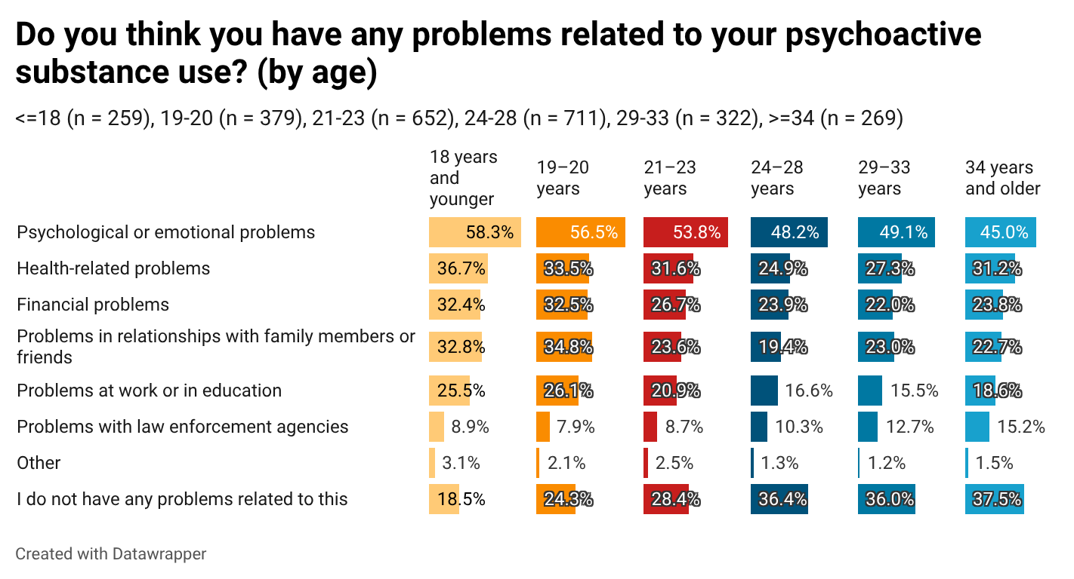

12.2. Adverse effects related to psychoactive substance use

Almost two thirds of respondents had experienced adverse effects after using psychoactive substances, in the form of acute physiological or psychological reactions: 39.8% during the previous six months, including 22.2% during the previous 30 days and 17.6% during the previous 31–180 days, and a further 24.0% in the more distant past.
Diagram 26. Experience of acute bodily reactions after psychoactive substance use.
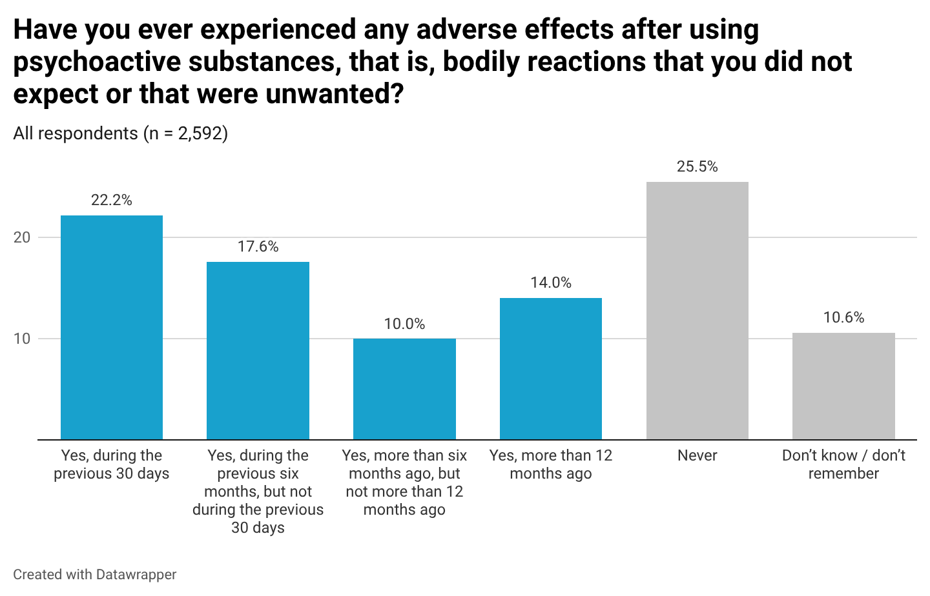

Women more often than men reported adverse effects after psychoactive substance use, particularly during the previous six months but not during the previous 30 days (19.3% versus 15.7%). By contrast, men more often reported no experience of adverse effects at all (29.7% versus 21.7% among women).

Diagram 27. Experience of acute bodily reactions after psychoactive substance use, by sex.
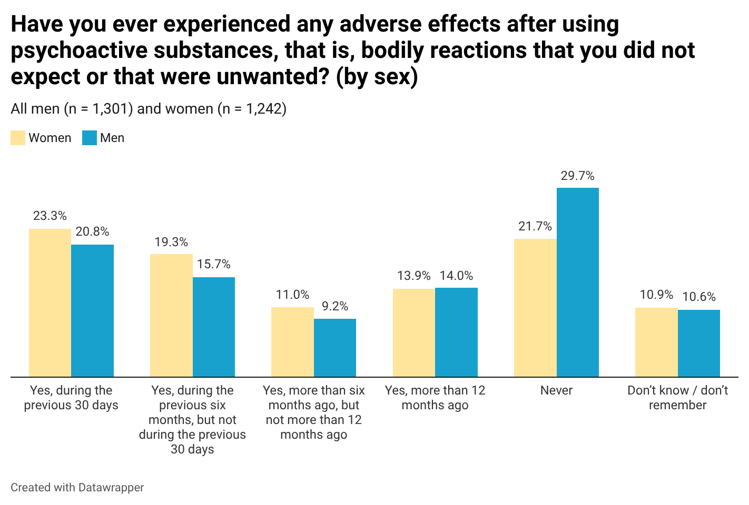

Adolescents aged 14–18 years somewhat more often than others reported adverse effects 6–12 months ago, whereas among respondents aged 24 years and older, the proportion who had experienced such effects more than a year ago increased.

Diagram 28. Experience of acute bodily reactions after psychoactive substance use, by age.
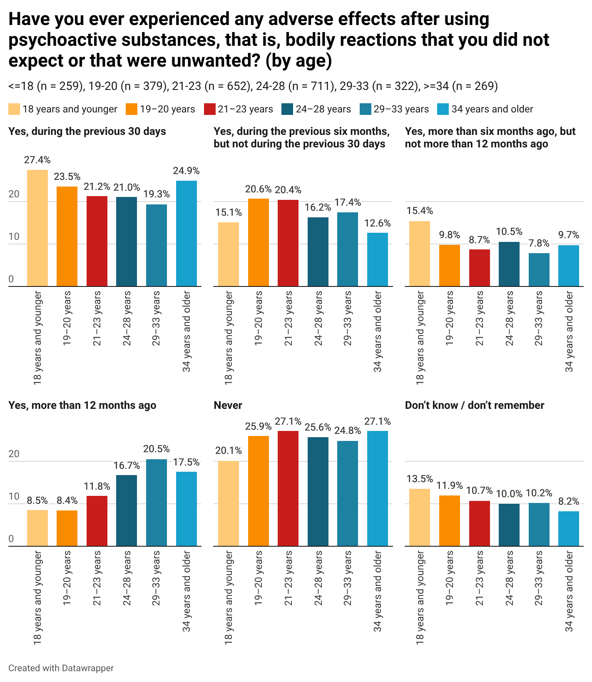

In terms of the nature of the most recent episode, psychological and non-autonomic reactions predominated: severe anxiety or panic attacks (60.5%), confusion (41.0%), and hypertension-related headache with blurred vision (38.5%). Somatic symptoms were also frequently reported, including stomach cramps with nausea (35.5%) and tachycardia with chest pain (29.0%).

Diagram 29. Adverse bodily reactions after psychoactive substance use.
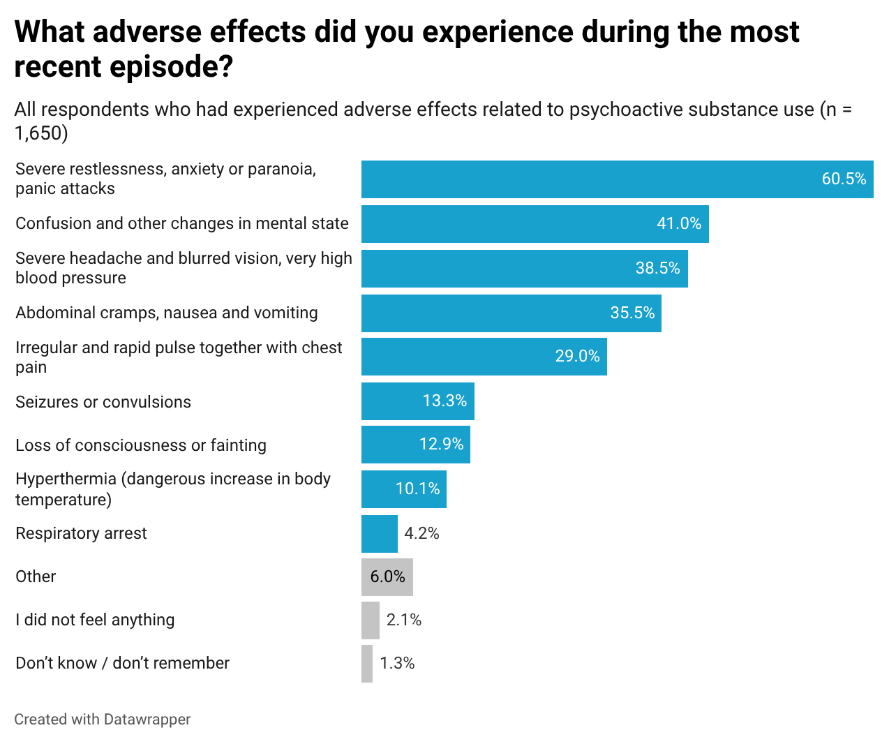

Severe restlessness, anxiety, or panic attacks remained the most common adverse effects among both men and women. Women were more likely than men to report a number of psychological and somatic reactions: severe restlessness, anxiety, or panic attacks (64.9% versus 56.4%), confusion and other changes in mental state (44.8% versus 36.9%), abdominal cramps, nausea, and vomiting (38.6% versus 31.6%), irregular and rapid pulse together with chest pain (31.8% versus 25.9%), and loss of consciousness (14.6% versus 10.8%). Overall, the results indicate that women more often reported most psychological and somatic adverse effects, whereas sex differences for rarer or more severe symptoms were less pronounced.

Diagram 30. Adverse bodily reactions after psychoactive substance use, by sex.
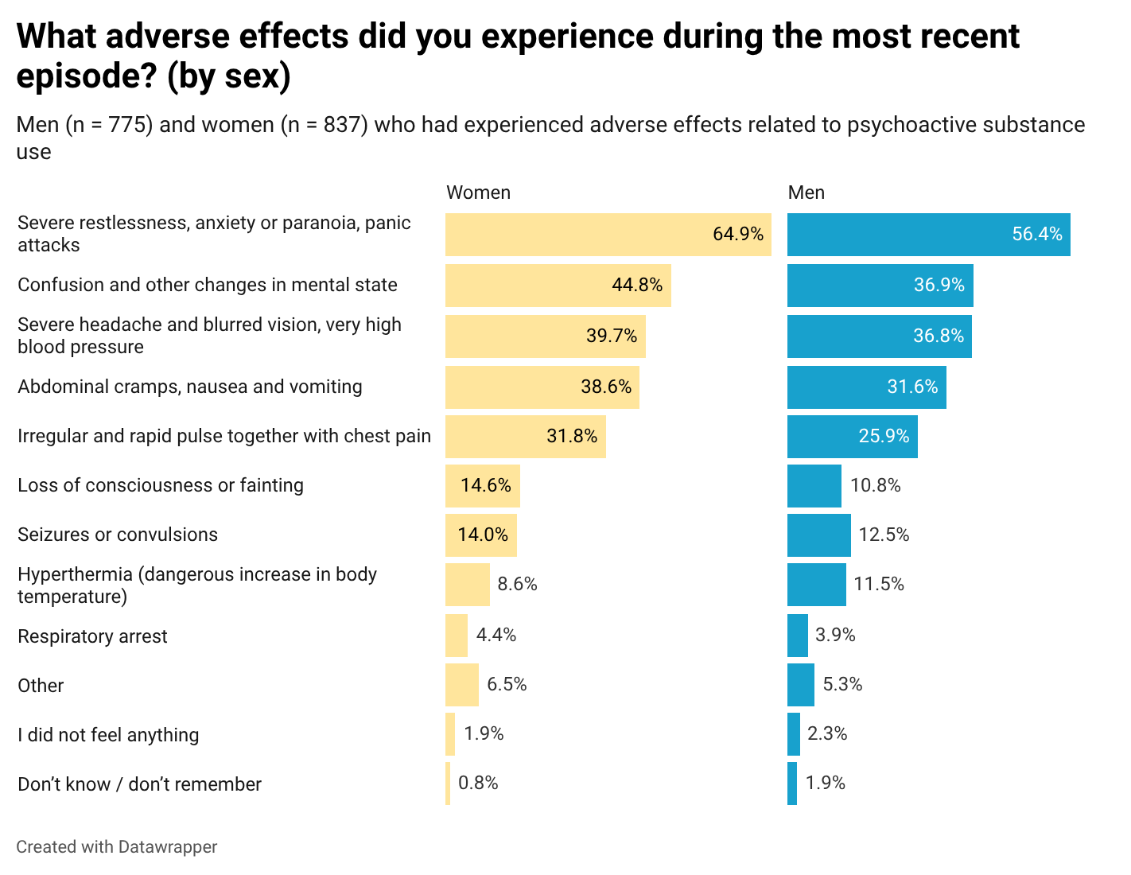

The age distribution of adverse effects indicates that the frequency of most symptoms decreased from age 24 onwards, and for several effects these differences were statistically significant. Severe restlessness, anxiety, or panic attacks were reported most often by respondents aged 21–23 years (66.3%), whereas in the oldest group, aged 34 years and older, this figure was considerably lower (47.7%). A similar pattern was observed for confusion and other changes in mental state, the prevalence of which declined from 45.9%–46.6% among younger respondents aged 14–20 years to 31.0% in the oldest group. The proportion reporting abdominal cramps, nausea, and vomiting also decreased with age, from around 39%–41% among those aged 14–23 years to 23.6% among respondents aged 34 years and older.

The most pronounced age-related decline was observed for more severe effects: loss of consciousness or fainting (21.5% among respondents aged 14–18 years versus 7.2%–10.3% in the groups aged 24 years and older) and seizures or convulsions (20.3% in the youngest group versus around 9%–12% among those aged 24 years and older). Other symptoms, including headache, rapid pulse, hyperthermia, and respiratory arrest, also generally tended to be less prevalent in the older age groups, although these differences were not statistically significant. This suggests that prevention of acute adverse reactions should focus particularly on younger cohorts.
Diagram 31. Adverse bodily reactions after psychoactive substance use, by age.
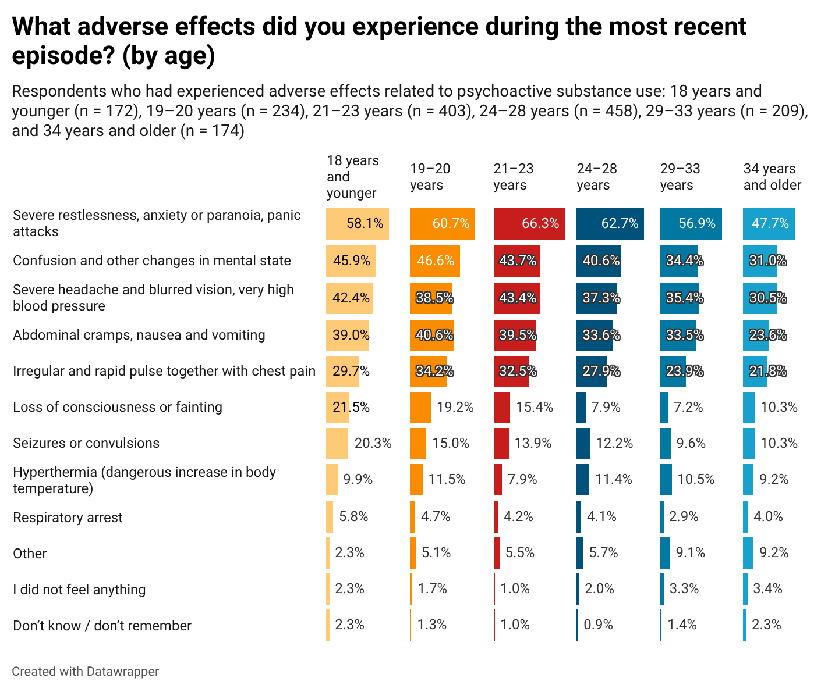
In respondents’ view, the main triggers of adverse effects were emotional state (18.4%) and deliberate dose escalation to achieve a stronger effect (18.4%). Other relatively frequently mentioned factors included dangerous mixing of several substances (12.6%), accidental overdose (12.3%), uncertain concentration of the active substance (11.5%), and poor physical condition (11.0%).

Diagram 32. Perceived triggers of adverse bodily reactions after psychoactive substance use.
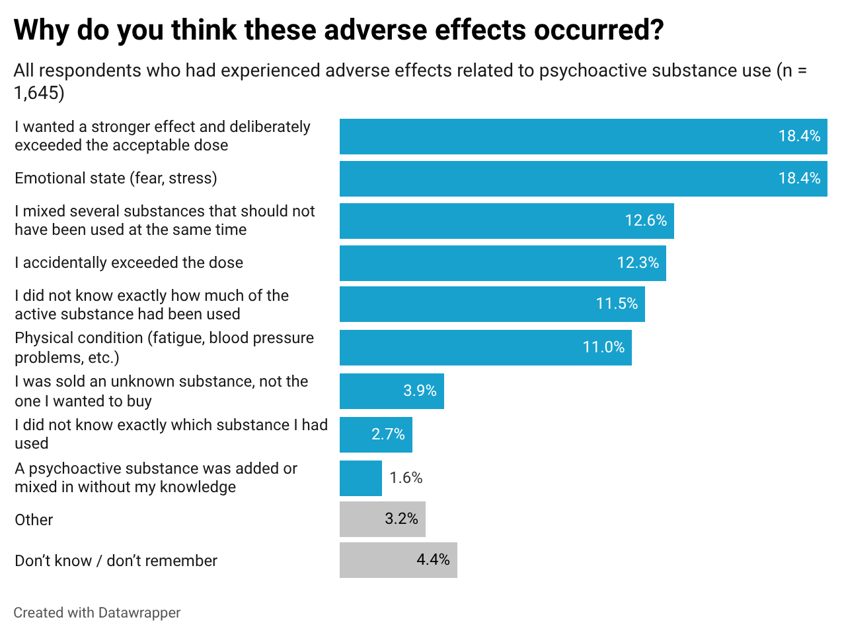
Sex differences in the perceived triggers of adverse effects were not statistically significant. The age distribution of perceived triggers of adverse effects after psychoactive substance use showed that most factors had a similar prevalence across age groups; however, statistically significant differences were observed for some triggers.
In particular, the response “A psychoactive substance was added or mixed in without my knowledge” was reported more often by the youngest respondents (18 years and younger: 4.7%), whereas in the older age groups this reason was much less common (0.5%–2.5%). By contrast, the response “I was sold an unknown substance, not the one I wanted to buy” reached its highest value among respondents aged 34 years and older (6.9%) and its lowest among those aged 29–33 years (0.5%).
Age differences were also noticeable for the reason “Emotional state (fear, stress)”: this was more often cited by respondents aged 24–28 years (21.6%) and especially 29–33 years (26.9%), whereas in the younger groups and the oldest group, aged 34 years and older, the figure was lower (12%–16%).

Diagram 33. Perceived triggers of adverse bodily reactions after psychoactive substance use, by age.
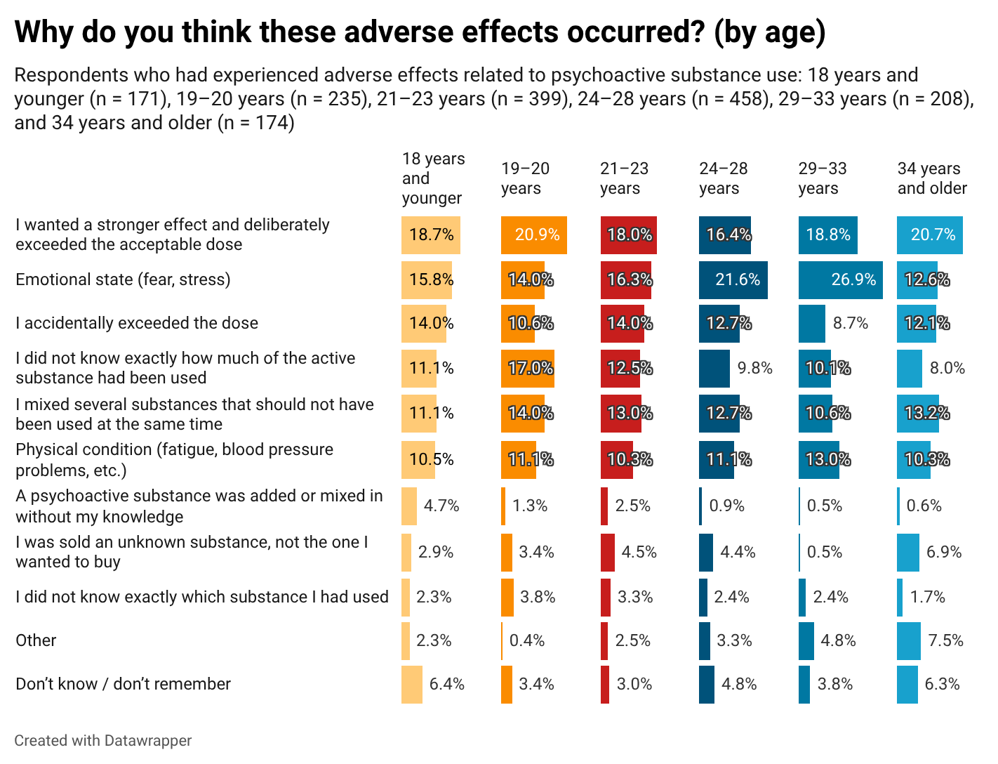

References

1. Rohr, B., Felderer, B., Silber, H., Daikeler, J., Roßmann, J., & Schröder, J. (2024). When are non-probability surveys fit for my purpose? GESIS Survey Guidelines. GESIS – Leibniz Institute for the Social Sciences. https://doi.org/10.15465/gesis-sg_en_050
2. Pötzschke, S., Weiß, B., Daikeler, J., Silber, H., & Beuthner, C. (2023). A guideline on how to recruit respondents for online surveys using Facebook and Instagram: Using hard-to-reach health workers as an example (Version 1.0). GESIS – Leibniz Institute for the Social Sciences. https://doi.org/10.15465/gesis-sg_en_045
3. Andreadis, I., & Andreadis, A. (2022). Survey data quality. In JSM Proceedings, Survey Research Methods Section (pp. 1999–2006). American Statistical Association. http://www.asasrms.org/Proceedings/y2022/files/323439_163724.pdf
4. Conrad, F. G., Tourangeau, R., Couper, M. P., & Zhang, C. (2017). Reducing speeding in web surveys by providing immediate feedback. Survey Research Methods, 11(1), 45–61. https://doi.org/10.18148/srm/2017.v11i1.6304
5. Zhang, C., & Conrad, F. G. (2014). Speeding in web surveys: The tendency to answer very fast and its association with straightlining. Survey Research Methods, 8(2), 127–135. https://doi.org/10.18148/srm/2014.v8i2.5453
6. Kim, Y., Dykema, J., Stevenson, J., Black, P., & Moberg, D. P. (2019). Straightlining: Overview of measurement, comparison of indicators, and effects in mail–web mixed-mode surveys. Social Science Computer Review, 37(2), 214–233. https://doi.org/10.1177/0894439317752406
7. Goodrich, B., Fenton, M. C., Penn, J., Bovay, J., & Mountain, T. (2023). Battling bots: Experiences and strategies to mitigate fraudulent responses in online surveys. Applied Economic Perspectives and Policy, 45(2), 762–784. https://doi.org/10.1002/aepp.13353
8. Cornesse, C., & Blom, A. G. (2023). Response quality in nonprobability and probability-based online panels. Sociological Methods & Research, 52(2), 879–908. https://doi.org/10.1177/0049124120914940
9. ESPAD Group. (2025). Основні висновки Європейського проєкту опитування учнів щодо вживання алкоголю та інших наркотичних речовин (ESPAD) 2024 року [Key findings from the 2024 European School Survey Project on Alcohol and Other Drugs]. European Union Drugs Agency. https://doi.org/10.2810/0658606
10. Lapin, M. S., & Shevchenko, M. V. (2025). Recreational use of pregabalin in Ukraine: Availability, patterns of use and chemsex [Preprint]. medRxiv. https://doi.org/10.1101/2025.10.06.25337361
11. Centers for Disease Control and Prevention. (2024, December 12). About standard drink sizes. https://www.cdc.gov/alcohol/standard-drink-sizes/index.html
12. National Institute on Alcohol Abuse and Alcoholism. (2025, February). Understanding binge drinking. https://www.niaaa.nih.gov/publications/brochures-and-fact-sheets/binge-drinking
13. Babor, T. F., Higgins-Biddle, J. C., Saunders, J. B., & Monteiro, M. G. (2001). AUDIT: The Alcohol Use Disorders Identification Test: Guidelines for use in primary care (2nd ed.). World Health Organization. https://www.who.int/publications/i/item/WHO-MSD-MSB-01.6a
14. Centers for Disease Control and Prevention. (2025, January 14). Alcohol use and your health. https://www.cdc.gov/alcohol/about-alcohol-use/index.html
15. World Health Organization. (2018). Global status report on alcohol and health 2018. https://iris.who.int/handle/10665/274603
16. World Health Organization Regional Office for Europe. (2024, July 31). Alcohol, health and policy response in the WHO European Region in 2019. https://www.who.int/europe/publications/m/item/alcohol--health-and-policy-response-in-the-who-european-region-in-2019
17. Esser, M. B., Pickens, C. M., Guy, G. P., Jr., & Evans, M. E. (2021). Binge drinking, other substance use, and concurrent use in the U.S., 2016–2018. American Journal of Preventive Medicine, 60(2), 169–178. https://doi.org/10.1016/j.amepre.2020.08.025
18. ESPAD Group. (2025). Key findings from the 2024 European School Survey Project on Alcohol and Other Drugs (ESPAD). European Union Drugs Agency. https://www.euda.europa.eu/publications/data-factsheets/espad-2024-key-findings_en

https://drugstore.org.ua/uk/
https://aph.org.ua
Rohr, B., Felderer, B., Silber, H., Daikeler, J., Roßmann, J., & Schröder, J. (2024). When are non-probability surveys fit for my purpose. Mannheim, GESIS–LeibnizInstitute for the Social Sciences (GESIS–Survey Guidelines), 10. https://www.gesis.org/fileadmin/admin/Dateikatalog/pdf/guidelines/non_probability_surveys_rohr_felderer_silber_daikeler_rossmann_schroeder_2024.pdf
Pötzschke, S., Weiß, B., Daikeler, J., Silber, H., & Beuthner, C. (2023). A guideline on how to recruit respondents for online surveys using Facebook and Instagram: Using hard-to-reach health workers as an example (Version 1.0). https://www.gesis.org/fileadmin/admin/Dateikatalog/pdf/guidelines/social_media_sampling_poetzschke_2023.pdf
Andreadis, I., & Andreadis, A. (1999). Survey Data Quality. JSM Proceedings, Survey Research Methods Section, 2006. http://www.asasrms.org/Proceedings/y2022/files/323439_163724.pdf
Conrad, F. G., Couper, M. P., Tourangeau, R., & Zhang, C. (2017). Reducing speeding in web surveys by providing immediate feedback. Survey research methods, 11(1), 45–61. https://doi.org/10.18148/srm/2017.v11i1.6304
Zhang, C., & Conrad, F. (2014). Speeding in Web Surveys: The tendency to answer very fast and its association with straightlining. Survey Research Methods, 8(2), 127–135. https://doi.org/10.18148/srm/2014.v8i2.5453
Kim, Y., Dykema, J., Stevenson, J., Black, P., & Moberg, D. P. (2018). Straightlining: Overview of Measurement, Comparison of Indicators, and Effects in Mail–Web Mixed-Mode Surveys. Social Science Computer Review, 37(2), 214-233. https://doi.org/10.1177/0894439317752406
Goodrich, B., Fenton, M., Penn, J., Bovay, J., & Mountain, T. (2023). Battling bots: Experiences and strategies to mitigate fraudulent responses in online surveys. Applied Economic Perspectives and Policy, 45(2), 762-784. https://doi.org/10.1002/aepp.13353
Cornesse, C., & Blom, A. G. (2020). Response Quality in Nonprobability and Probability-based Online Panels. Sociological Methods & Research, 52(2), 879-908. https://doi.org/10.1177/0049124120914940
Until mid-2025, a similar study was conducted among men who have sex with men (MSM) who practise chemsex.
Findings of the European School Survey Project on Alcohol and Other Drugs - ESPAD». https://www.uisr.org.ua/wp-content/uploads/2025/11/espad_ukrayina_2024_vysnovky.pdf
Lapin MS, Shevchenko MV. Recreational Use of Pregabalin in Ukraine. Availability, Patterns of Use and Chemsex. MedRxiv. 2025. doi: https://doi.org/10.1101/2025.10.06.25337361
t-test, p < 0.001
χ² = 98.8; p < 0.001
The difference in proportions is statistically significant at p < 0.001
The distribution of responses by men and women to the question on cannabis use differs statistically significantly: χ² = 19.2; p < 0.004
The distribution of responses to the question on cannabis use differs statistically significantly across age groups: χ² = 129.1; p < 0.001
The difference in proportions is statistically significant at p < 0.05
χ² = 8.5; p < 0.03
The difference in proportions is statistically significant at p < 0.05.
χ² = 76.3; p < 0.001; Cramer’s V = 0.122
χ² = 238.1; p < 0.001
For all of these psychoactive substances, the difference between the proportions of men and women reporting lifetime use is statistically significant (p < 0.05)
p < 0.05
Age differences were assessed using contingency tables for each substance separately; responses of “Difficult to say / Don’t know” were excluded from the relevant analysis. Pearson’s chi-squared test, the Linear-by-Linear Association test, the Gamma coefficient, and pairwise comparisons of column proportions were used.
Age differences were analysed using contingency tables for each substance separately, applying Pearson’s chi-squared test and pairwise comparisons of column proportions.
The Cochran–Armitage test for linear trend assesses not only the difference between individual waves, but also the presence of a systematic unidirectional shift in the indicator over the entire observation period. Accordingly, a significant result may also be observed in cases where the difference specifically between 2025 and 2021 does not, on its own, reach statistical significance.
Statistical significance of changes was assessed using the two-sided Cochran–Armitage test for linear trend across the four survey waves and the two-sided z-test for the difference between two proportions for comparison of the 2025 and 2021 indicators; p < 0.05 was taken as the criterion for statistical significance.
Statistical significance of changes was assessed using the two-sided Cochran–Armitage test for linear trend across the four survey waves and the two-sided z-test for the difference between two proportions for comparison of the 2025 and 2021 indicators; p < 0.05 was taken as the criterion for statistical significance.
χ² = 38.8; p < 0.05
χ² = 28.67; p = 0.001
χ²=8.442; p=0.038; Cramer’s V=0.058
p < 0.05
About Standard Drink Sizes. https://www.cdc.gov/alcohol/standard-drink-sizes/index.html
Understanding Binge Drinking. https://www.niaaa.nih.gov/publications/brochures-and-fact-sheets/binge-drinking
AUDIT. https://nida.nih.gov/sites/default/files/files/AUDIT.pdf
Understanding Binge Drinking. https://www.niaaa.nih.gov/publications/brochures-and-fact-sheets/binge-drinking
Alcohol Use and Your Health. January 14, 2025. https://www.cdc.gov/alcohol/faqs.htm
World Health Organization. Global Status Report on Alcohol and Health 2018. https://iris.who.int/server/api/core/bitstreams/9530de1c-1fd2-4c20-a167-ec6ba7cb00c3/content
Alcohol, health and policy response in the WHO European Region in 2019. 31 July 2024. Technical document. https://www.who.int/europe/publications/m/item/alcohol--health-and-policy-response-in-the-who-european-region-in-2019
Esser, M. B., Pickens, C. M., Guy, G. P., Jr, & Evans, M. E. (2021). Binge Drinking, Other Substance Use, and Concurrent Use in the U.S., 2016-2018. American journal of preventive medicine, 60(2), 169–178. https://doi.org/10.1016/j.amepre.2020.08.025
Key findings from the 2024 European School Survey Project on Alcohol and Other Drugs (ESPAD). https://www.euda.europa.eu/publications/data-factsheets/espad-2024-key-findings_en
Esser, M. B., Pickens, C. M., Guy, G. P., Jr, & Evans, M. E. (2021). Binge Drinking, Other Substance Use, and Concurrent Use in the U.S., 2016-2018. American journal of preventive medicine, 60(2), 169–178. https://doi.org/10.1016/j.amepre.2020.08.025
χ²=1.109; p=0.292; Cramer’s V=0.021
χ²=34.227; p<0.001; Cramer’s V=0.115; Gamma=−0.143; p<0.001
χ²=15.513; p=0.008; Cramer’s V=0.077; Gamma=−0.113; p<0.001
p<0.05
χ²=29.223; p<0.001, Cramer’s V=0.107
p<0.05
p<0.05
χ²=39.897; p<0.001; Cramer’s V=0.072; Gamma=0.156; p<0.001
p<0.05
p<0.05
χ²=0.864; p=0.649; Cramer’s V=0.018
χ²=28.896; p=0.001; Cramer’s V=0.075
χ²=38.16; p < 0.001; Cramer’s V = 0.122.
p < 0.05
χ²=32.292; p<0.001; Cramer’s V=0.149
χ²=28.670; p<0.001; Cramer’s V=0.141
χ²=26.613; p<0.001; Cramer’s V=0.135
χ²=15.863; p=0.007; Cramer’s V=0.105
χ²=22.479; p<0.001; Cramer’s V=0.158; the proportions differ significantly at the 0.05 level.
χ²=53.203; p<0.001; Cramer’s V=0.169
p<0.05
p<0.05
χ² = 76.4; p < 0.001; Cramer’s V = 0.214
χ² = 63.0; p < 0.001; Cramer’s V = 0.194
χ² = 81.9; p < 0.001; Cramer’s V = 0.221
χ² = 81.9; p < 0.001; Cramer’s V = 0.221
p<0.05
https://drugstore.org.ua/uk/
https://e-likari.com.ua/mentalhealth/
https://pleso.me/
https://app.mindlyspace.com/
χ²=12.89; p<0.001; Cramer’s V=0.151
χ²=8.14; p=0.004; Cramer’s V=0.120
χ²=4.23; p=0.040; Cramer’s V=0.086
The question was worded as follows: “During the previous 6 months, did you feel a need for medical care (for example, examinations, treatment of any acute or chronic illnesses, etc.)?”
χ²=66.61; p<0.001; Cramer’s V=0.199; р<0.05 for the difference in proportions for the response option “yes”.
р<0,05
χ²=37.49; p<0.001; Cramer’s V=0.150; р<0.05 for the difference in proportions for the response option “yes”.
р<0.05
р<0.05
χ²=7.87; p=0.005; Cramer’s V=0.069; p<0.05 for the response option “yes”
χ²=7.82; p=0.005; Cramer’s V=0.068; p<0.05
χ²=15.36; p<0.001; Cramer’s V=0.096; p<0.05
χ²=9.85; p=0.002; Cramer’s V=0.077; p<0.05
χ²=6.81; p=0.009; Cramer’s V=0.064; p<0.05
χ²=16.49; p=0.006; Cramer’s V=0.099
χ²=17.13; p=0.004; Cramer’s V=0.101
χ²=26.66; p<0.001; Cramer’s V=0.126
χ²=23.62; p<0.001; Cramer’s V=0.118
χ²=28.76; p<0.001; Cramer’s V=0.130
χ²=20.64; p<0.001; Cramer’s V=0.135; p<0.05 for the difference in proportions for the response option “yes”
χ²=6.22; p=0.013; Cramer’s V=0.074; p<0.05 for the difference in proportions for the response option “yes”
χ²=9.92; p=0.002; Cramer’s V=0.093; p<0.05 for the difference in proportions for the response option “yes”
χ²=40.67; p<0.001; Cramer’s V=0.188
χ²=29.69; p<0.001; Cramer’s V=0.161
χ²=19.71; p=0.001; Cramer’s V=0.131
χ²=17,03; p=0,004; Cramer's V=0,122
χ²=20,63; p=0,001; Cramer's V=0,134
According to the Mann–Whitney test, U = 287,686.5; Z = -5.78, p < 0.001
p < 0.005
Spearman’s ρ = -0.044, p = 0.072
χ² = 287.685; p < 0.001; Cramer’s V = 0.236
Using the Agresti–Coull method.
Spearman’s ρ = -0.064, p = 0.001. Age explains less than 1% of the variance in the indicator.
χ² = 60.081; p < 0.001; Cramer’s V = 0.157
p<0.005
p < 0.05
χ² = 34.475; p<0.001; Cramer’s V = 0.083
p < 0.05 for the relevant comparisons of the response option “Yes, I have heard of it”
p > 0.05
p < 0.05
p < 0.05
p < 0.05
χ² = 60.302; p < 0.001; Cramer’s V = 0.239
p < 0.05
p < 0.05
p < 0.05
p < 0.001
p < 0.05
p < 0.05
p < 0.05
p < 0.05
p < 0.05
p < 0.05
p < 0.05

